

News Letter –
August 2007 (Vol 4)

CLUB COMMITTEE MEETINGS IN REVIEW
MAY REPORT
- The club is still trying to decide on a venue for the committee meetings, as the Westbury Hotel while it is a central location and has good affordable meals, the venue itself is at times noisy, and very difficult for all to hear the proceedings of the meeting. Some options other venues in Westbury or Deloraine, or another maybe quieter night at the Westbury Hotel?

- Rodney Rouse has supplied a First Aid kit and Louella Reines has supplied a Bum Bag for the kit.

- A table has been purchased as a ride registration collection/information point for Trail Rides. Therefore please proceed to the table and pay your fees, or check on ride/club information. Horses are not to be bought to the table!!!!

- A vote was taken on the Redhill’s Football Club Grounds , and it was decide not to proceed.

- Directional signs for THCRA trail rides to be purchased, these signs should mean no one will ever get lost finding a trail again (well hopefully)

- Trails Tasmania Project discussed by Philip Eeles

- ATHRA merchandise is for sale and forms available from Philip Eeles or the ATHRA website

- Rosevale Sports Ground is available for hire at a moderest fee, this could be used for a club Training/Members and Family fun day.

- If anyone is planning a ride and wishing to have a BBQ, and you want David Jarman to be the head cook, please remember to make arrangements with David at least one week before the ride, i.e. numbers etc. It is not up to David to chase the info, and it is not fair to just assume David will automatically cook with out prior arrangement!

JULY REPORT
- Jane Becker is gathering information on horse riding trails in Tasmania, with a view to publish the information. This will only help clubs like ours in promoting and developing our love of trail horse riding in Tasmania, and raising funds to maintain the tracks on which we ride. Any information that you can supply will be greatly accepted and can be passed on to Rex.

- The clubs ride direction signs were approved. The signs will be made in the form of a double sided metal sandwich board style with arrows that can be rotated to point in any direction. Here is a sneak preview of the first Draft.
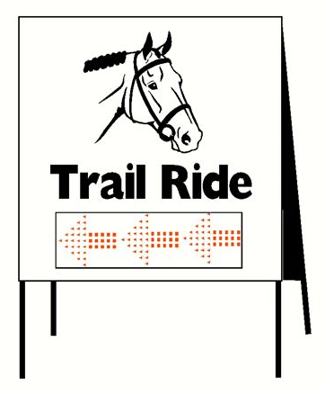

- The property report list was tabled. Anyone with a small truck that Philip can use on ride days to cart it all around please contact him.

- The training/ family day is gathering memento, some events tabled were, Obstacle course, leading a horse, leading a horse obstacle course, Walk and Trot Barrel ride, etc. if you have any ideas please see Sandra Littlejohn or Jamie Corney.

- ATHRA membership is to rise by $3.00 as from the 1st of October 2007.

- The THCRA donated $50.00 to the ST Helens Club for the more than generous generosity, all that attended were made to feel extremely welcome.

NEXT CLUB/COMMITTEE - SEPTEMBER 27th at the WESTBURY HOTEL 7.30pm

RIDE REPORTS

Date: 9th, 10th & 11th June 2007- JUNE LONG WEEKEND

Name & location of property: St Helens Equestrian Club

Ride leader & Assistants: Katrina Dakin & Donna Beeton

Weather conditions: Clear, sunny days – cool at night, but perfect weather.
Condition of track: Good, firm, well defined tracks through bush land leading onto beach ride.
Accidents or Incidents: Nil.

ATHRA Members attending: Riders: Phil Turner, Stephanie Jarman, Colin & Linda Harper, Rodney Rouse, Robert Smith, Philip Eeles, Kim & Josie Etchell.
Non riders – Phil Stott, David Jarman.
Non members attending: Jodie Spaulding, Ellen & Luke McCarthy

Payment received $21

Brief summary of day’s ride:
“WHAT A TURNOUT”
After much deliberation and organization it was finally decided on the last week to join the St Helens Riding Club for the weekend.

Northwest and Northern participants travelled most of Saturday morning to arrive at St. Helens by mid afternoon, to be greeted by a warm log fire and refreshments in their well maintained and appointed club rooms, with secure safe yards for our horses.

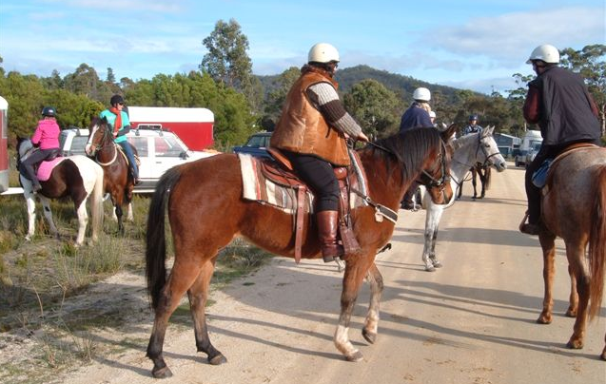
Late afternoon T.H.C.R. group decided to do a short ride on the outskirts of the Club Grounds, familiarizing ourselves with some of the local territory. We were greeted by the two Phil’s on our way back in their Landrover, and Donna at the grounds. Horses were bedded down, some preparing sleeping arrangements at the club ground, other departing for accommodation close by.
Saddle up and move em out

Sunday morning, clear and sunny, we met with the St. Helens group at the designated area south of St. Helens. There was a brief outline by the St Helens ride leader, and we hit the trail by 10.20am. We rode along gravel roads, past St Helens airport, through sand dunes and onto the beach.

There was an interesting mix of riders from first time trail riders to experienced showies and pony clubbers, and veteran trail riders. Horses ranged from ponies through to draught horses.

After negotiating tea tree scrub we finally hit the softer sand area where some horses chose to roll, then we navigated our way through sand dunes and trail bikes to arrive on the beach. Reflections of sun on water reminded us of how fortunate we are to experience such fantastic rides. Meandering along the beach for 4 to 5 km, some horses entered the water and appeared old hands, for others it was a new learning and frightening experience.

We were greeted at the top of Perrin Dunes by both club members (non riding) and were directed towards our lunch area, where we enjoyed home-made soup, sandwiches, tea and coffee prepared by our hosts.

After members trying various ways of mounting, and Linda deciding not to chance the way back, she offered her young horse to Steph for the return trip. Phil Eeles rode Steph’s Billie back. It was an uneventful return on the same route, with everyone getting back to the floats safely. We then returned to the Club Grounds where horses were fed and watered and bedded down for night.

Riders were treated to a magnificent BBQ dinner, and we shared many horsey experiences around the camp fire enjoying “refreshments”. It was great to network and relax with our hosts from St. Helens.

Monday morning was a “slow start”, we tidied the hose yards and grounds, thanked Donna and husband Heath for a great weekend and hospitality, and went our various routes to return home.
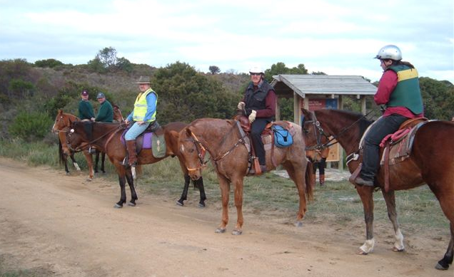

Hurry up and take the Photo, we want to go play in the SAND!

A big thank you to the St. Helens group for a fantastic and memorable weekend.

“What a turnout this turnout turned out to be”
Rob A Smith

GREENHILLS RIDE
Date: 21-07-07

Name & location of property: Campbelltown ‘Greenhill’

Ride leader & Assistants: Jane Taylor, Steph Jarman - First Aid, Tracey Corney - Drag

Weather conditions: Clear, sunny days perfect weather, snow on the mountains in the distance.

Condition of track: Through bush land and pasture.

Accidents or Incidents: 2 Riders came off with nil injury.
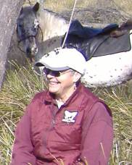
ATHRA Members attending:
Riders: Tracey Corney, Anne Robarts, Steph Jarman, Robert Sulzberger, Kellie Boyd, Rex Lee, Rob Smith, Rod Rouse, Jodie Baker, Craig Hoodless, Wendy Bush, Steve Bush, Louella Raines, Jane Taylor, Sarah Byers.
Non riders – Phil Stott, Phil Eeles, Jamie Corney.

Non members attending: Clare Davey, Prue Jordan, Steve Broad, Glen Boyd, Ian Sims, Isabella Sims, Gaynor Goold, Steve Daley, and Virginia Hogarth.
Payment received $129.00

Brief summary of day’s ride:
Louella and Elly

Hope all enjoyed the ride. Would love to say I planned the beautiful day so I will....I planned the beautiful day and no wind. except from me!?
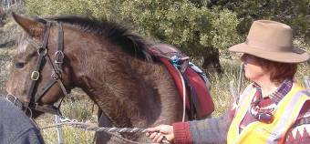
We had two falls on the ride, the first was Ian Sims from up the coast. He usually rides in a cart, on flat ground, so handled the terrain well for the day. Loved it and will be back with his daughter Isobel as soon as they can. The other was Sarah, she also fell off last thing Saturday. Her first fall ever and only hurt the ego.
Jane with her Baby

Thanks to the Double family, Andrew Nicolson and wonderful husband Ewan for the country to ride in. Also to Val and Laura for opening the first lot of gates in the ride...and the scones and soup at the end of the day. This may be a new standard to keep. Thanks to Jinx, Gaynor, Rex, Broady and anyone else who opened gates on the way round...many hands make light work. Need my key back too Rex..thanks.

So nice to see many new faces at the ride and I hope to see them all again soon. I really loved showing people about our area and enjoyed great company. Not often do we all get the opportunity to mix in such a diverse age group of people and relax for the day. This is what I enjoy about trail riding...and my young horse went SO well.

Regards Jane T
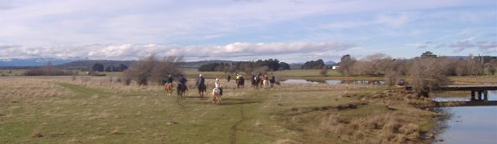
On the way back to Greenhill’s

TRAILS TASMANIA Update 5
A discussion paper was released for public comment in June 2007, which summarised the key findings from research and initial consultations about trails in Tasmania. It also provided an outline of the proposed strategies for trail management in Tasmania. Over 95 submissions were received from a range of different individuals and organisations across the state, commenting on the paper. Overall, there was strong support for the development of a statewide approach to trails and a high level of support for the strategies and assessment criteria outlined.
The consultants from Inspiring Place are currently preparing the draft Trails Tasmania Strategy. It is expected that the first draft of the Trails Tasmania Strategy will be circulated to a group of around 20 key stakeholders in the first week of August. Based on the feedback received from these key stakeholders, the strategy will be revised before being released for public comment.
Sport and Recreation Tasmania would like to thank all those individuals and organisations who have participated in the various consultations, to date. A large number of people have participated in different aspects of the formal consultation phase. This is shown in the following numbers:

- over 50 people attended the three regional public forums in February
- 60 survey responses were received for the inventory of existing trails
- 70 proposals for new trail developments were received, which equated to 61 unique trail development proposals
- over 95 submissions were received on the discussion paper
- 268 individuals have received the project updates via e-mail.
- For further information on the Trails Tasmania Strategy please visit the Trails Tasmania website at www.development.tas.gov.au/sportrec/trails

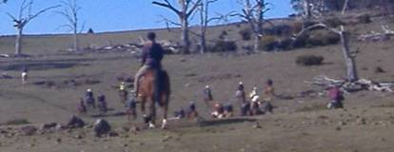
Riders spread out to play “find the blade of GRASS at the not so Greenhill’s

Upcoming Rides
Date Where Contact Closed/Open ride Lunch

19/08/08 Holwell David Jarman Open Yes
BOOKINGS ESSENTIAL - 6396 3395. Lunch $5 – Hot Dogs, Soup. (Cans of drink for sale)

23/09/08 Cluan Tiers Trail Linda Harper Open BYO
BOOKINGS ESSENTIAL - 6363 1381 .

27/10/08 Bakers Beach Wendy Bush To be confirmed BYO
BOOKINGS ESSENTIAL - 64286070 .

November Long Weekend to be confirmed
Option One - Skittle Ball Hut Miena area, Option Two - Bronte Park

RIDE RULE REMINDER
Previous members, who have let their membership lapse, are not permitted to ride as a “Non Members” and only pay the Non Members ride fee. In addition to this Non members are only permitted to have 2 rides to see what the THCRA is about, after this if they wish to ride again they must join as a full member.
THIS IS AN ATHRA RULING.
The only exception to this rule is when a previous member or a non member leads or takes a ride, it is only then that the 2 ride rule is not applicable.
Ride Fees - Member $3.00, Non Member $15.00, Ride Leader – No Charge

NEW MEMBERS
A big welcome to Sarah Byers of Campbell Town. Sarah is 11years old (12 This Month), her horses name is Jimmy and is in his mid 20’s and his breed is just “a good one”. Sorry that there is no photo as Sarah was too quick for the camera, but we will get her one day.

CLASSIFIEDS
For Sale
15h Buckskin gelding draught X, 11 years old, good to float, shoe, catch and lead. Done trail riding and stock work. Phone Heidi 0429 943 155 evenings. $2500.00ono Selling due to new baby no time for horses.

Mobile Saddler & Rug Repairs –
Rick Allan, comes around every 6 weeks next due August 9th Ph 6254 6196

HELPFUL HINT
A remedy for colic – bran mash made from 1 packet of unprocessed bran, with 50/50warm water and vegetable oil. Mix to a texture like runny porridge. Keep horse moving until they poo.

What is COLIC?
The following information was taken from the following web site www.equinecentre.unimelb.edu.au
The term "colic" means only "pain in the abdomen" or "pain in the belly." There are many causes for such pain, ranging from the mild and inconsequential to the life-threatening or fatal. One of the problems with equine colic is that it can be very difficult in the early stages to distinguish the mild from the potentially fatal. This is why all cases of abdominal pain should be taken seriously right from the onset.
Major Types of Colic
Impaction Colic:
This is the term used when the intestine becomes blocked by a firm mass of food. Impactions most commonly occur in the large intestine at one of the flexures. This is a fairly common type of colic which usually resolves relatively easily with appropriate treatment. However, an impaction may be just the first obvious sign in a more complicated case.
Gas colic:
Sometimes gas builds up in the intestine, most commonly in the large intestine and/or caecum. The gas stretches the intestine, causing pain. Gas colics usually resolve fairly easily with appropriate treatment, although it is essential to ensure that there is no underlying reason for the problem.
Spasmodic colic:
Some cases of colic are due to increased intestinal contractions, the abnormal spasms cause the intestines to contract painfully. These cases usually respond fairly well.
Displacement/volvulus/torsion ('twisted gut'):
In a "displacement", a portion of the intestine has moved to an abnormal position in the abdomen. A "volvulvus" or "torsion" occurs when a piece of the intestine twists. The suspension of the small intestine from the mesentery (the "net curtain") and the unfixed nature of much of the large intestine predispose horses to intestinal displacements and torsions. Except in rare cases, these types of colic cause a total blockage of the intestine and require immediate surgery if the horse is to survive. In the early stages of a displacement / torsion colic, the signs may be similar to those of a horse with one of the more benign causes of colic. That is why it is important to take all cases of colic seriously, and to seek veterinary advice at an early stage.
Enteritis/colitis:
Some cases of abdominal pain are due to inflammation of the small (enteritis) or large (colitis) intestines. These are serious medical cases and require immediate veterinary attention.
Gastric distension/rupture:
When a horse gorges itself on grain or, even more seriously, a substance which expands when dampened like dried beet pulp, the contents of the stomach can swell. The horse's small stomach and its inability to vomit mean that in these circumstances the stomach may burst. Once this has happened death is inevitable. If you suspect that your horse may have gorged itself on concentrate feeds, seek veterinary advice immediately.
"Unknown":
In many cases of colic it is impossible to determine the reason for the pain. Symptomatic treatment, close monitoring and attention to any adverse developments usually lead to resolution of the problem.
Signs of Colic
The signs of colic in horses range from almost imperceptible in mild cases to extremely violent in severe cases. The following list includes the most common signs:

lying down more than usual - getting up and lying down repeatedly - standing stretched out
standing frequently as if to urinate - turning the head towards the flank - pawing at the ground - repeatedly curling the upper lip - kicking at the abdomen - rolling

What to do
The severity of the case will dictate what you do when you find your horse showing signs of colic. If he is behaving violently call your veterinarian immediately. Violent behaviour usually equates with great pain which usually equates with a serious case of colic. Time is of the essence here. Not all horses show the same severity of signs with the same type of colic, though, and some horses may become quite violent with a relatively "mild" case.
If the signs of pain are less extreme, you can take a few minutes to observe the horse's appearance and behaviour before calling the veterinarian.

If possible, take his temperature, pulse and respiration rates.
Note what his appetite has been like in the past day or so, and the consistency and frequency of defecation.
Has his water intake been normal?
Are his gums a normal colour?
Think about whether he has had access to any unusual feedstuffs in the past day or so, whether any medications have been administered, and whether there have been any changes in management.
Now call your veterinarian. It is important to take all food away from the horse until the veterinarian arrives. If he is nibbling at his bedding, find a way to prevent this. Walking the horse can be a useful way of distracting him from the pain, but he should not be walked to exhaustion. If the horse insists on rolling, there will be little you can do to prevent it. If possible, try to get the horse to an area where he will do himself the least damage when he rolls. But do not get hurt yourself. Do not administer any drugs until your veterinarian has seen the horse, unless he/she tells you to do so.
Prevention of Colic
If you happen to be a horse, colic is probably an unfortunate fact of life. Annual colic incidences of approximately 10% are quite common. Listed below are some of the management factors which are thought to reduce colic incidence. Horses which fall into high-risk categories, such as stabled horses in intense training and fit horses recently injured, should be monitored particularly closely

- allow as much turnout as possible
- maintain a regular feeding schedule
- ensure constant access to clean water
- provide at least 60% of digestible energy from forage
- do not feed excessive digestible energy
- do not feed mouldy hay or grain
- feed hay and water before grain
- provide access to forage for as much of the day as possible
- do not over graze pastures
- do not feed or water horses before they have cooled out
- maintain a consistent exercise regime
- make all changes in diet, exercise level and management slowly
- control intestinal parasites and assess efficiency periodically

Risk Factors
The following information is taken from a study of a normal, healthy horse population in an effort to identify risk factors associated with colic. An understanding of risk factors can provide practical approaches to preventing colic.
The study, conducted by Dr. Nathaniel White II professor of surgery at Marion DuPont Scott Equine Medical Centre in Virginia, profiles 1,443 horses from farms in Virginia and Maryland which had populations of 20 or more horses.
After monitoring the farms for a full year, 100 factors were analysed to see if a pattern could be identified. The possible risk factors examined were based on the farm's history, the age, sex and breed of the horse, its use, feeding, parasite burden, the weather, management routines and daily events.
Risk Factors  Identified in Study | Lower Than  Normal Risk | No Effect | Higher Than  Normal Risk
Sex, breed
Crossbred
(other than thoroughbred)
Foals, weanings, yearlings
Fed grain before hay at meals
Horses in training for racing or eventing
School horses
Horses confined to stall more than 12 hrs/day
Letters to the Editor
Hello my name is Flicka and my Owner's a clinic junky.
Yes, it’s true. She went thru her mid life crisis and came to the sale yard and bought me. I spent my whole life misbehaving and being passed from Greenhorn to Greenhorn till someone finally got smart and sent me to the sale yard. I was seriously hoping to be picked up by one of those show horse fellas so I could live in a fancy barn and stand around and look pretty, but they told me my butt was too small, my heads too big, and the crest on my neck from a bout with grass founder (thanks to owner number 2) is not desirable, and in general I was just not that capable of looking pretty, so I went home with Phyllis instead. She pets me and loves me, and in general I had a pretty good life at first. Then she heard about those guys who whisper to horses. Life has never been the same.

First there was Pat. At Pat’s clinic Phyllis learned to twirl a big stick and chase me around a round pen till I was ringing wet with sweat. Once I had quote “calmed down” (I was never really fired up in the first place until that guy came at me with the stick like an idiot) she began learning to ride me with no bridle. Talk about giving an old spoiled horse an opportunity to have some fun! Initially I went along with it. I’d lope around the pen real nice like, and everyone would oooh and cooo over my natural horse abilities. Then, just when everyone had gathered around to watch, I would see the SCARIEST!! (tehehehe) shadow in the history of scary shadows and switch directions and take off with my rider clinging terrified to my back. Every other horse on the place was envious of me because their owners would take them out back and beat them with that overpriced stick when no one was watching, but I knew my Phyllis would not. Eventually Philly (as I like to call her) gave up on the whole natural horse idea when Pat tried to talk her into jumping me without a bridle over some barrels.
Off we went in search of another guru. In our search we found Monty. He threw a string at a horse and talked to the horse with winks and stares. I spent some time with his clinic
horses. I saw the demonstration where an unbroken 2 year old became an overnight Reiner. Later I talked to the 2 year old. He was actually 5 and had been doing this same routine for about 5 clinics now. The first time Phyllis broke out the string I again, went along with it. Well, until she got tired of me stopping and looking at her like she was stupid. When she went to get herself a glass of water and refer to that chapter in Monty’s book I grabbed the string and chewed it to pieces. And this is how I got my Jolly ball!
Then there was the Indian fella with a name I can’t pronounce. To get the full effect of his clinic Philly painted stuff on my body and put feathers in my hair. I looked like I was in a Costume class, but hey whatever floats your boat. I thought maybe at least with this guy we might get to play Indian pony games and have mock battles or something but no. More round pen work and gimmicks. This time there was a fire in the middle of the round pen and they danced
around it while praying that I would become a good horse and always mind my owner. He only took her for a couple thousand pelts and a bottle of firewater.
There’s been the Australian guy. Training with a Boomerang while he hopped around like a kangaroo and called me his mate Sorry fella, you’re cute and all but my mate has 4 legs. I just don’t swing interspecies. A horse psychic who told Phyllis my momma didn't lick me enough when I was born. A guy who used his hands like ears to talk to me and of course the touchy feely lady. I can't complain though I've got an owner who loves me and has devoted her time to trying to make me a better horse. I really should behave, really I should, but I think I am contributing to her youth by giving her a reason to take me to all these clinics. Maybe the next clinic will involve turning me out with the mustangs so I find my inner wild stallion, after all at the end of the day no matter what she wants me to be, I will still be a HORSE.
Sincerely, Flicka

