Kyogle Rainforest Riders Inc
May 9th & 10th RIDE

427 Homeleigh Rd, Homeleigh.

RSVP by 2/5/09 please: 0413859800 or 66331289

Hi all,
Hope you all are as eager as I am to get this club out on our first ride!

Some things to remember:
- Riders under 18 must wear an approved helmet (this appears to have increased as my understanding was 16!)
- No dogs on ride
- Suitable footwear that prevents the foot from sliding through the stirrup must be worn.
- Remember electric fencing tape, poles and energiser
- $2 per ride/day/person if already a member
- $12 per ride/day/person if non-member (2 rides- 1 weekend allowed)
- Please try to bring exact money as we will have minimal change.
- Allow yourself enough time to prepare for pre-ride talk. You will need to fill in necessary paperwork & pay Debbie for ride and be saddled up prior to this.
- Bring feed for your horse, ample horse water available from dam. Buckets for water and feed. Rugs for horse if required.
- Camping gear for you, Chair, warm jacket, plate & utensils
- Families are all welcome to arrive later & camp over.
- Dinner Saturday, BBQ available. Fresh drinking water available.
- Breakfast Sunday
- Lunch, snacks & drinking water for Sunday ride in saddle bags
- Prepare your horse b4 the ride; the Homeleigh area is quite hilly.

Kyogle Rainforest Riders Inc

- We recommend that horses be shod; we do have gravel roads to follow.
- All Junior riders must have a nominated guardian supervising whilst riding
- Get organised and get there early. You are most welcome to come in the morning, get set up, have some lunch and relax prior to riding out.
(Then when you get back, sit around eating dip and throwing back a coldie watching everyone else get sorted.)

THE RIDES

Saturday – Leaves 1pm, for approx 3 hours
Sunday - Leaves 9am for approx 5 hours riding with a break for lunch.

All ride times are calculated at a walk.
The rides terrain is flat, to undulating with some hilly tracks.
Some gravel roads, bitumen verges & grassy tracks as well.
May include creek crossings with a rainforest track.
May require a light jacket at times.

If we have a large roll-up we may stagger the depart time, say 5 minutes apart, so horses are kept as quiet as possible. The horses are then allowed to settle as we go along and catch up to the lead pack.
Bring your digital camera and send me the good shots after the ride, I will put them on our website.

Hope to see you there
Regards
Karen

Directions to Homeleigh Rd Ride Base

Travelling north through Kyogle turn right at Collect service station on Kyogle rd for approx 2 klm. Turn right onto Kyogle – Murwillumbah Rd for approx 2 klm. At bottom of hill turn left onto Homeleigh Rd. follow rd for 4.27 klm. Ride base on left, first house on left after leaving bitumen. Proceed up past house, drive behind shed into paddock. Park wherever you like!
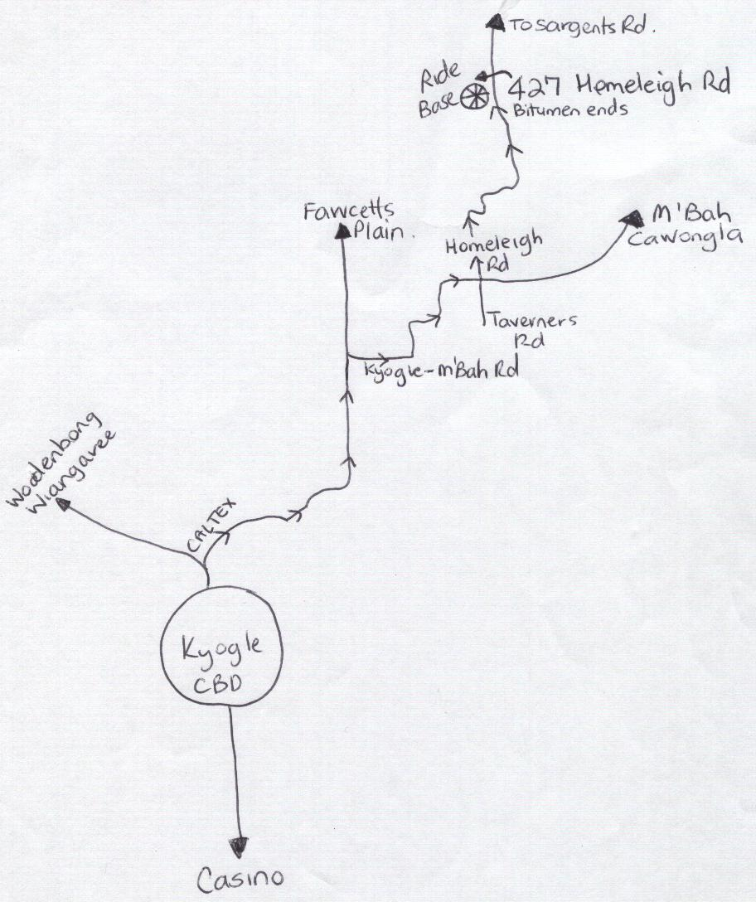

Kyogle Rainforest Riders Inc.
Proposed Ride Dates 2009

- 30th & 31st May
- 27th & 28th June
- 25th & 26th July
- 22nd & 23rd August
- 26th & 27th September
- 24th & 25th October
- 21st & 22nd November
Xmas Party 12th & 13th December.
If any of the weekends are not the 4th weekend, please forgive me. I have had to correlate the rides with my roster.
We need to allocate rides to weekends that suit the hosts, so, if you have a great ride you would like to share with all of us, please let me know asap what month suits you. First in, first served.
We need access for cars towing floats and a safe, self contained ride base.
Cheers,
Karen
66331289 or 0413859800

