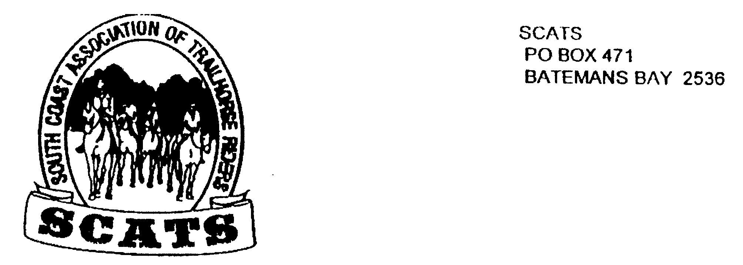
SCATS
PO Box 316
MORUYA NSW 2537
SCATS CHATS

Newsletter of the South Coast Association of Trail Horse Riders Inc.
July 2014

PRESIDENT: Lesley Whale 0421 331002 / 44740232
VICE PRESIDENT: Lawrie Smith 44713754/ 0414 429802
SECRETARY: Bronwyn Ludlow 4474 4291/0428 130 744
TREASURER: Terry Love 4472 3219
RIDE SECRETARY: Karen Scott 0428 643133
TRAIL BOSS: John Davidge 0410 204 123
PUBLICITY OFFICER: Sylvia Sharpe 44743427/ Rosemary Bunn 44781187

At last! The SCATS newsletter! Here’s the blurb on recent happenings including an interesting and informative ride report from Lesley about the Shoebridge ride.

The Shoebridge Ride
Started from Buckenbour yards across the paddocks with Mt Wandera to our
Left: 13 riders a pack horse and a spare horse. We crossed the Quart Pot
Creek (I think) seven times before lunch and stopped for a bite at the junction
of Firebreak Firetrail and Quart Pot Rd. The actual track branched off the
firebreak f.trail not far from our rest spot. The track skirted around the edge
of the mountains intercepted unfortunately by the Golaribee fire trail 5 times
(if I remember rightly). The fire trails were dusty like talcum powder so what a
welcome relief to duck onto the track, out of the dust into rainforest-like
atmosphere among tree ferns springing up all around you, and at one point
masses of grass trees, huge hundred year old ones all in perfect condition.
The most steep part of the track which had been incredibly hard work to
clear some years ago by the Reid family, JD etc had held up remarkably well
and we led our horses along it on the first day just to be on the safe side.
The views in every direction were spectacular, particularly the ones that were
straight down! After that it was pretty good going again except for one huge
tree that we had to ride up and over. The NP&WS will take care of that one
hopefully.
Our camp was at a spot belonging to people called Hester I believe, who didn't mind us occupying their space for the night. We had a visit from Conrad who grows veg at Little Oaky just up the road. The camp oven dinner was awesome as usual.
Next day 7 rode back the as some had work commitments etc or just a sore
Bum! We took some photos of the passing places which we had wondered
about the previous day. And imagined how it would have been 100 yrs ago
passing pack horses or mules carrying gear to the huge storehouse which
stood somewhere on the site of Hesters place. There was also a pub and a
school right there at the end of the Shoebridge Track.
Now in my ignorance I had always assumed that the track continued on to
Araluen, not so I am told; Hesters was the end. So that place must have
been a hive of activity over 100 yrs ago with goods being brought in and
carted out, bought and sold, haggled over etc. The pub would have thrived
and had a place to dump all the rubbish and old bottles etc, metal detector
needed? The place is loaded with history and if you breathe deeply you can
smell the past wafting up yer nostrils. (or was that just stinking rodger)
Lesley

Nelligen Ride Report 5th July
This was a fairly impromptu ride from Kathy Grinrod’s place in Nelligen. However the ride was taken out by Kathy’s neighbor and fellow SCATS member, Sue Clifton and consisted of 8 riders.
This was a terrific four hour ride through local country with the usual creek crossings, interesting bush and some beautiful green paddocks! Sue and Bill had spent a lot of time marking out the bush with pink tags and the locals are determined to keep it open for future rides! But the best surprise was, of course, finding Bill there in the scrub with billy boiling and tea, coffee, cake! That was a very nice rest stop! And then on our return when horses were resting we carried on again having a lovely time sitting around the table at Kathy’s with afternoon tea! Thoroughly spoiled! It was a great ride and a great day!
Needless to say much conversation settled interestingly around Sue’s impending pack ride with a friend of hers starting in Kuranda west of Cairns and heading south who knows how far?!! You can follow their hoof beats at : theoldgreymares@gmail.com Well I hope that’s correct!

FUTURE RIDES
August 10th at Rosemary’s
This is a right turn from the Kings Hwy onto Western Distributor Rd and it is 2.78km from the road. Then turn left into the paddock. This is a 9.30 start to ride out at 10am BYO lunch.
PHONE KAREN TO BOOK IN!

Nethercote Ride
This ride is to be held on the 12th 13th 14th September. More information is on the way so listen in!

Day Ride
A day ride will be organized for September and will be discussed at the next meeting.

Bemboka Ride 12th October
A two day weekend is in the pipeline as a fund raiser for the Bemboka Show. More information coming!

Cracking Cancer Ride 27th September to 4th October Megalong Valley
Obviously this is a camp! The itinerary is yet to come! Take all your own food; breakfast and lunch. Only two meals over two nights will be provided. Cost for the week is $200. I’m sure Kathie Grinrod could provide you with more details.

Remember to book in with Karen or Lesley for all SCATS rides!

HAPPY BIRTHDAY TO YOU!!
Kerry Reid! Terry Love! Kate Abel! Ez Jones!
Kathy Grinrod! Keryn White!

NEXT SCATS MEETING
The meeting will be held on 20th August at Oaks Ranch at 6pm for a 6.30pm start before dinner. All are welcome; it’s always a good night!
Please book in with Lesley for meal numbers a few days before!

