
Forrest Horse Riding Club Inc (A0048951B)
UNDER NEW MANAGEMENT
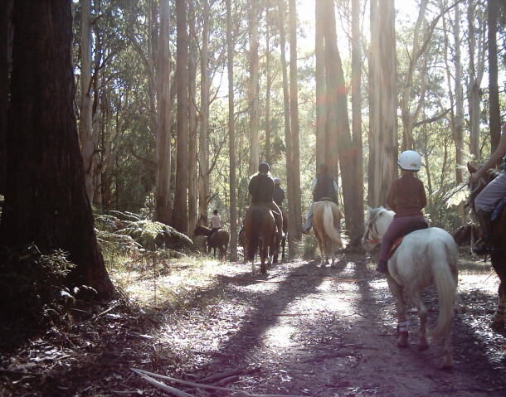

Forrest Horse Riding Club Inc is an Australian Trail Horse Riders Association (ATHRA) affiliated Club, based in Forrest, with access to Great Otway National Park trails.

Trail Rides range from beginner to advanced abilities.
Our day rides are held on the 2nd Sunday of each month.
Visitors welcome for 2 guest rides @ $10.00 per ride.
Club Membership currently $85.00 per person per year
(5 - 80 year old riders welcome!)
Family Discount applies.

CONTACT:
PUBLIC OFFICER : JO Tel: 03 52 366 092
PRESIDENT : TASH 03 52 362 417
Mobile 0423 812 083
SECRETARY : LAURA 03 52 366 014

