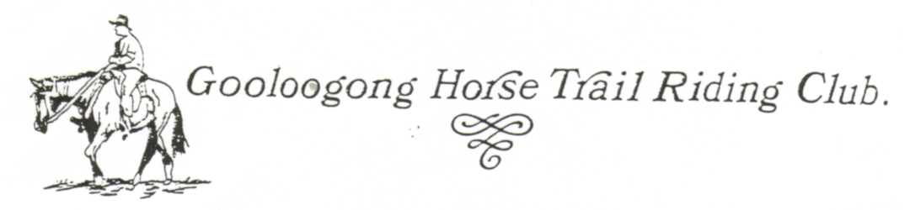
Newsletter – June 2007

LAST RIDE

Our last ride was a camp over which I finally made it to after at least 2 years. We had beautiful days but a freezing cold night I think that must be why it’s taken my so long to get back to a camp over. I’m still trying to dry out my bedding from all the frost. It was a lovely atmosphere at the showground with Camp Drafting on the Sunday so lots of horses and cattle around.

Thanks to Squizzy for hosting the weekend, to Ann Maree and Alan for supplying the caravan and supplies, Alan for driving the support vehicle and putting up with Aaron most of the time, Roger for his filming.

NEXT RIDE

The Next ride is a day ride to be held on Sunday 24th June. Craig Livingston and Megan Taylor will be organising this at Pinnacle. Craig said although it is a day ride that anyone can stay the night before if they want at the Wrights. (Which is the same place as before.) You will need to bring your own supplies for that.

Otherwise we will meet at the usual time of 9.30am for a 10am start. Lunch will on the way.

Information about the ride from Craig & Megan
Yesterday, Megan & I drove around the track that we intend to take on this day.
We feel that it will be better to keep everyone together in one group rather than have two separate groups at various stages of the trip.
We have decided to have lunch on top of the hill or near abouts where we had a photo taken & not where we had lunch last year.
We have decided to cut out the immediate area where the Quarry is situated as we feel that is too dangerous for carts.
There is still plenty of scrubland that will be utilised & will only shorten the ride by about 2 klms.
The only spot we are concerned about is the pinch immediately before the last years lunch spot as it is steep toward the last 30 metres.
However with a bit of care I think it will fine.
The total trip will be approx 20 klms. Probably a good idea to shoe the horses or wear boots as it is fairly stoney at times.
There is a heap of emus in a couple of paddocks just before lunch & might have to hunt them away as they are sitting on eggs.
Attached is the map & directions from last year.
If anyone wishes to camp the Saturday night before please let me know.
The woolshed, toilets & shower is available for our use.

Directions from last year.

THIS IS BLOODY EASY. YOU CAN’T POSSIBLY GET LOST FOLLOWING THIS MAP.

FROM GRENFELL TO PINNACLE HOMESTEAD

Travel West on Mid Western Hwy toward West Wyalong for 8 klms.
Turn Right (North) on The Henry Lawson Way toward Forbes. Travel for 5 Klms until “Nags Head Bridge”.
(No this is not a joke) Turn Left immediately over the Bridge onto the Pinnacle Rd. Travel for about 22 Klms until you get to Goode’s Ln on your Right & then Hoctors Ln on your Left. There will also be a sign at Hoctors Ln saying “Guinea Pig Races” Start Slowing Down cause your nearly there. Keep going straight ahead for about another One Klm over the hill in front of you & through the S Bends.
The Pinnacle Turn Off will be on your Right.
A Mail Box there will have “R & V Walsh, Pinnacle” written on it. And if you’re really nice I might even have a HORSE RIDE sign hanging off it. Turn into this dirt Rd for about 500 Metres till you get to the end.
Turn to your Right & The Pinnacle Homestead will be fair in front of you about 400 metres away.

FROM FORBES TO PINNACLE HOMESTEAD

Travel from Forbes to Grenfell on The Henry Lawson Way for approx 45 klms until you get to a road on your Right that says Mortray Rd. This sign will also say WIRRINYA 32 KLMS.
(On your way to the Mortray Rd you will go past Wilcox Ln on your Right & Matchett’s Rd on your Left.
When you go past Matchett’s Rd you have about 6 Klms to travel before you come to The Bald Hills Rd, which will be on your Left. PUT THE BRAKES ON cause about Two Hundred Metres up the road on your Right is the Mortray Rd turn off.
Turn Right onto the Mortray Rd & travel for approx 10 or 11 or 12 Klms (WATCH OUT FOR THE KANGAROOS!!!!) until you come to an intersection. On your Right is the Rd to Garema. DON’T GO THIS WAY Instead turn left onto the Pinnacle Rd & travel for approx 2.5 Klms.
On your right, on top of the hill in front of you next to the road, is a home with the property name of “TABOR” written on it. PUT THE BRAKES ON AGAIN !!! cause just over the hill about Two Hundred Metres down the road on your Left is the Pinnacle Turn Off
A Mail Box there will have “R & V Walsh, Pinnacle” written on it. And if you’re really nice I might even have a HORSE RIDE sign hanging off it. Turn into this dirt Rd for about 500 Metres till you get to the end.
Turn to your Right & The Pinnacle Homestead will be fair in front of you about 400 metres away.

CALENDAR CHANGES & WEDDIN MUSTER

In the October Section. It says 7th & 8th/Grenfell Campover/Join Weddin Mountain Muster.
The Muster actually starts on Sunday 30th September & Finishes on Friday 5th Octber 2007.

Please read the attached Calendar and note the changes.

A flyer about the muster will be forwarded shortly.

LEE KERNIGAN CONCERT

If anyone is interested, Lee Kernigan is doing a Drought Concert in Grenfell on Saturday 30th June. commencing at 2.30pm and going till 8pm

You can go to the web site:-- www.spiritofthebush.com and check it out or www.leekernaghan.com

The concert if FREE.

Also appearing are:- Jimmy Barnes, Leo Sayer, Adam Brand, Johnny Diesel, Tania Kernigan, Steve Forde and the Flange and The McClymonts.

Should be a great afternoon/evening.

Entry wristbands will be available from Woolworths (? Cowra) and the Grenfell Council after 12th June.
Let Ann Maree know if you would like her to get you a wristband.

FOR SALE

Mitzubishi Canter Truck
1983 Model
Takes 5 Horses

$14,000.00

Contact Rose: 6342 4729

If anybody has anything advertising or news they would like me to put in the newsletter please contact me on Ph/Fax 02 6859 2307 or email gerwyk@allstate.net.au

I’m going to China soon so I probably won’t see you all until July
Karen

This months interview is with Vicki Doyle.
Please read on.

Interview with a GHTRC Member - Vicki Doyle member of 5 years

Horse’s name: Kiona, She chose Vicki, When Vicki went to view another horse Kiona walked up to Vicki and put her head on her shoulder and wouldn’t move.

Town of Residence: Born In Victoria but has loved in Cowra 28 years

Occupation: Nursing Assistant

Favorite Food: Chinese and anything none fattening.

Favorite Drink: UDL Lemon Line and Soda

Favorite Band/Singer: Any thing Country and Western

Favorite Movie The Note book

Favorite Book: The Bible or Debbie does Bethlehem

Hobbies/Interests apart from those involving Horses:

Traveling in company of good friends, Sewing, loves all animals including Mick

What you hate? (Not too long please.)

I hate people who slag off especially if there not good at it.
Blunt razor blades when shaving ones legs.
And human beings that have not discovered they joy of wearing deodorant

