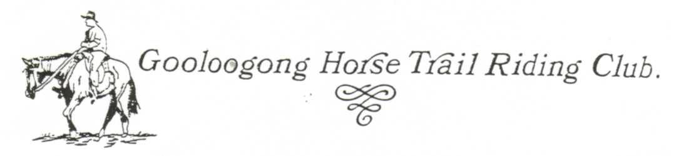
CALENDAR OF RIDES & CAMP OVERS FOR 2007

MONTH | DATES | LOCATION | TYPE OF RIDE | WHO IS ORGANISING  RIDE & SUPPORT
January | No ride too hot
February | 25th | BILLIMARI | Day Ride | Karen Harding
March | 25th | WOODSTOCK | Day Ride | Erica Allen
April | 7th, 8th, 9th | GOOLOOGONG | Easter  Camp Over | At Garry Hagan’s - Perrie organising
May | 26th & 27th | WATTAMONDARA | Camp Over | Garry Birrell
June | 24th | GRENFELL (Pinnacle) | Day Ride | Craig Livingstone & Megan
JULY | 21st | GOOLOOGONG | CASSEROLE  NIGHT | Night at Gooloogong Country Club.  Get together + chance to discuss rules, ideas, etc.
July | 22nd | GOOLOOGONG (Kangarooby) | Day Ride | Terri Moczar
August | 25th & 26th | CANOWINDRA (Nangar) | Camp Over | Matthew Rice
September | 23rd | COWRA | Day ride | Vicki
October | 7th & 8th | GRENFELL | Camp Over | Join Weddin Mountain Muster
November | 25th | WOODSTOCK | Day Ride | Erica
December | 1st | GOOLOOGONG COUNTRY CLUB | No Ride | Christmas Party . Everyone to bring a salad and sweet.

PLEASE WRITE UP YOUR CALENDAR FOR NEXT YEAR OR DISPLAY PROMINATELY

