
Tamworth Bushrangers

President: Alison Swindale – 0427 671 240
Vice President: Angela Witherdin – 0418 234 854
Secretary: Francie Maclean – 0407 660 334
Treasurer: Donna Smith – 0429 642 351
February 2019
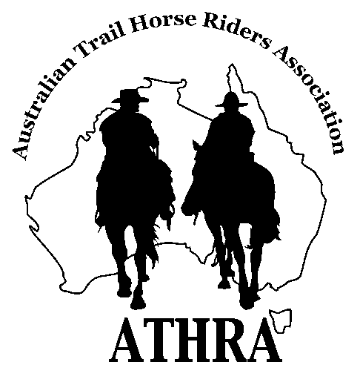
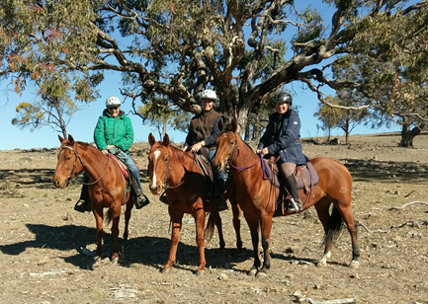


Welcome from the New President
Welcome to another year for the Bushrangers Club. I would like to thank everyone who held a position with the club last year, especially Ange who has taken a little step down from President (now Vice President). Thank you, Francie and Donna, for taking on your positions again. Also, thank you to all who attended the AGM.
Robyn has done a great job of doing the newsletter and keeping us up to date with what was happening. I always looked forward to hearing about rides especially if I wasn’t on them. Helen is now taking on this role so please keep the ride reports coming in and any other news you might like to share.
We are very fortunate to have a great club with fantastic members. While everyone can’t take up a position in the committee there are still many things that help to keep the club running smoothly. We are once again looking for members to organise the monthly rides. So, let’s get thinking about where we can go.
I look forward to seeing you on the trail and having a safe 2019. Let’s hope we get some rain soon.
Alison

Ride Report
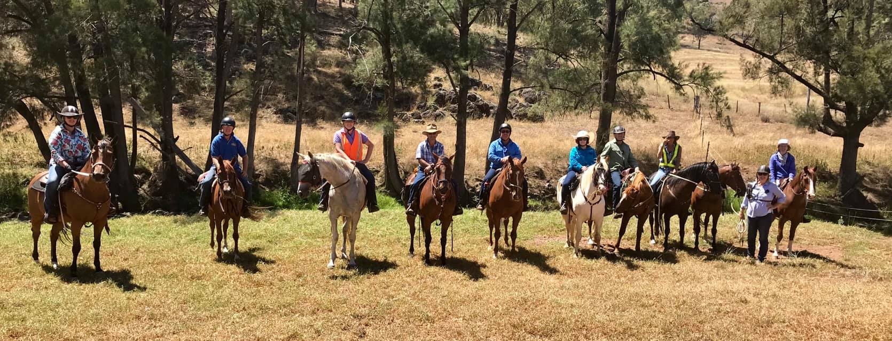

We had a moderate rollup of 10 riders today for the first ride back for 2019 and unfortunately the last club ride at OakView Mulla Creek.
OakView has hosted some beautiful riding experiences over the past few years. The property has now sold after a short time on the market and Duncan and I are off to different experiences in the Moore Creek area of Tamworth.
Thank goodness some hardy souls came to enjoy some great canters through the hills and gullies on a warm dry summer’s day. Our first ride back for the year generally sees unfit horses and their riders still showing some signs of recent Christmas cheer, 2 months ago! Today was no different.
We had a picturesque ride through the waters of the Mulla Creek, the day started with a mustering job moving cows, calves and heifers along the creek and up to another paddock to graze. The ride was well supported by Gunnedah members and it’s always great to catch-up with them and their horses.
Gail Paddison’s gelding Judge enjoyed the challenges of the hills and gullies, we were pleased to have Allana Donovan and her husband Greg join us and they faced some different challenges keenly.
Lynda has taken plenty of footage of the day to remind us how great it is to catch up with friends we have so much in common with, we are all so fortune. Another mutual riding friend I haven’t seen for ages is Merryl, we always love to spend time with Merryl and her flash little chestnut gelding. Clayton and Cruise took the day in their stride as usual, Cruise wasn’t too sure about going under the Trough Gully Bridge, and fortunately both came out the other end. Kevin and Ken job shared the many gates with Gail jumping off ‘ Judge ‘ to lend a hand scrambling back on that grey Goliath, how she does it I don’t know, must be all her experience jumping on and off ride-on mowers at Chaffey’s.
Ken and I held the ride together with our Walkie Talkie skills, although it regularly became awkward in a weird way hearing Ken’s voice purring over the radio when he was just behind me.
Our trail Boss was Bernie Irwin sporting a ‘Mankini’ styled lime fluoro mini jacket that I was envious of, she’s always great company and I enjoyed picking her brains about her trip with ‘Globetrotters’ to Mongolia last year. What any amazing experience, 30 to 60 kms a day, she’s fit and has a great sense of adventure, what and inspiration to women her age. She’s also a generous person and gave me the Borat ‘Mankini’ mini jacket; Yay! I will sport it gladly around my new neighbourhood.
We often find the smaller rides most enjoyable, and today was no different, it was loads of fun. It was for me a fitting way to end 16 years at our much-loved property. On our return our lovely friends Kaz and Scooter were there to greet us with Banoffee pie made by Scooter, he’s a gem in the kitchen, thank god as he was the only one with sweet treats on the day, thank you both. Thank you all for sharing this day with Dunc and I, we do value our friendships.
Our next ride is being organised by Donna Smith and will be a great ride, rumour has it the ride is to be held around Dungowan. Also keep an eye for the ATHRA Trail Boss Coarse, Ride Co-Ordinator and Steward Courses to be held over the June long weekend and hosted by the Gunnedah Club.
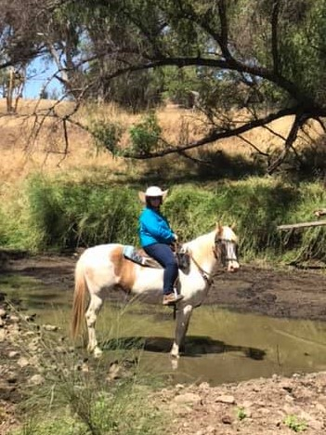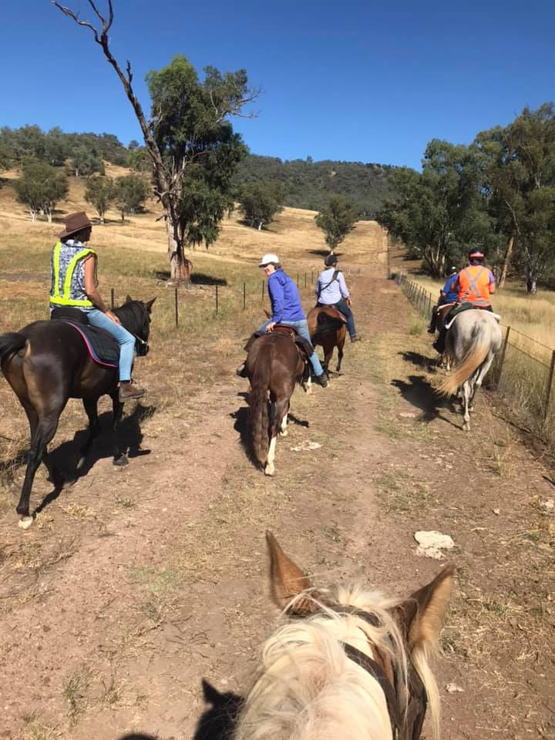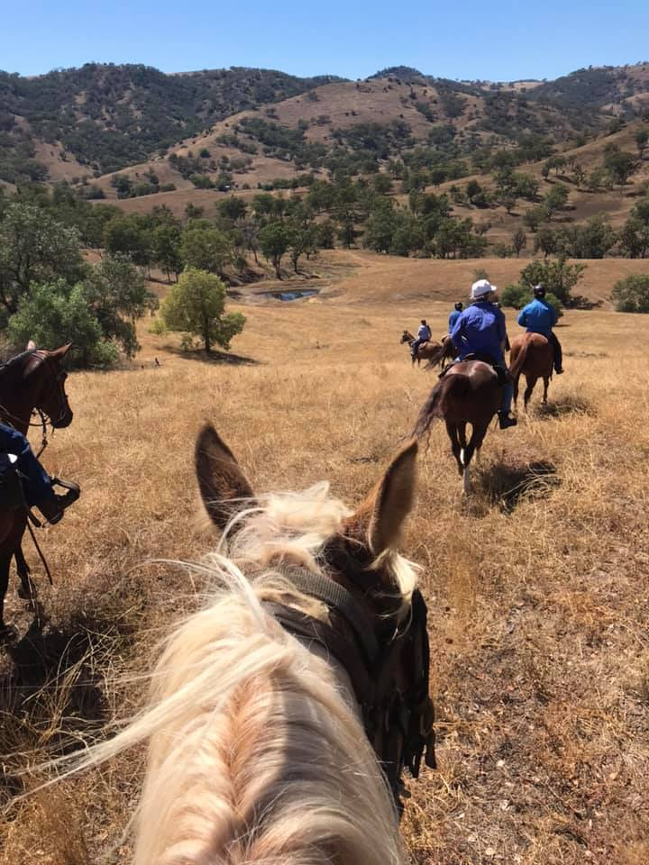
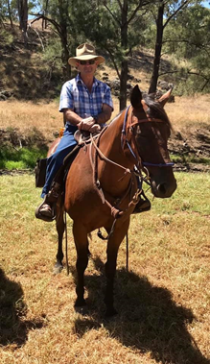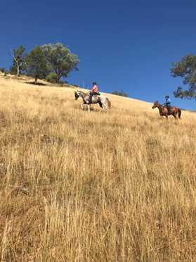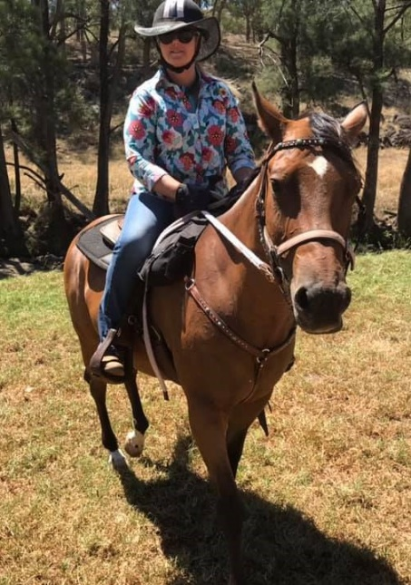


- At this stage our March ride will be a mystery ride in Dungowan.

- Please send ride reports, member news and photos to helenwds@gmail.com no later than 5th of each month as I would like to have newsletter out by 7th of the month
- Please forward any recommendations or ride ideas to organisers.
- ......If we all do a little, then we all have fun.
- Keep updated by our club face book page Tamworth Bushrangers Trail Riding Club

