Cobargo Horse & Trail Riders Inc

President Vice Pres
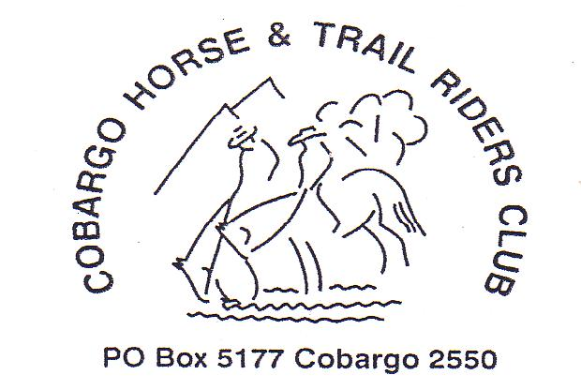
Richard Tarlinton Pauline Blair Noel Haase Athol Moon
64937263 64938401 64934695 64920846

Secretary Treasurer Publicity officer
Trish Hayes Marea Blair Julie Moore
64921459 64938288 64938470

Newsletter No 3 March 2010

Snowy camp – 5 Cobargo riders represented our club at the ATHRA NSW AGM held at Cooinbil campsite. A large number of NSW clubs attended with over 80 people at the meeting on Saturday 20th Feb. It was great to hear the club reports and get inspired by the various activities that other clubs run. ATHRA clubs make generous donations to their local communities with the total of the fundraising being very impressive(but I forget exactly how much!) We missed the wet weather on the coast but scored some mountain downpours which meant the streams were flowing well up in the high country.
Luckily because of the previously dry weather, the bogs were not too wet and crossing the plains was trouble free.
National Parks have done some upgrading of the facilities at the designated horse camps and everyone was appreciative of their efforts…the safe fenced enclosures makes camping with horses much more enjoyable…at Cooinbil there is a permanent electric tape that you only need to attach one unit to and all the yards are ‘hot’.

At the AGM, our lovely Pauline Blair was nominated for the position of NSW Vice President and with no other contenders, gained herself a job! We now have some far south coast representation on the NSW executive. Go Pauline!

ATHRA Code of Conduct – various speakers at the AGM mentioned the value of the ‘rules’ and conventions that we ride under. In general, ATHRA clubs provide non-competitive trail rides on private and public land. The safety standards ensure that everyone has as safe and enjoyable a time as possible, and riders are reminded that riding with ATHRA affiliated clubs implies that you are agreeing to these rules and are prepared to modify your riding to fit in with everyone else in your group. If you always want to travel at faster paces, this is not the group for you.
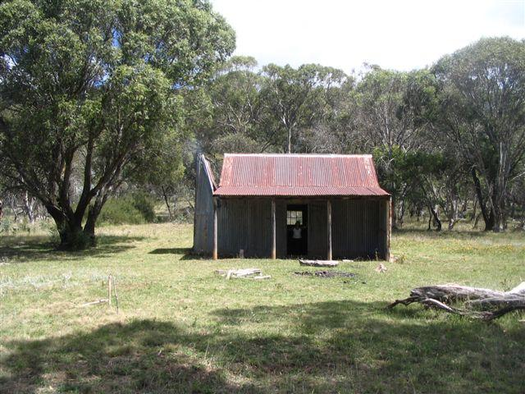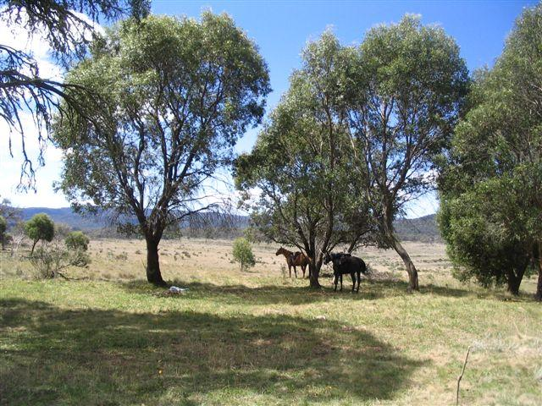
Bill Jones Hut on Cooleman Plain View from hut looking to plain

Ride Calendar

MARCH
Saturday 20th – day ride – Brogo
- Ride co-ordinator : Richard
- Ride host : Trevor Pearce
- Venue : meet at the dairy on Trevor’s farm
Cross Greendale Bridge. Dairy is a green building on the left about 5km past the crossroads. There will be a marker on the turn-off

    - 9.00am for 9.30am ride out
    - Saddle bag lunch/snacks

    - 5 hr ride to Mumbulla falls. Generally bush trails with some steep downhill sections and some rocky/shaley sections. Recommend horses shod or have boots to put on.
    - contact Richard to book in 64937263

Thursday 25th March Meeting – Cobargo hotel

APRIL

Friday 8th – Sunday 11th Corryong Festival

Saturday 24th – Monday 26th Yowrie Reserve Camp – ANZAC weekend - come for 3 days or just for part of the weekend.

Various rides will go out during the weekend, including Peak Alone and Super’s Hut rides.

As trails in this area have not been used much recently, there will be some trail clearing rides/hikes needed. Proposed Sunday 18th April. If you can help, please ring Richard for meeting place, times and equipment requirements.

MAY
Saturday 1st Cathcart ride – details next Newsletter

Sunday 9th MOTHER”S DAY RIDE and lunch
Ride co-ordinator : Julie
Venue : Tilba Meet at Maz’s place ‘Jingara’. Turn right off Hwy at Bermagui
turn-off. Maz’s farm immediately on left. Club marker on driveway.

- 9.30am for 10.00am ride out. Ride to Tilba – 1 ½ hours
- Lunch at Tilba Hotel...12 – 2pm (meet family there!)
- Ride back to vehicles – 1 ½ hours
- Must book in for ride by Thursday 6th May(and include numbers of extras) so we can let Hotel know for catering.
- Ring Julie on 64938470

Saturday May 15th - Annual Horse Sale (tentative date)

JUNE

Biggest Trail Ride Ever!!! An initiative from the US…the Australian Brumby Alliance is organising a simultaneous trail ride to fund raise for Brumby rehabilitation and training. There is a $20 ride fee per person with prizes
and incentives donated by Cavallo equestrian products. A similar group in the US is
organising a ride to raise money for Mustang rehabilitation. It will be the biggest trail ride ever organised! Details are sketchy at present but ATHRA will pass on info when it comes through.

Accreditation Weekend - Date in JUNE to be confirmed. Nethercote’s accreditation weekend looks to be going ahead with 6 Cobargo members so far expressing interest in attending. The date will be confirmed after NSW ATHRA executive receive a date from the US for the fundraising ‘Biggest Trail Ride’.

Membership Fees – new members welcome! 2010 membership now due!
Adult $55
Junior (16 years & under) $35

Visitors $10 per day ride. 2 rides allowed then must join club to continue riding. Weekend ride requires full membership

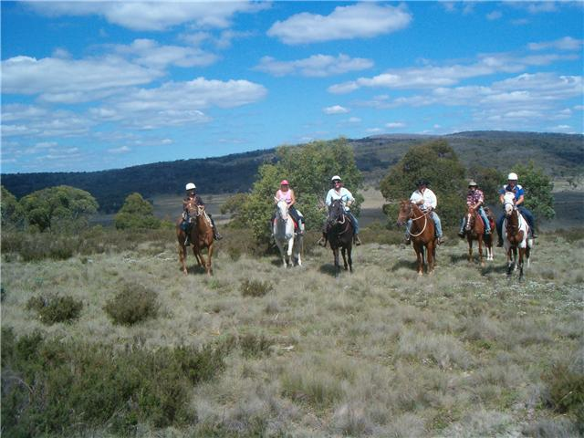
Nelson’s mystery ride – he can’t tell you where you are going cause he doesn’t know till he gets there!
But it was fun and the views were amazing!

