Cobargo Horse & Trail Riders Inc
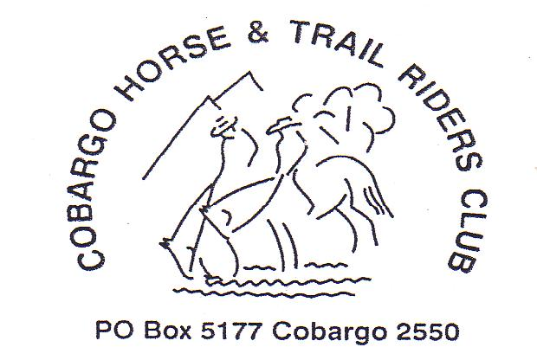
President Vice Pres
Richard Tarlinton Pauline Blair Noel Haase Athol Moon
64937263 64938401 64934695 64920846

Secretary Treasurer Publicity officer
Trish Hayes Marea Blair Julie Moore
64921459 64938288 64938470

Newsletter No 4 April 2010

*** Horse Sale : Saturday 15th May 2010***

Organisation for this year’s sale is well under way with a trusty team already volunteering for the many tasks required to get it underway. The format is the same as previous years with gear being accepted on Friday evening and Saturday morning before the pavilion is opened.
After some discussion it was decided to retain the ‘Dutch Auction’ system for selling the horses. Horses for sale can be booked in from now on by ringing Pauline or Marea Blair.

ATHRA has approved the event with the extra requirement that ALL sellers – either gear or horses – must sign a waiver form to be able to participate. These will be available on the day.

Further arrangements will be finalised at the club Meeting on Thursday 22nd April…anyone wanting to help or contribute please come along to the meeting or ring through your input.

Club News
‘Get well soon!’
Our intrepid Leone Cramer is recovering from a broken collar bone and cracked ribs sustained when she came off her lovely young horse Black Jack. After an enjoyable ride on Mumbulla Mt, something spooked Jack as we crossed the last open paddocks before ‘home’ and Leone was tossed onto the grass. Unfortunately she came down at the wrong angle and hit the ground shoulder first. Reports are that friends are rallying and helping with the animals and meals!

- Club member Judi Hearn was named Bermagui Citizen of the Year for her contributions to the local community in 2009(and previously!). Congratulations Judi. Great article singing her praises in the Triangle.

- Thanks are due to June Tarlinton and Anne Spires for the production of club flags to mark turn-offs, camp sites and tracks when we are out in unfamiliar areas. These will be put to good use over the ANZAC weekend.

Ride Report

Mumbulla Mt ride – Saturday 20th March
In beautiful weather 6 club members joined Trevor Pearce and his two children for the ride to Mumbulla Falls for a planned BBQ lunch. After crossing some open grazing land, the track headed up into the forest and we climbed through the hills following old fire trails and bush bashing in places where the track disappeared under the burden of fallen timber, leaves and wash outs from the recent rains. Unfortunately, after some hours of easy going, we lost the track on a steep and somewhat rocky section heading down the hillside towards the falls area. Despite two forays into the scrub, one on horses and one on foot, no tracks were found and we were forced to backtrack to the top of the ridge where we rejoined the firetrail. We shared the few lunches that had made their way into saddle bags – some people had offloaded their food into the support car that was waiting for us at the falls. After some fun with mobile phones and phone numbers, a message was left for the support car to be notified that we wouldn’t be making it to the falls for the BBQ! Luckily Leone had a big bag of Anzac biscuits to fuel us up for the ride back to the farm.
However, as we crossed a grassy paddock only 30minutes from our destination we had to face the demands of an injury from a nasty fall. With the ambulance called, Marea borrowed an umbrella from a nearby house to shade Leone from the 30 degree heat and Noel headed off down the long driveway to ensure the ambulance found the right track in. We were all very relieved when we heard Leone answering Pauline and saw her moving into a more comfortable position.
It was a sobering end to what had been an enjoyable, if a little frustrating, ride. The terrain was interesting and the bush very lush in some sections and we could see that the ride to the falls WOULD be good if you could hack your way through the bush! We assured Trevor that it was time in the saddle that pleased most of us, so the actual route didn’t really matter! Legend has it that they DID go that way 5-6 (or was that 9-10)
years ago, so there was a track there once.
We thank Trevor and his family for hosting this ride…it was great riding in more lovely country close to home.

Ride Calendar

APRIL
- Friday 8th – Sunday 11th Corryong Festival

- Sunday 18th April – track clearing for ANZAC weekend camp.
As trails in this area have not been used much recently, there will be some trail clearing rides/hikes needed.
If you can help, please ring Richard for meeting place, times and equipment requirements.

- Saturday 24th – Monday 26th Yowrie Reserve Camp

– ANZAC weekend - come for 3 days or just for part of the weekend. Camp from Friday night - Various rides will go out during the weekend, including Peak Alone and Super’s Hut rides.
BYO everything for horses and people except for Sat. night if you are having the special!!!

- First ride to Peak Alone going out at 9.30am Saturday led by Pauline.

Saturday night – Les Hayes SPECIAL. Volunteers to provide deserts.
Catered camp meal ******$15 per head****** BYOG
Ring Pauline by Tuesday 20th to book in numbers requiring dinner

MAY
- Saturday 1st May - 11th CATHCART CHARITY TRAIL RIDE
Horse Assembly 7:15am - Departs from Cathcart School of Arts 7:30pm SHARP!!!
Adults: $55.00 Children (under 16 years): $35.00
Family (2 adults & up to 2 children under 16yrs): $140.00 additional child $20 each
non ATHRA Riders will be charged $7.00 extra for insurance
Non-riders: $30.00 for Saturday Dinner/Dance, campsite and Saturday/Sunday breakfast.
BYO Alcohol - Music till midnight
Contact - Jenny Moreing - 02 6458 2018
All Nominations to be in by 10pm 27th April and paid by 2nd May

- NB. Mother’s Day ride to Tilba has been cancelled due to date clashes and organisational hiccoughs. May/June ride/s will be detailed in the next Newsletter.

Membership Fees – new members welcome!
2010 membership now due!
Adult $55
Junior (16 years & under) $35
Visitors $10 per day ride. 2 rides allowed then
must join club to continue riding. Weekend ride requires full membership.

From this month on, anyone who hasn’t renewed membership will not receive a posted hard copy of the Newsletter. Email recipients will continue to receive emails. Let me know if you do not want it sent to you.

Next meeting – Horse Sale Meeting

Thursday 22nd April ****come and help****

Cobargo Hotel – Dinner 6-6.30pm – Meeting 7.30pm

