Wagga Wagga Trail Horse Riders Club Inc.
Newsletter - May 2010

In This Issue:
  - ATHRA Restructure & Changes to Code of Conduct
  - What ATHRA changes mean for our club
  - Future up-date of our Constitution
  - Meeting Highlights – Welcome new members
  - Past & Future Rides/Functions & Memberships
  - Riders Information - a must read for all new members
  - Current Membership List

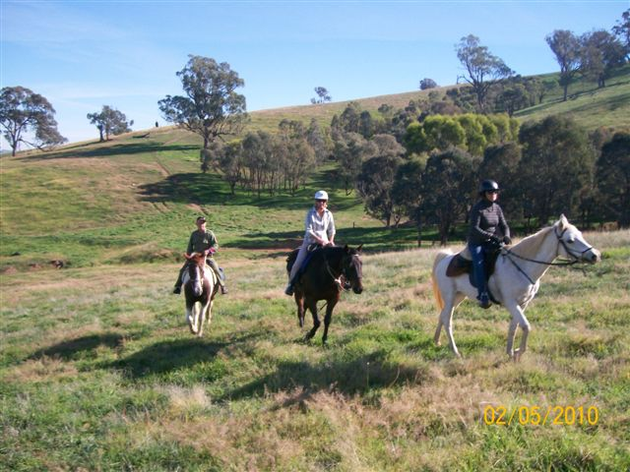

Jeannette, Sandy & Alan at ride at “Glenelg” Holbrook
ATHRA NATIONAL AGM

Restructure
The 2010 ATHRA Annual Council Meeting & AGM was conducted at Redcliffe, Queensland on the weekend of 16, 17 & 18 April.
Your new 2010 National Executive consists of: President-Tony Hart, Vice President-Claire Bourke, Secretary-Gail Ferris, Treasurer-De’hanne Keir, Insurance Coordinator-Alan Salter.
At this meeting some significant decisions were made which have the full support of all State Branch Executives. The most significant and historically important decision to affect members is the restructure of the ATHRA organization - designed to streamline administration and business practices and provide the basis for continued growth and development.
This change comes into effect from Jan 1st 2011 and will result in very little change for clubs and their members, perhaps merely a change of postal address to send club affiliations and memberships and a moderate, if any, increase in membership fees ($50 Adults $40 Juniors).
What the changes will allow is the streamlining of the management and administration processes and costs, including additional benefits to its members.
Effectively the organization will move from a federated model with State Branches and a National Body to a Central Board supported with Regional Managers and functional groups. This will certainly provide a streamlined approach and efficiencies for all.
Your State Branch Executive will be provided with an information pack outlining and explaining the new structure, some branches will conduct meetings to explain this detail. You are all encouraged to seek this information from your respective branch executive.
This is an historic time for the organization, as historic as when ATHRA was first formed in Gatton, Queensland in 1972. It seems only appropriate to have made this historic decision also in Queensland.
There are also many initiatives underway to improve the experience of ATHRA membership and the ATHRA National team look forward to providing the detail of these in the near future.
In the near future there will be a request on members for application to positions, you are encouraged to apply for these.
Finally, should anyone have any questions on this new structure please contact you respective State Branch Executive.

Restructure Model

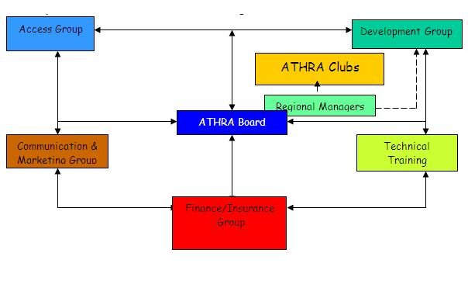

Code of Conduct Amendments
In addition to the above the following changes to the Code of Conduct were approved and become applicable as listed.
Change 1: Additional Environmental Rule effective Jan 1, 2011
5.9 All ATHRA members are to utilise supplied facility yarding where it is logical and appropriate. Members should be conscious of the space they take up within the yards to ensure efficient and shared use of the available area.
Rationale: ATHRA is a responsible horse trail riding organisation that lobbies regional, state and federal government bodies for access and facilities on public and private land. One of these areas is the provision of secure yards for our horses in different public areas, eg. BNT & National Parks (Kosciuszko)
Further, this provision addresses:
1) Individual horse yards taking up camping areas
2) Individual horse yards blocking access to facilities eg toilets
3) In the event horses break loose from individual yards they present significant risk to those in swags & tents
4) If the practice (inappropriate or lack of use of supplied/existing horse yards) continues it will be detrimental to the future plans and upkeep of such supplied yards. Further it will provide argument for those who wish to eliminate access to such areas.
Change 2: Change to “Prospective Members/Visitor participation On Charity Rides & Special Events and affects sections 7 & 9.
Changes have occurred so as to permit “prospective members/visitors to participate in “Charity Rides/Special Events” that span periods of greater than 2 days. This change now permits “prospective members/visitors to participate providing their participation does not exceed the two (2) day limit. This applies from July 1, 2010.
Change 3: This is a significant change and will affect most clubs:
“Prospective Member/Visitor” cost has increased from $7 to $20 per ride/day and is effective from July 1, 2010. All monies to be directed to ATHRA National.
Rationale: The increase of risk and claims for this group have necessitated the increase.
Change 4: “Prospective Member/Visitor” applicable from Jan 1, 2011
All “Prospective Member/Visitors” on general club trail rides must now be “sponsored” by a club member who is to accompany the visitor/prospective member during the trail ride and be responsible for them.
Rationale: The introduction of a sponsor is aimed at reducing risks and providing some accountability for a Prospective Member’s behaviour etc. It is intended that the sponsor (who must remain with the prospective member for the entire ride) will assist, guide and advise them as to rules and expectations and thus remove this onus from ride officials. It is suggested that these changes will assist the reduction of incidents/accidents involving Day Members.
Change 5: Effective from Jan 1 2011, the following applies to stallions where clubs permit participation of such.
"All stallions used on ATHRA sanctioned trail rides, drives or events shall be clearly identified with a blue ribbon on his head gear and in their tail so as to be clearly recognised as a stallion from the front and rear. Stallions shall be identified to all participants at the pre ride briefing".
Rationale: This should be self-evident but clearly identifies such equine gender.
Tony Hart on behalf of ATHRA National Executive.

What ATHRA changes mean for our club
Visitors to be charged $25 per day from the 1st July 2010
This decision was not taken lightly & caused some considerable discussion at our recent meeting. ATHRA’s changes to their Code of Conduct, numbers 3 & 4 (on page 3 of this newsletter) which we have to adhere to being an affiliated member of ATHRA sealed our decision. If prospective new members wish to come on a weekend ride it is going to cost them $50 making our current membership attractive at $65. Becoming a member ensures the Code of Conduct is adhered to and thus reducing insurance claims against the ATHRA insurance policy. Obviously more insurance claims means higher premiums which means higher membership costs which ATHRA is working hard at keeping to a minimum.
Future up-date of Constitution
Copies of our Constitution will be sent out to all committee members in the near future for reviewing & commenting on. As the only date that can be found is the original formation of the clubs constitution in 1988, it is certainly time for an update.
Amendments will be discussed at meetings prior to our AGM and then submitted for approval in November. Any members not on the committee wishing to be involved please get in touch with Karen.
Meeting Highlights
- Saving Account Balance $4,362.28 (includes special funds $3,000)
- Jeannette would like to thank the club for the flowers received when she was in hospital
- Lucky door prize won by Alan (Caramel Slice)
- Raffle donated by members won by Alan (2 bottles of wine, eggs, chocolate & camping toaster) raised $16
- Karen to submit report on ATHRA National AGM at next meeting
- Next Meeting 10th June 2010
Welcome to new junior members
A big special welcome to our youngest members!
Grace Armour from Bookham & Jordon Price from Wagga (Michelle’s grandson). From talk at the meeting there are going to be many occasions when children will be riding with us, so it looks like WWTRC will be taking on a more family orientated atmosphere in the future.
Past Rides
- March 20 & 21st Murraguldrie, Saturday & Sunday 5 riders, lovely weather & picnic lunches
- April 2nd, Easter Camp - Narrandera Grahams Grave, Friday 5 riders, Saturday 4 & Sunday 2, good weather
- April 2^{4th} to 2^{6th}, The Rock at Sandy’s 5 riders Sunday & 4 riders Monday, rain Saturday, no incidents

Perhaps here is a good time to remind ride organisers they are more than welcome to put forward editorials on their rides & pictures which I have been asking for. I am sure it would make much more interesting reading than my point notes taken for the minutes of the meeting. If we have any budding photographers out there that would like to offer assistance for Ride Co-ordinators please let yourselves be know, sometimes it is hard enough just organising a ride!

- Holbrook 1st & 2nd May, 5 riders Saturday & 4 on Sunday, fantastic weather, 360 degree views from the range that went through the 3,500 ac property. Riders looking forward to going again & camping in the back paddock rather than wool shed which was a bit close to the highway, but brought great entertainment for members commenting on trucks different lighting by the fire on Saturday night

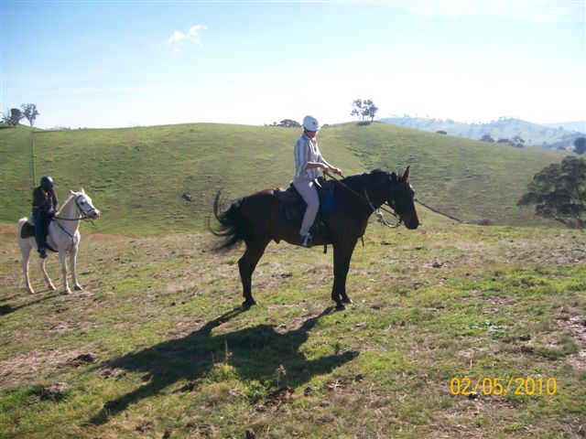

Sunday’s great feat to make it to the tower on “Glenelg” Holbrook

Future Rides
- May 15th postponed to July at Coventry’s for updating clubs history for website & listing clubs assets residing in their shed.

- May 22th Wallacetown Rest Area to Jail Break Cafe
North out of Wagga on the Olympic Way turn left at Baylis Lane (beside the rest area) & we can park vehicles over the creek & off the highway, those needing the rest rooms will need to go there first. It is about a 12 km ride. - BYO Lunch or we can buy at the Café. Contact is Karen (see list at end of newsletter)

- June 12th to 14th at “Bullenbong Hut” to arrive Saturday afternoon to set up camp & ride Sunday & Monday.
Directions from Collingullie, take Lockhart Road on left & follow until Bullenbong Road on the left.
Contact is Sandy (Map to be sent with reminder before the weekend)

- June 27th River Road Reserve, contact is Sue

Please Remember:
Rides are always 10 am ride & assume packed lunch is required out unless otherwise stated .
Always RSVP to ride contact by the Wednesday before the ride
Ride Co-ordinators to complete Attendance List & Pre/Post Ride Reports
MEMBERSHIPS
This may also be a timely reminder that memberships are due each year on the 1st of January, so if you have not paid your membership you will not appear on the members list on the last page. 2011 memberships actually start from the 1st October 2010, so if you have been dragging the chain this year you may wish to wait until then to renew.

Riders Information

Pre-Ride: Introductions and meeting 9.45am & to sign Attendance Register without horses

Ride Start: 10am ride NO LATE STARTERS

Lunch BYO lunch & water to carry on ride
Landowners
Conditions: Public or private areas courtesy to others & take rubbish with you

First aid: Basic first aid kit will be carried on the ride

Emergency Mobile phones, emergency contact list to be carried by Ride
Contact: Co-Ordinator

Horse feed: Please bring your own requirements

Equipment: Headstalls for tying, leading horses – check your own gear before attending any ATHRA ride

Dogs/Stallions: Not allowed

Helmets: All junior riders (under 18) require AS3838 safety helmets. Junior riders must be accompanied by a parent or nominated guardian.
Boots: All riders to wear smooth soled boots with heel.

Guest riders: Will be required to sign an ATHRA waiver form and pay a $10 ride fee up until the 30th June, 2010, then increasing to $25 per day.

Please be familiar with the ATHRA Code of Conduct before the ride. It can be found on www.athra.com.au You will be required to adhere to this code as these conditions are part of our Ride Risk Assessment Plan. Adherence to the Code of Conduct ensures potential risks are minimised and that insurance conditions are met.

1 | ARMOUR | LOUISE |  | 6227 7241 | Tony.armour@bigpond.com.au
  Bookham
2 | ARMOUR | GRACE | Bookham
3 | BAHR | DEBBIE | The Rock | 0427206256 | gdbahr2@bigpond.com
4 | CARTER | KAREN |  | 0427279049 | kcsfws@activ8.net.au
  Yass
5 | CARTER | MARGIE | Wagga Wagga | 0417692527 | benloch@bigpond.com.au
6 | COVENTRY | ALAN | Wagga Wagga | 0411263732 | viminaria@austarnet.com.au
7 | COVENTRY | JEANETTE | Wagga Wagga | 0409915006 | jeanette.coventry@tafensw.edu.au
8 | DAY | HELEN | Coolamon |  | (life member)
9 | DYCE | MAL | Matong | 6927 7933 | mdyce@dodo.com.au
10 | FLYN | MARIA | Ladymsith |  | nimblethimble@bigpond.com
11 | FOX | MICHELLE | Matong | 0408229824 | foxy.lady.62@hotmail.com
12 | HALLIDAY | DIANA | Lake Albert | 0413316173 | coleslea@skymesh.com.au
13 | HIMSLEY | CANDICE | Alleena |  | candice_himsley@hotmail.com
14 | JARICK | SANDRA | The Rock | 0418424611 | candsjarick@clearmail.com.au
15 | JOHNSON | ANNETTE | Wagga Wagga | 0488315924 | johno.go@bigpond.com
16 | MARTYKA | DIANA | Narrandera | 0458592763 | coleslea@skymesh.com.au
17 | MCKEOWN | JULIA | Lake Albert | 0410585429 | juliamckeown@hotmail.com
18 | PRICE | JORDON | Wagga Wagga
19 | PUMPA | JANICE | Pleasant Hills | 0428896421 | j.jumpa@bigpond.com
20 | REYNOLDS | BERT | Wagga Wagga |  | (life member)
21 | STRONG | SUE | Wagga Wagga | 0409202995 | studmaster@iprimus.com.au
22 | TROPEANO | VIRGINIA | Hanwood | 408630024 | vtrop@gmail.com
 | President
 | Secretary/Treasurer
 | Committee Members

Current 2010 Members List

