TOONGABBIE & DISTRICT RIDERS CLUB
JANUARY NEWSLETTER 2011
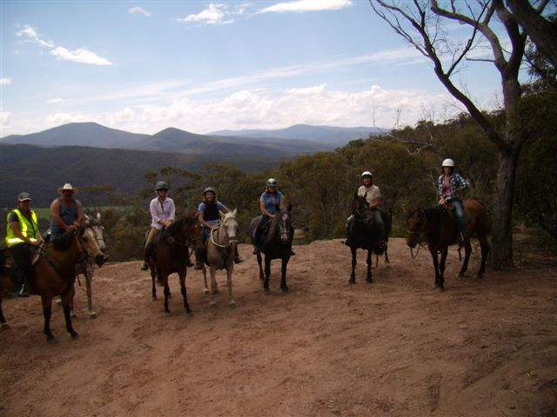
Huggets Lookout November ride
Office Bearers: President : Dave Smith ph 51 489 344
Secretary Rhonda Hunter ph 51918191 Vice President: Steve Coleman ph 51482117 Treasurer Heidi Page ph 51483308
Toongabbie and District Riders Club meetings
Third Tuesday of Month 7.30pm
All welcome Supper Neil
November Ride Report
Our November ride was spectacular and so far my favorite ride. It did not start off too well for me as I found myself going backwards down Kentucky road with a horse float as my car had lost traction. Both Heidi and Vicki were not answering their mobiles so I had to put it back in low gear and try the hill again, this time with more success!
I did not realize how steep it was up behind Newry, it certainly has some awesome gullies and spectacular views! Heidi led us confidently through all of it and our horses huffed and puffed up many hills with a trail of female voices following. (yes, the ride started off with only females).
As usual Heidi weaved us up and down goat trails that I could never find again and we always crashed through the more difficult options as Heidi seems to think that is more fun than the easy ones and I suppose she is right .It certainly makes the ride more memorable!
Our lunch stop was a beautiful river crossing, the prettiest lunch spot we have ever had. Thanks to Anne-Maree, Steve and Dave we had a very yummy BBQ lunch. However I know they hid the KitKats they had been munching on when we arrived. Thanks to Heidi for leading a very enjoyable and memorable ride. I was so impressed I returned in a 4 wheel drive the following weekend to show my partner the fabulous spot we had been riding at.
Ride report Dawn

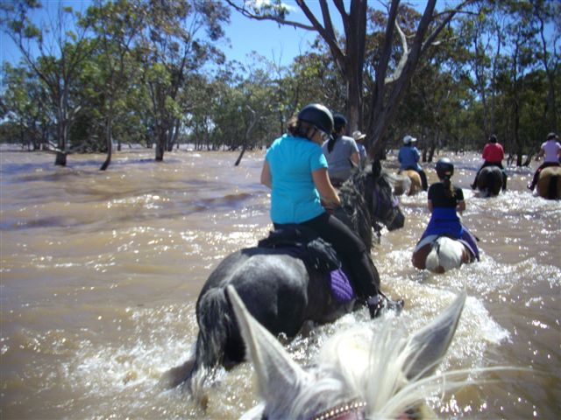Lisa on Gumpy before he decided to take her for a swim!

Glenmaggie Camp Report!
On the 12th of December Ann-Maree and Steve Coleman organized a Camp at the Glenmaggie Lake. There was about 15 riders 26 for dinner and 10 people that stayed at the Camp. The weather was very good. I went swimming in the lake with my brother Angus. Angus brought his John Deer to the camp spot. Every ride that we went on we had to go through the lake on the way there and on the way back. The Dinner at Wallaby Rise was very nice. At Wallaby Rise they had very good music and all the people that came to Wallaby Rise all had a very good Dance. Then after that we came home and sat around a very nice and warm camp fire. The next day some other people came just for the Sunday ride. The Sunday ride we did the same ride as Saturdays ride excepted we did it backwards. When we were going through the water Lisa’s horse Gumby thought that he might have a bath in the Lake with Lisa on him. So he went down into the Lake and had a roll, Lisa saturated! Then Mum’s horse Veah was trying to jump the waves and Mum nearly fell in the water!
After the Sunday ride I went into the Lake with my horse Bella Bareback. After that I had a swim and then Dave came in the Lake with his horse Clancy bareback as well. And then I got to ride Clancy bareback in the Lake. Then Dave told me to jump off Clancy’s back into the water so I tried to jump off but I fell straight in the water and under Clancy’s belly! After that Dave got on Clancy and told me to hold on to Clancy’s tail. So I held on to Clancy’s tail and then Dave started to trot through the water with me holding on to Clancy’s tail! And then we had lunch and went home.
By Ella Hunter!
Club Rides are the first Sunday of the Month
February Ride Martin Walker Reserve Yinnar South
Pre-ride talk 9.15 and 9.30 RIDE OUT.
ATHRA membership number or receipt of payment must be shown.
ATHRA FEES $50 Club membership single adult $15 and family $30
Directions Travel along the Monash Way between Churchill and Boolarra. About 5 mins out of Churchill turn left to Yinnar South. Follow signs to Yinnar South. Along Gilberts road just near Upper Middle creek road is Martin walker Reserve it has toilets and water. Riders club direction signs will be out.
Chuckwagon Phil Henderson. Lead riders: Jason/Pam
This ride is a lovely 17kms ride, it climbs up and down some beautiful bush tracks plus river crossings. It is stony in parts so make sure your horse is well shod. It is a great ride to start our year back in the saddle. Any questions you can ring or email Pam Briffa.
WORKING BEE Saturday 12th Feb (9am start) General clean up bring gloves/rake/wheelbarrow
Also bring a plate to share for morning tea.
FUTURE RIDE CALENDAR
February club ride Yinnar South lead riders Jason and Pam
ATHRA 14th/15th Feb four regions camp and get together
50 Manby road Narbethong see ATHRA website for details
March Reeves Beach volunteers for Chuckwagon
Willow Grove leukemia ride12/13/14th March Long weekend in March Port Albert to Rosedale ride.
April Tyers beginning W4 track volunteer needed for chuckwagon
Please Note if these days become TOTAL FIRE BAN the ride will be cancelled.
Advertisement
Epic Equine Photography
greysphotography@hotmail.com
Facebook Fan page "Epic Equine Photography"
0438451978
Services offered are Competition Photos at Show's, Campdrafting, Show jumping, Pony Club, HRCAV, Club days and more, Private shoots for individuals or Stud Farms, Other animals or Families are also available.
Good news, Epic Equine Photography will be attending our Reeves beach ride. So you can order a lovely photo of you and your horse on the beach. Price list attached.

FOR SALE
$10 Imprint training of the newborn foal by Robert M. Miller, D.V.M
See Dawn Gillies
GENERAL CLUB INFORMATION
- Only one ride can be attended before insurance and membership must be paid
- Ride out starting time is 9.30 am. Lunch may be at starting point or at another point to be advised.
- Ride fee is $6 adult member and free child member under 16. All Non Toongabbies member $10 Chuck wagon is attended by volunteers and a fuel rebate of $50 is paid by the club as well as ride fee waivered.
- Lead riders get their ride fee wavered or $10 subsidised for
a bought lunch (eg pub lunch)
- It would be great if each member could/would take a turn in towing the chuck wagon, which would be once every 2-3 years!
. All Cakes, Slices etc are all gratefully received on
rides to share, which is in addition to payment of ride fee.
- All riders are asked to be respectful of other riders on the trail ride and give everyone space. NO FAST RIDING PAST OTHER RIDERS.
- Newsletters are written by Dawn Gillies if you would like yours emailed instead of posted contact Dawn on gillies.dawn.d@edumail.vic.gov.au or ph 51924231
- All newsletters are posted on ATHRA Website go to ATHRA then Victorian Clubs then scroll down to Toongabbie.

