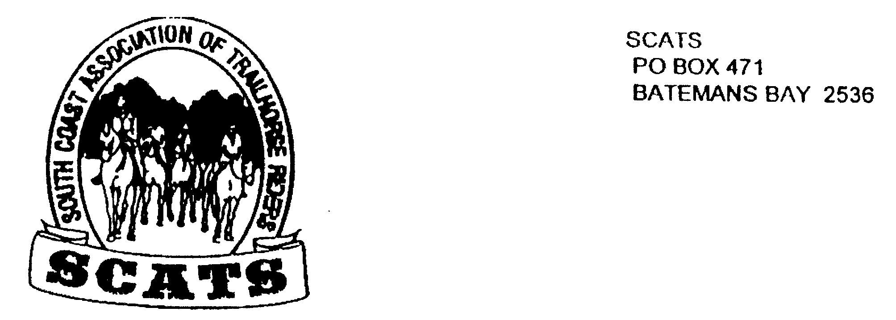
SCATS
PO Box 316
MORUYA NSW 2537
SCATS CHATS

Newsletter of the South Coast Association of Trail Horse Riders Inc.

January 2011

PRESIDENT: Kate Abel 0412 115 068
VICE PRESIDENT: Yvonne Willis 4472 3219
SECRETARY: Bronwyn Ludlow 4474 4291/0428 130 744
TREASURER: Terry Love 4472 3219
RIDE SECRETARY: Lesley Whale 4474 0232
TRAIL BOSS: John Davidge 0410 204 123

Welcome to 2011 and now that the Christmas and New Year holiday period is behind us we hope to be back in full swing with plenty of rides and loads of enthusiasm.

Annual General Meeting

The next meeting 16th February 2011 is the Annual General Meeting and will commence at 7.30pm at Tomakin Sports and Social Club. The General Meeting will be held immediately afterward.

All positions will be declared open. Please give consideration to taking on one of the executive positions above. The executive work together to ensure the ongoing operation of the club, and this is both interesting and rewarding.

All members are encouraged to support SCATS and attend the AGM. Make it a night out and have dinner with us at the Restaurant beforehand.

Memberships - 2011

Memberships are due – a Membership Form and Waiver attached. Remember to complete both and return to the Pox Office Box above with your Membership Fee or, better still, come along to a meeting and hand them over in person.

The Membership Fee for adults is $60.00 and for juniors is $50.00.

Please support SCATS and ATHRA and rejoin.

Ride Reports

While not exactly at Ride Report, our Christmas Party was held 4th December 2010. Unfortunately, due to wet weather the planned ride and camp was cancelled. Instead 20 members and guests enjoyed a lovely meal at the Balcony On Shore Restaurant above the Adelaide Hotel in Moruya. The food was great and we were able to enjoy the views from the balcony before and after dinner, along with a sociable drink. The cost of the meal was subsidized by the Club.

Future Events

February Ride 27th February 2011 Mystery Ride

We are claiming the date but no venue has been decided at this stage. It will be a day ride, BYO everything. The ride will start at 9.30am (meeting at 9.00 am).

The ride fee will be $5.00 for members. Non- member/guests are welcome and a $25.00 ride fee will apply.

A decision for the location of the ride will be made at the next meeting.

Bendethera

There has been discussion about including a ride to Bendethera in the ride calendar this year, probably in early May. There will be further discussion next meeting.

Other Rides

Please have a think about the rides you would like to do this year and bring your ideas to the next meeting. All ideas are welcome.

