TOONGABBIE & DISTRICT RIDERS CLUB
February NEWSLETTER 2011
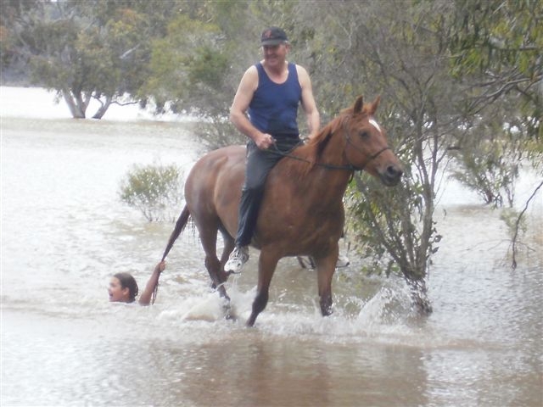
Ella Hunter being towed by Clancy and Dave at the Glenmaggie camp
Office Bearers: President : Dave Smith ph 51 489 344
Secretary Rhonda Hunter ph 51918191 Vice President: Steve Coleman ph 51482117 Treasurer Heidi Page ph 51483308
Toongabbie and District Riders Club meetings
Third Tuesday of Month 7.30pm
All welcome Supper Lauren

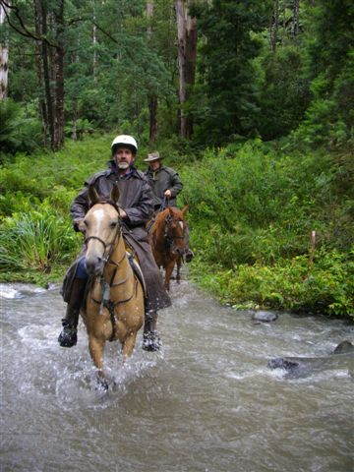

February Ride Martin Walker Reserve Yinnar South
Ride Report
Yinnar South Ride Ride report Dave

After a cuppa & riders brief 15 riders, which included 2 new members & 3 visitors from Traralgon, we were about to set out from Martin Walker Park and the heavens opened up to let us know that it wasn’t only Queensland that gets rain in the summer. But with a bit of drying off and saddled up everyone was set and Pam, or was it Jason that was leading the ride? Who cares it was a ride and that is the important part and I think between them they knew where we were going.
After a short time we were headed up a side track into the bush and it would have been a lot better if the rain had not persisted. One minute it looked like we could take our coats off and the next it was coming down again. But who cared? No one. Because we were out with a great group, riding our horses in the bush.
After a fairly steady climb with a few switch backs we descended down to the Middle Creek at what I was told the roundabout for one of Dawns many photo opportunities and a group shot. A short while later Ray Cox pointed out an old hut to me down in the bush which looked fairly deliverance like. He then proceeded to tell me about meeting some blokes up here in an old Laser one day looking for the way to Morwell and he was surprised how they had got through the creek up further. When we had crossed the creek later I had to tell him that I had towed the chuck wagon through there a couple of years ago with the Commodore Ute. (The things we do for the club and its starving members)
We were all on the home stretch heading back for the lunch spot where Phil was preparing a feast for us on the barbie. Rhonda & I would have been there a lot quicker if a certain person who rides a small coloured pony didn’t have to stop at every plum tree on the way back to fill her pockets, try to empty them before the next tree just to fill them up again. (Rhonda & I just tested them to make sure that Ella didn’t get bad ones to make her crook.)
All in all it was a great ride, even though it rained a bit. Thanks Pam for taking the time to map it out and go up the night before to make sure it was not all flooded out. Thanks Phil for the catering job.
PS Fiona & Dallas. The rides start at 9:30 not 1:30. Teach you to play up the night before!. 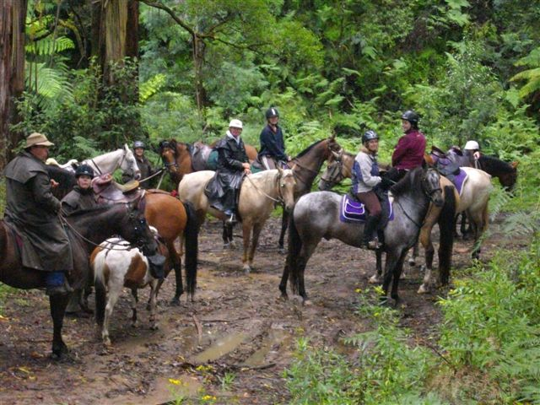
Club Rides are the First Sunday of the Month
NEXT RIDE MARCH REEVES BEACH RIDE Location REEVES BEACH
Directions drive to Woodside and head towards Woodside Beach. On the way you will see a sign pointing Right that says Mcloughlins Beach turn onto that and along that road will be another road turning left with a sign saying Reeves Beach. Reeves Beach has the one road in and the same road out.
Chuckwagon will be a group effort.
Pre-ride talk 9.15 and 9.30 RIDE OUT.
ATHRA membership number or receipt of payment must be shown. ATHRA FEES $50 Club membership single adult $15 and family $30
FUTURE RIDE CALENDAR
March Reeves Beach ride lead rider Heidi
Willow Grove leukemia ride12/13/14th March Long weekend in March Port Albert to Rosedale ride.
April Tyers Lead Rhonda/Neil beginning Wirilda Park Tyers. Chuckwagon Pam/Jenny
May Combined club ride hosted by Yarram
Please Note if these days become TOTAL FIRE BAN the ride will be cancelled.
THANK YOU to everyone who attended our working Bee
We had a great attendance from Pony club and Riders club members. Our grounds now look well kept and the snakes have all been chased away. It was a great example of many hands make light work.
Another working Bee is scheduled for 26th March
Due to aShire grant we have had the material for a new front fence supplied. On this day we hope to build it. Could members please bring gloves, fencing tools such as crow bars, shovels etc . Plus the very important plate to share for morning tea
Start 9am.
Advertisement
Epic Equine Photography
greysphotography@hotmail.com
Facebook Fan page "Epic Equine Photography"
0438451978
Services offered are Competition Photos at Show's, Campdrafting, Show jumping, Pony Club, HRCAV, Club days and more, Private shoots for individuals or Stud Farms, Other animals or Families are also available.
Good news, Epic Equine Photography will be attending our Reeves beach ride. So you can order a lovely photo of you and your horse on the beach!

FOR SALE
$10 Imprint training of the newborn foal by Robert M. Miller, D.V.M
See Dawn Gillies
I have 17 inch status black stock saddle brand new fully mounted for sale ex cond no use anymore , for $300 and a 15 inch western saddle brown fully carved good cond for $200 fully mounted and my phone number are 0400248388 or 51743375 Jo Watts

GENERAL CLUB INFORMATION
- Only one ride can be attended before insurance and membership must be paid
- Ride out starting time is 9.30 am. Lunch may be at starting point or at another point to be advised.
- Ride fee is $6 adult member and free child member under 16. All Non Toongabbies member $10 Chuck wagon is attended by volunteers and a fuel rebate of $50 is paid by the club as well as ride fee waivered.
- Lead riders get their ride fee wavered or $10 subsidised for
a bought lunch (eg pub lunch)
- It would be great if each member could/would take a turn in towing the chuck wagon, which would be once every 2-3 years!
. All Cakes, Slices etc are all gratefully received on
rides to share, which is in addition to payment of ride fee.
- All riders are asked to be respectful of other riders on the trail ride and give everyone space. NO FAST RIDING PAST OTHER RIDERS.
- Newsletters are written by Dawn Gillies if you would like yours emailed instead of posted contact Dawn on gillies.dawn.d@edumail.vic.gov.au or ph 51924231
- All newsletters are posted on ATHRA Website go to ATHRA then Victorian Clubs then scroll down to Toongabbie.

