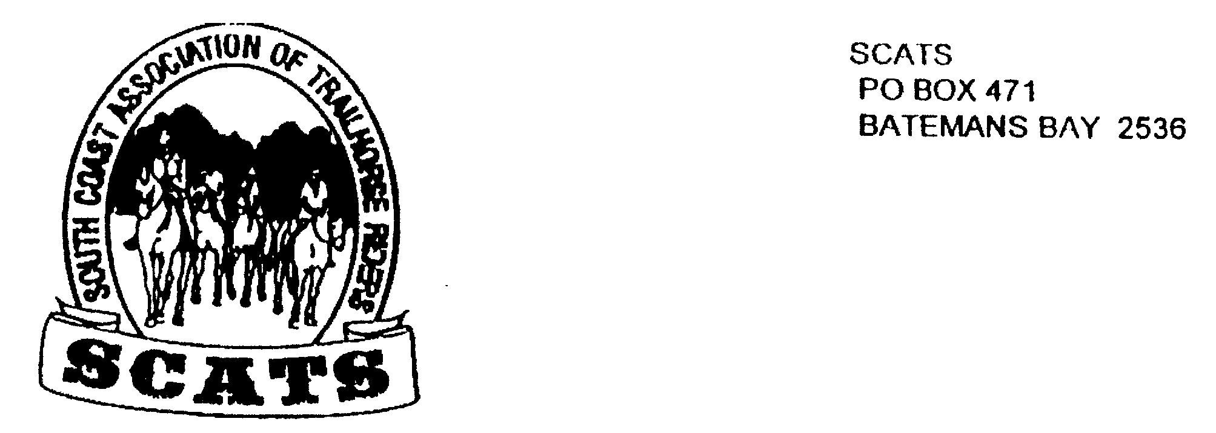
SCATS
PO Box 316
MORUYA NSW 2537
SCATS CHATS

Newsletter of the South Coast Association of Trail Horse Riders Inc.

March 2011

PRESIDENT: Kate Abel 0412 115 068
VICE PRESIDENT: Yvonne Willis 4472 3219
SECRETARY: Bronwyn Ludlow 4474 4291/0428 130 744
TREASURER: Terry Love 4472 3219
RIDE SECRETARY: Karen Scott 0428643133
TRAIL BOSS: John Davidge 0410 204 123

Hi everyone! Here we are in Autumn and looking forward to some cooler weather with bright and sunny rides! There are quite a few things happening and some in the planning. And we’re very glad to have Leslie and Erin safely back from their fabulous overseas trip and to hear their great stories!

Cobargo Horse Sales
This will be held on Saturday 14th May so if you’ve got anything to sell start polishing now!

National Breast Cancer Foundation Pink Ride
Here is a ride that may interest some of our members. And it’s for a good cause!

For the first time, the Australian Stockman’s Hall of Fame, in conjunction with the National Breast Cancer Foundation [NBCF], will host the “Pink”Ride in the Southern Highlands, on Saturday 2 April 2011 in Bowral, to help raise money for breast cancer.
Just a one day event, which involves a slow paced trail ride of about 20km, followed by a dinner and auction, with proceeds donated to the NBCF.
The ride will cross some spectacular scenery. The trail ride will start at the Bong Bong Race Track in Bowral. Registrations will close 24 March-forms can be found at the Stockman’s Hall of Fame website - www.stockmanshalloffame.com.au . The ride will depart at 9am and finish at approximately 3.30pm. A dinner and auction with proceeds being donated to the National Breast Cancer Foundation will follow the day’s proceedings. Awards will be given for best dressed horse and rider [JNR and SNR].
Event information:
Sonya Cullen
Events Manager
0407 882 114
e.events@stockmanshalloffame.com.au

Man from Snowy River Festival
Just a reminder that this will be held on 1st to 3rd April at Corryong. It is not a club ride but start organising if you want to go, by booking in early for a campsite. Information can be found at The Man From Snowy River office:02 60761992 or online.

Newsletters
Associate members who would like to continue receiving newsletters please send in the customary $10 fee. You can send in a cheque by mail, or come on a ride and give it to the organiser there! Or pay on line: BSB: 032 and Account number: 20 4143

Beach Ride
Neville’s popular beach ride on Sunday 20th March was unfortunately cancelled due to inclement weather. Hopefully, Neville will take us out at a later date for a fair weather ride!

Up and Coming Rides

Runnyford
Next day ride will be held on Sunday 10th April at Runnyford and led by John. Starting time is 9am for a 9.30am start. The ride fee is $5 and bring your own lunch and drink. Directions will be given when you phone to book in.

Camp
Slot in the 29th to 2nd May for a four day ride as is customary at this time of year. We are all looking forward to a camp over and it’s bound to be good! Due to consistent rain in the catchment it is necessary to make safe decisions as to which ride. At present Bendethera on the Deua may be too wet for safety. However, there will be a ride and it will be one of the following and will be further discussed at the next meeting:
Belowra- with a base camp
Corn trail- Monga/Araluen; moving camp
Bendethera; moving camp
It is possible for riders to come and go freely at any time during the ride if you can arrange your own back-up transport. For those who have four days to spare, drop-off and pick-up will be arranged, thanks to John.
Make sure you come to the next meeting for arrangements!

Bimbermala
Our ride last year to the beautiful property of Bimbermala was most enjoyable, particularly the old gold mines and the afternoon swims in the beautiful creek and the great company! So keep Friday/Saturday on the weekend of the 20th May free! We may return there for a day ride or a one night camp. Stay tuned!

CALENDAR

April 1-3 Corryong

April 2 Pink Ride

April 10 Runnyford

May 14 Cobargo

April 29-2 May Camp

May 20 Bimbermala

Ride Report

Bimbimbie Ride 2011
With everyone looking forward to a ride after a very wet summer, members were looking forward to a fine but not too hot day. However, with rain through the night, the morning of the 26th February came with dismal gray skies and a pessimistic outlook. There were numerous phone calls but at it was decided to go ahead with the ride, but to start half an hour later.

But though the day began with rain, it was short lived, and 11 riders met for a lovely ride to Bimbimbie mine. We were joined by regulars, Lesley and Erin, back from their overseas trip, .and it was good to have them back riding with us. Kerryn, was also back, after taking a break from riding due to the birth of her very cute son Max. We were also joined by Jayne, from Leisure Coast Club.

We rode along the bush road, along fire tails and cleared easements in roughly a Northerly direction????( I have no sense of direction!!) and ended up on a lovely track that led to Bimbimbie mine. The ride was pretty gentle compared to some and the horses (and unfit riders) probably appreciated it.

We stopped for lunch at the Bimbimbie Mine, the area around the mine having been cleared to allow clear visibility of mine entrances. No one was brave enough to go too far in to the mines, it was very dark and damp!!!!

After lunch, led by John, we crossed the creek and bush-bashed up the steep rocky hill on the other side until we reached the fire trials leading back to Pollwambra Rd.

Just as we returned a few drops of rain began to fall so everyone loaded their horses and headed home after an enjoyable day.

Meeting
Our next meeting is 20th April at the Tuross Club: 6pm for dinner and meeting starts at 7.30pm. All welcome!

I

