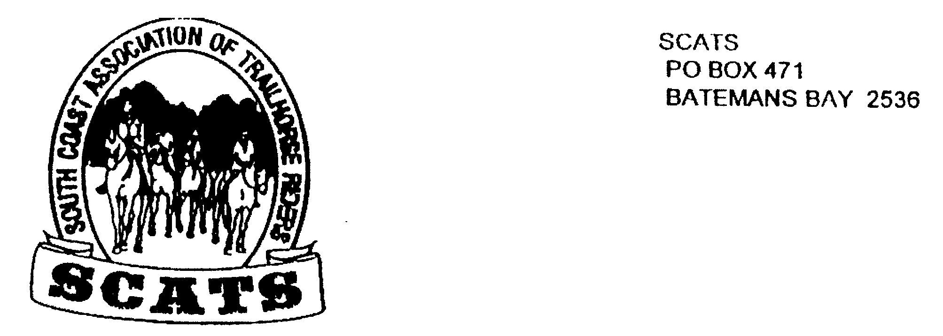
SCATS
PO Box 316
MORUYA NSW 2537
SCATS CHATS

Newsletter of the South Coast Association of Trail Horse Riders Inc.

April 2011

PRESIDENT: Kate Abel 0412 115 068
VICE PRESIDENT: Yvonne Willis 4472 3219
SECRETARY: Bronwyn Ludlow 4474 4291/0428 130 744
TREASURER: Terry Love 4472 3219
RIDE SECRETARY: Karen Scott 0428643133
TRAIL BOSS: John Davidge 0410 204 123

Welcome to another month of fun rides with SCATS!
The Runnyford ride was a great day out- we’ll hear all about that in our next Newsletter.
Members who went to Corryong enjoyed themselves immensely saying the “reenactment” was the best yet, catering was marvellous and lots more…!

Brimbamala Four Day Ride
This is the reason for the rushed newsletter!
From Friday 29th April, Saturday 30th, Sunday 1st May and Monday 2nd May we will set up camp on the beautiful property of Brimbamala out past Shallow crossing.
This will be a base camp for the four days. People are welcome to arrive when they can and to leave when it suits.
This is a BYO EVERYTHING camp! Please bring all your catering needs. However the chuck wagon will be available for all to use and of course a lovely roasting fire!
Having said that we will have a shared catered meal on Saturday night and so we need to know numbers. Please phone Karen Scott to book in on 0428643133 as above or on 44743133 by WEDNESDAY 27 April!
There will be a short ride on Friday afternoon for those who can arrive during the day.
The cost of the ride is $15, this being a $5 ride fee and $10 for Saturday night dinner.
If you have not renewed your membership yet please do so now! The membership and waiver forms are attached.
We’re looking forward to some interesting rides and fun times. Don’t forget your gum boots!

Directions to Brimbamala

- 17 km from Batemans Bay bridge [going north] just before East Lynne store turn LEFT onto Old Princes Hwy

- After 5km branch LEFT onto Barkshead Rd

- 5km LEFT onto River RD

- Cross Shallow Crossing

- Go past the first rd [Backhouse} turn right into 2nd rd Dury
- RIGHT into Clyde Ridge
- 1 km LEFT onto Folders Rd
- Pink tape will be at Folders RD
- Through gate and downhill to camp site
- Please note approximate klms

May Ride
Neville Davie is going to try again! So we’re hoping for good weather!
This is a Congo Beach ride from Neville Davie’s property.
From South Heads Rd turn right onto Congo Rd and follow it about 4km until the road descends to the Congo Creek which you will cross at the causeway. Large cleared paddock on the right, turn in at the stockyards, left gate.
This is a picturesqe ride so don’t miss it! BYO. There is a $5 ride fee. Arrive at 9.30 for a ten o’clock start.
June Ride
In the planning is an overnight camp and rides in Belowra. Keep Friday 17th June and Saturday 18th free! You are welcome to camp Friday night or turn up on Saturday. More directions and information will be in the next newsletter.
Don’t forget to book in with Karen for every ride!
Happy Birthday !!!!!!
24th March Roydon 16 February Jan 1st April Glynnis
Next meeting Tomakin Club 18th May

