TOONGABBIE & DISTRICT RIDERS CLUB
April NEWSLETTER 2011 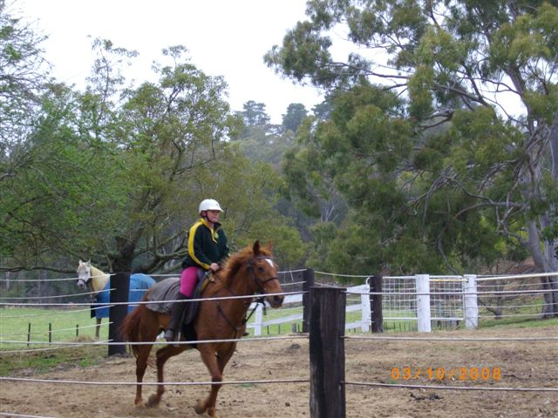
Pictured Neisha riding Clancy

Office Bearers: President : Dave Smith ph 51 489 344
Secretary Rhonda Hunter ph 51918191 Vice President: Steve Coleman ph 51482117 Treasurer Heidi Page ph 51483308
Toongabbie and District Riders Club meetings
Third Tuesday of Month 7.30pm
All welcome Supper Heidi
April Ride Report by Niesha HUNTER

On the 3rd of April, 2011, the Toongabbie and District Riders Club had a ride out at Tyers. My dad, Jason Hunter lead the ride which started from the W4 track just off the Walhalla-Tyers Road. In total, 12 riders turned up for the ride including some new people. Just after we had a cuppa and chat around the fire, we were off like a flash to start the ride. On the morning ride it was a bit rocky in some places, slippery in other places and there were some good hills which pulled the horses up a bit. Some people decided to take the shorter and flatter route home but most continued on the planned route and ended up being back at camp earlier than the others anyway and nearly bumping into a deer which was trying to hide in the bush on the edge of the track. It gave my dad’s horse and a few others nearby a fright when it decided to take off at the last second.

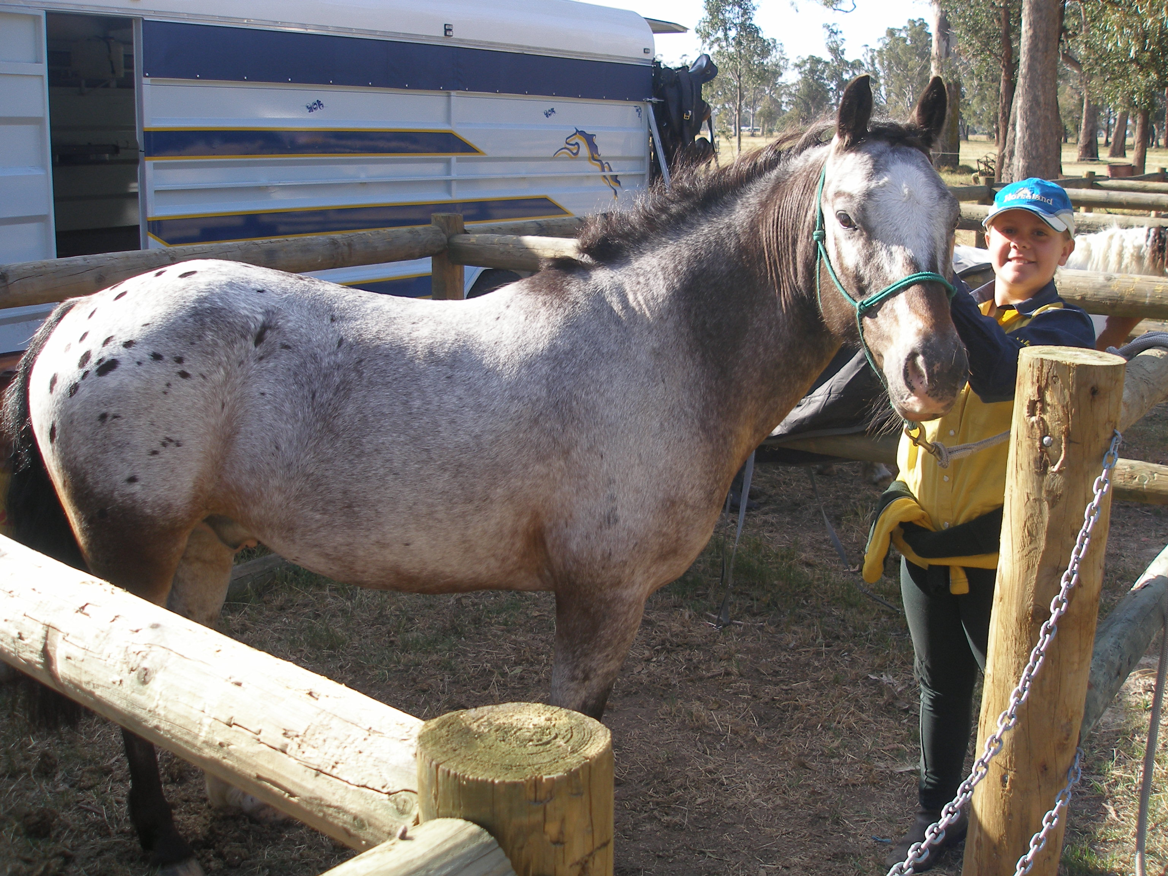
Pam Briffa and Jenny Clarke cooked a wonderful lunch and they were assisted by Polly Riddell and Pam’s daughter in-law, Cara. We were overloaded with sweets that many of our riders had brought along to share which was fantastic, thank-you to everyone that brought something.

After we all had lunch, seven of us mounted up again for a lovely easy ride to the Tyers River Gorge look-out. It was a very peaceful and easy ride and the view was spectacular and worth the final bit on foot to get to the actual lookout.
Jenny, Pam and Cara kept the fire and the billy going for our return so we could relax with a hot drink and more sweets.. After that I’m sure that we were all puffed out, especially the horses. After a quick wash and drink for the horses we loaded up and were off home.
This is a picture of my horse Mickey, and I at Novelty

Thanks to everyone who came on the ride and hope that you all enjoyed riding with us in our local area. I hope that the new riders join us again as Toongabbie is a great club. A big thanks to our chuck wagon crew, Pam and Jenny and thanks to my dad, Jason who lead the ride. I hope to see you all again next time. Bye, from Niesha.

Club Rides are the First Sunday of the Month
Next ride starts from Toongabbie Grounds .
Pre-ride talk 9.15 and 9.30 RIDE OUT.
This ride will be go into the hills behind Toongabbie. The hills are steep and rocky. Please email me or ring if you have any queries. Lunch will be back at the grounds using the chuckwagon. After lunch we will offer a short local flat ride.
.

FUTURE RIDE CALENDAR
May Vicki/Dawn starting from Toongabbie Club Grounds
Heywood st

June: Combined club ride hosted by Yarram : 1st Regional Combined Brumby Trail Ride. Yarram Horse Trail Riding Club Location Hedley, VIC Event Date 3/06/2011 - 5/06/2011 Description
Registrations from 4.00pm Friday night and 8.00am Saturday morning Horseless muster at9.00am Saturday . 5-6hour ride through the Alberton State Forest with a spit Roast meal and sweets prepared by the local Lions club. Bacon and egg breakfast both Saturday and Sunday prepared by the Lyons club. Light entertainment and raffles and door prizes Saturday night. Come along for a great Family weekend. Registration sheet attached, register by the 20th of May.

Contact Details
Name: Kerri McFarlane
Phone: (03) 5662 4267
Email: mcfarlane_kerri@yahoo.com

A Big THANK YOU to all those who attended the working Bee on Saturday April 16th! There was a lot of club members as well as Pony Club members and this has made the grounds look FANTASTIC.
We can all admire the grounds when we start our ride there next club ride. We have a fabulous new front fence and just for the record, the tree fell down and NOBODY helped it!

Toongabbie and District Riders club Polar fleecy windcheater
Expressions of Interest to Rhonda if you want to buy a Toongabbie and District Riders club Polar fleecy windcheater. It is green and gold and has a cloth badge sewn on it. We need at least ten orders before we can put an order in.
GOOD FRIDAY APPEAL
Damian Byrne is riding a horse with pack horse in tow from Merrijig in Victoria to Cooktown in Far North Queensland to raise money and awareness for The Royal Childrens Hospital.
The ride will take Damian between 18 months and 2 years to complete. The trail is 5330Klm's through the Great Dividing Range. The Biography section of this site will inform you a bit more as to the outlines of this charity ride through some of Australia's history and locations.
On the Blog pages you will be able to get updates of Damian's progress and the trials and tribulations involved on the Bicentenial National Trail.
The Trail section of this site contains maps and photo's of the Bicentenial National Trail. I met Damian at Lovics hut in January he is a genuine fellow and his photos and blogs are very interesting.
You will find a donations page on this site and I hope you can find it in your hearts (and wallets) to donate to the funding of the Childrens cancer centre at the Royal Childrens Hospital. This centre needs constant funding to keep doing the great work it does with very sick children.
http://www.childrenscancerride.com.au/home_frame.htm

Club member will be sadly missed.
It is with deep regret that I announce the death of our lifelong club member, “Ian Price”. The club sends their deepest sympathy to his family. He was 84 and still rode his horse and shoed it! He will be sadly missed.

GENERAL CLUB INFORMATION
- Only one ride can be attended before insurance and membership must be paid
- Ride out starting time is 9.30 am. Lunch may be at starting point or at another point to be advised.
- Ride fee is $6 adult member and free child member under 16. All Non Toongabbies member $10 Chuck wagon is attended by volunteers and a fuel rebate of $50 is paid by the club as well as ride fee waivered.
- Lead riders get their ride fee wavered or $10 subsidised for
a bought lunch (eg pub lunch)
- It would be great if each member could/would take a turn in towing the chuck wagon, which would be once every 2-3 years!
. All Cakes, Slices etc are all gratefully received on
rides to share, which is in addition to payment of ride fee.
- All riders are asked to be respectful of other riders on the trail ride and give everyone space. NO FAST RIDING PAST OTHER RIDERS.
- Newsletters are written by Dawn Gillies if you would like yours emailed instead of posted contact Dawn on gillies.dawn.d@edumail.vic.gov.au or ph 51924231
- All newsletters are posted on ATHRA Website go to ATHRA then Victorian Clubs then scroll down to Toongabbie.

