TOONGABBIE & DISTRICT RIDERS CLUB
June NEWSLETTER 2011

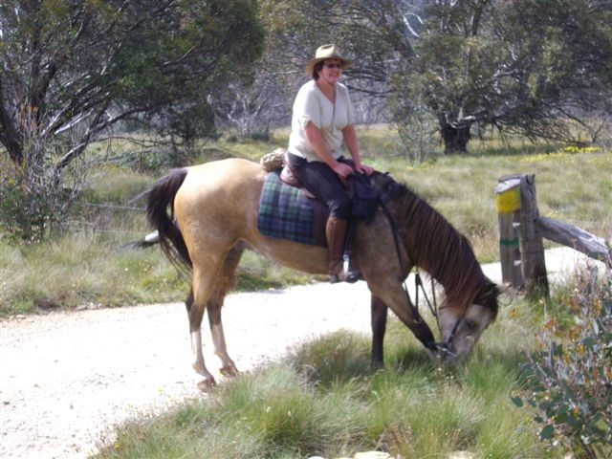Pam in the high country

Office Bearers:
President : Dave Smith ph 51489344
Secretary: Rhonda Hunter ph 51918191
Vice President: Steve Coleman ph 51482117
Treasurer: Heidi Page ph 51483308
Toongabbie and District Riders Club meetings
Third Tuesday of Month 7.30pm
All welcome Supper - Vicki

Club Rides are the First Sunday of the Month
Pre-ride talk 9.15 and 9.30 RIDE OUT.
FUTURE RIDE CALENDAR
July: Gormandale area with Carly Lansdown, maps attached, quick run down, on the Traralgon side of Gormandale turn down Onley's Road and then follow the signs :-)
July Saturday 9th is also a working bee at the Toongabbie grounds, please come along to help, many hands make light work
July Saturday 30th We have decided to have a Xmas in July tea at the Moe RSL, it would be great to see all members come for a great night out, we need to confirm numbers by 16th July to Heidi -51483308
August: Heyfield area with Heidi as lead rider and lunch will be at a shop I've yet to organise, but yum yum
September: Greens Gully area with Steve Coleman – need volunteer for chuck wagon please
October: Glengarry area – Vicki to organise, we were having a camp but it has now been moved to next year in March/April for better weather conditions
November: 6th Novelty Day
November:20th ?? Hand up if you would like to lead ?? Come on everyone it seams to be the same people all the time, we would love to ride in your area so please put your hand up and show us around :-)
December: Xmas break up ride from Toongabbie Grounds
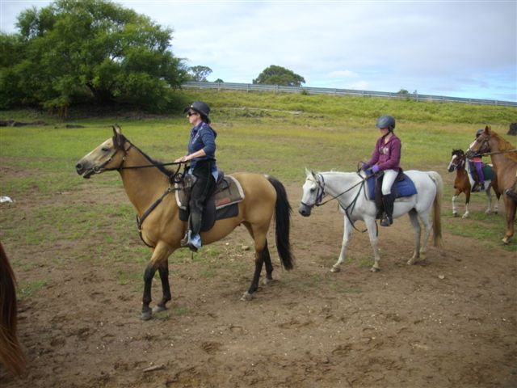

GENERAL CLUB INFORMATION
- Only one ride can be attended before insurance and membership must be paid
- Ride out starting time is 9.30 am. Lunch may be at starting point or at another point to be advised.
- Ride fee is $6 adult member and free child member under 16. All Non Toongabbie members $10 Chuck wagon is attended by volunteers and a fuel rebate of $50 is paid by the club as well as ride fee wavered.
- Lead riders get their ride fee wavered or $10 subsidized for
a bought lunch (eg pub lunch)
- It would be great if each member could/would take a turn in towing the chuck wagon, which would be once every 2-3 years!
. All Cakes, Slices etc are all gratefully received on
rides to share, which is in addition to payment of ride fee.
- All riders are asked to be respectful of other riders on the trail ride and give everyone space. NO FAST RIDING PAST OTHER RIDERS.
- Newsletters are written by Dawn Gillies if you would like yours emailed instead of posted contact Dawn on gillies.dawn.d@edumail.vic.gov.au or ph 51924231
- All newsletters are posted on ATHRA Website go to ATHRA then Victorian Clubs then scroll down to Toongabbie.

