TOONGABBIE & DISTRICT RIDERS CLUB
May NEWSLETTER 2011

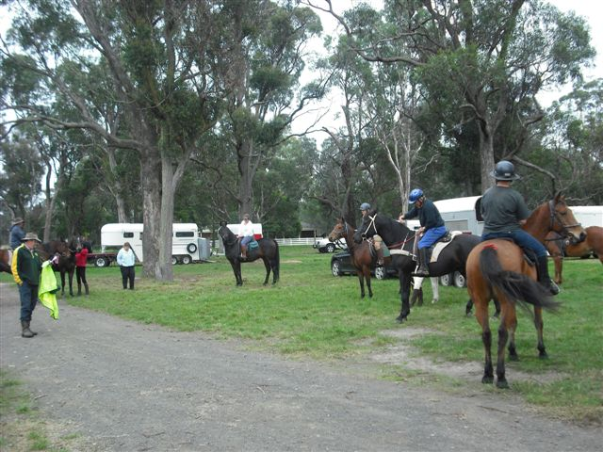
Dave reading ride out

Office Bearers: President : Dave Smith ph 51489344
Secretary: Rhonda Hunter ph 51918191
Vice President: Steve Coleman ph 51482117
Treasurer: Heidi Page ph 51483308
Toongabbie and District Riders Club meetings
Third Tuesday of Month 7.30pm
All welcome Supper - Steve & Anne-Maree
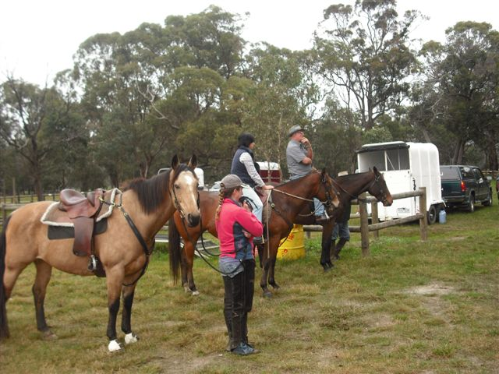
May Ride Report by Fiona,
A nice fresh morning in Toongabbie saw 13 Riders take a minutes silence to remember good times had with Ian price. (He will be missed) Then we headed for the hills, most of the horses were fresh, Dawn lead us up Humphreys Road and up to a steep descent before climbing the other side, that hill took the steam out of the horses, they were in a lather of sweat. After a couple hours of riding we arrived back at club grounds for a lovely lunch. Heather had taken some photos and footage of riders and made a great slideshow.

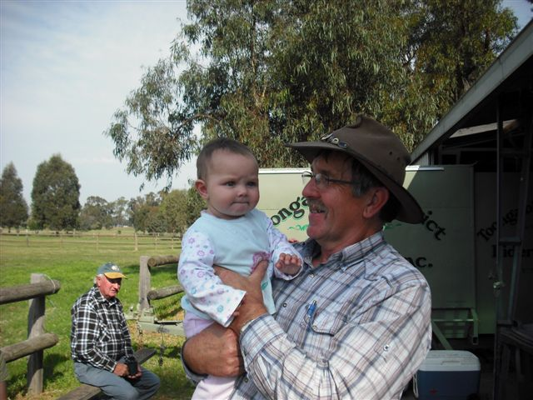

Club Rides are the First Sunday of the Month
Pre-ride talk 9.15 and 9.30 RIDE OUT.
FUTURE RIDE CALENDAR

June: Combined club ride hosted by Yarram : 1st Regional Combined Brumby Trail Ride. Yarram Horse Trail Riding Club Location Hedley, VIC Event Date 3/06/2011 - 5/06/2011 Description
Registrations from 4.00pm Friday night and 8.00am Saturday morning Horseless muster at9.00am Saturday . 5-6hour ride through the Alberton State Forest with a spit Roast meal and sweets prepared by the local Lions club. Bacon and egg breakfast both Saturday and Sunday prepared by the Lyons club. Light entertainment and raffles and door prizes Saturday night. Come along for a great Family weekend. Registration sheet attached, register by the 20th of May.

Contact Details
Name: Kerri McFarlane
Phone: (03) 5662 4267
Email: mcfarlane_kerri@yahoo.com
July: Gormandale area with Carly Lansdown
July Saturday 9th is also a working bee at the Toongabbie grounds, please come along to help, many hands make light work
August: Greens Gully area ? with Steve Coleman
September: Boolarra with Fiona Henderson
October: Camp at Won Wron ? Heidi is organising
November: 6th Novelty Day & 20th ?? Hand up if you would like to lead ??
December: Xmas break up ride from Toongabbie Grounds

GENERAL CLUB INFORMATION
- Only one ride can be attended before insurance and membership must be paid
- Ride out starting time is 9.30 am. Lunch may be at starting point or at another point to be advised.
- Ride fee is $6 adult member and free child member under 16. All Non Toongabbie members $10 Chuck wagon is attended by volunteers and a fuel rebate of $50 is paid by the club as well as ride fee waivered.
- Lead riders get their ride fee wavered or $10 subsidised for
a bought lunch (eg pub lunch)
- It would be great if each member could/would take a turn in towing the chuck wagon, which would be once every 2-3 years!
. All Cakes, Slices etc are all gratefully received on
rides to share, which is in addition to payment of ride fee.
- All riders are asked to be respectful of other riders on the trail ride and give everyone space. NO FAST RIDING PAST OTHER RIDERS.
- Newsletters are written by Dawn Gillies if you would like yours emailed instead of posted contact Dawn on gillies.dawn.d@edumail.vic.gov.au or ph 51924231
- All newsletters are posted on ATHRA Website go to ATHRA then Victorian Clubs then scroll down to Toongabbie.

