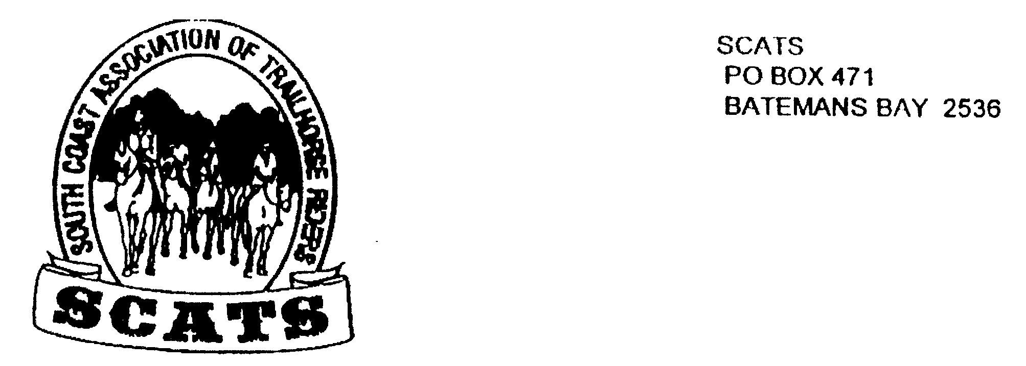
SCATS
PO Box 316
MORUYA NSW 2537
SCATS CHATS

Newsletter of the South Coast Association of Trail Horse Riders Inc.

June 2011

PRESIDENT: Kate Abel 0412 115 068
VICE PRESIDENT: Yvonne Willis 4472 3219
SECRETARY: Bronwyn Ludlow 4474 4291/0428 130 744
TREASURER: Terry Love 4472 3219
RIDE SECRETARY: Karen Scott 0428643133
TRAIL BOSS: John Davidge 0410 204 123

Cheers everyone and welcome to another SCATS newsletter, albeit a short one!
What a great weekend camp we had at Merricumbene! Thank you to John for the trail guidance and Debbie for such great organisation and food! Also for true Reid hospitality on Royden and Debbie’s beautiful property! And ofcourse to everyone who attended, making it such fun! The Merricumbene ride report will be in the next newsletter.

Future Rides
Bridget has offered to take the next ride out from her place on Sunday 10th July. There is parking along the roadside at 428 Dunns Creek Road which is made noticeable by a mosaic sign reading “Sunriah.” Be there at 9.30 for a 10a.m. start and byo lunch. Ride fee is $5.
Don’t forget to book in with Karen by Friday 8th!

Womban or Turlinjah Ride
Bronwyn has offered to take us out at one of these locations to be decided at the next meeting. So keep Sunday the 14th August available on your calendar!

The Corntrail ride is yet to be organised. Keep posted!

PLEASE REMEMBER TO PHONE KAREN to book in before every ride!

Happy Birthday to Terry, Keryn and Kate Young

Horse Float for sale
Caprice straight load
Sliding windows
Rear storm cover
$5000
Phone Nicole 44742425
For Sale
Captain Buck leather endurance saddle
18” fully mounted
$500
Phone Ross 44742425

Congo Ride 22nd May 2011

The Congo Ride from Neville Davie’s property is a popular ride and seems to be an annual event and once again we were able to enjoy parts of the wonderful Eurobodalla Coast and National Park. I think one of the best aspects of this ride is the wide range of landscapes we ride through and of course the spectacular views from the headland.

This ride had been scheduled for March but was postponed due to the heavy rain. Fortunately the weather was much better for us this time, with a fine sunny morning for most of the ride and though showers threatened in the later part of the ride, no rain fell.

Nine riders met near the yards on Nev’s property at the designated time and set off through some of the nearby private land. We rode though lightly wooded bush and open paddocks until we reached Congo Rd and then we crossed over into the banksia forest and headed south towards Meringo. After a little whale and dolphin spotting we kept going until we reached Meringo. We left the track and headed for the beach, the more adventurous members testing their horse’s bravery in the surf. The less adventurous ones were hanging back, though possibly they were hoping to see a spill. As well as the surf itself the beach holds other very scary obstacles such as dangerous horse devouring sea weed which we all had to watch out for!!!!

We continued to head south until our stomachs told us it was time for lunch. We stopped at a cleared area along the “Bingi Dreaming Track”.

After lunch it was back in the saddle and now, with their heads turned towards home, the horses were quite lively on the return trip along the beach.

Neville led us off the beach along the grassy tracks of the “Bingi Dreaming Track” just behind the dunes for most of the return journey, then through an area that used to be part of Meringo Stud and back through the bush to the starting point.

After unsaddling and loading our horses we said our goodbyes and headed for home, after another lovely ride.

