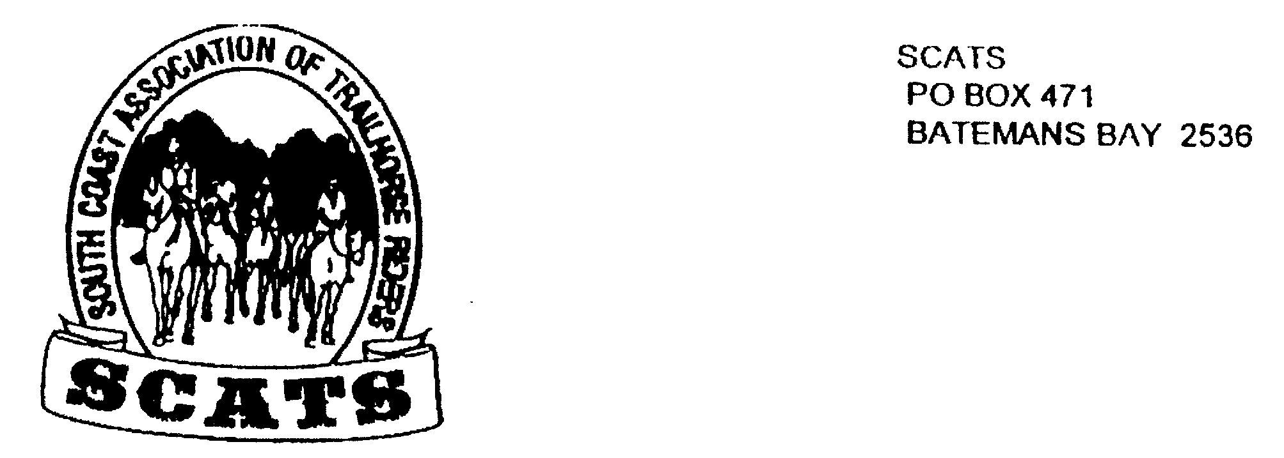
SCATS
PO Box 316
MORUYA NSW 2537
SCATS CHATS

Newsletter of the South Coast Association of Trail Horse Riders Inc.

May 2011

PRESIDENT: Kate Abel 0412 115 068
VICE PRESIDENT: Yvonne Willis 4472 3219
SECRETARY: Bronwyn Ludlow 4474 4291 /0428 130 744
TREASURER: Terry Love 4472 3219
RIDE SECRETARY: Karen Scott 0428643133
TRAIL BOSS: John Davidge 0410 204 123

Cheers to all those who attended the Brooman ride and had a fabulous time! Because it was such a good ride we have been overwhelmed with ride reports and so have two for Brooman attached! Thank you to our budding writers Keryn and Rosemary! Our diligent photographer, Rosemary, displayed some gorgeous and picturesque photos at the last meeting including a handsome portrait!

On Saturday June 4th 2011
ATHRA will join with the American Competitive Trail Horse Association (ACTHA) in the conduct of an historic trail ride to raise awareness of the plight of the Australian Brumby and the American Mustang. The ride also aims to break the record for the biggest trail ride ever organized, so ride registers will be important. Every club is encouraged to participate and support this day with their own arranged trail ride. Together, both countrys’ rides can help to break a world record for the biggest trail ride in history.
· The cost is $10 for Members. That is all that is required to cover for the donation.

Ride
Consequently, Lesley will take us out from her place at 11 Yungarra Drive off Dwyers Ck Rd on Saturday 4th June. You may only need to carry a snack with you whilst riding as Lesley is kindly organizing lunch for all at her place. We can all put in for costs. Tea and coffee available also.

Remember the ride fee for brumby awareness is $10 as above.
We’re looking forward to seeing everyone there at 9.30am for a 10am start.
Don’t forget to ring Karen to book in!

Equine virus in the U.S.A
Unfortunately ATHRA has received advice from the American Competitive Trail Horse Association that riders in America are unable to participate in the joint ride scheduled for the 4th June 2011. They have had to cancel riding in the USA due to an outbreak of Rhino EHV-1 Equine Virus. Our USA counterparts are planning to reschedule the ride in America on the 10th September 2011.
The following is an excerpt from the ACTHA website:
NOTICE: The World Record Ride for the Mustangs has been rescheduled due to the RhinoEHV-1 Equine Virus to September 10th, 2011 (Originally scheduled for June 4th, 2011)
We are sure that all ATHRA members join us in feeling for these people as we all have very clear memories of the EI outbreak in Australia….
Whilst it is very early days with this EHV-1 outbreak the industry in America have high concerns and will no doubt, be taking all precautions.
What does this mean to us?
It appears obvious that due to this late advice the World Record Attempt is not going to be feasible this year, perhaps there will be another opportunity in the near future? ATHRA plans to continue with the Australian effort in support of the Brumbies and suggest that we all continue on with the excellent plans currently in place for the 4th June.

Merricumbene Ride
This is to be held on Friday 17th June, Saturday 18th June and Sunday 19th June.
The main ride will be on Saturday and a shorter one on Sunday. If you arrive on Friday cater for yourself including daytime Saturday. On Saturday night there will be shared catering at a cost of $20 per person. This will include breakfast on Sunday morning but bring your Sunday lunch.
Ring Karen for numbers and catering by Sunday 12th June.

MERRICUMBENE DIRECTIONS
In Moruya - go to the roundabout and turn RIGHT into Campbell St. Travel straight for 37.8km (aprox. 1 hour with a float) after you see a PEACH ORCHARD on your LEFT and a letterbox in the shape of a HELICOPTER on your RIGHT you are nearly at the gate where you will turn LEFT. 4003 and 4005 are on the gate.

After this, follow the PINK TAPE which will lead you through 7 gates to camp site.

Future Ride
Keep the weekend of 25th July free as a possible Corn Trail ride. This will be discussed at the next meeting.

Next Meeting
Our next meeting will be held at the Tomakin Club on the 15th June. Be there around 6pm for drinks and dinner at 6.30pm. The meeting starts at 7.30pm. All are welcome- it’s always a good night!

Birthdays
Happy Birthday! Neville and Rayleen!

For Sale

Child’s stock saddle.
Must be sold.$1
$150 ono
Phone Lesley 44740232
Full sized stock saddle. Aussie made in great condition. $600
Phone Rosemary on
44781187

Wanted Welcome to new members
Very quiet beginners pony14hh suitable for young child.
Phone Bridget on 44717622
Ryan Smith
Sean Reid
Kate Foster
Tom Hanlon
Bridget Buchanan

Ride Report, Brooman Saturday 30th April

John rounded us up by about 9.30am and decided we'd ride out, straight over the beautiful river, which had quite a lot of clear water flowing. I think it was a fairly uneventful crossing, although i was looking ahead rather than behind! I didn't notice anyone particularly wet afterwards anyway! Getting wet happened later on, but that was everyone.
My usually docile horse thought he'd prance the first few kilometres and I'm sure a few other horses were feeling quite well that morning. Even though it was a bit overcast and tending to drizzle, it was still exciting to be heading out for a day of riding. I think John and Roydon must have felt great because i heard a lot of shouting going on. They must have been singing out to each other about how good the day was and what an excellent meal they'd had the night before. It did seem like they were disagreeing about the direction to ride, but I must have heard them wrong because I don't think anyone would disagree with John's sense of direction.
Most of the morning riding was through the bush with a few little gullies and ridges to traverse. There was a particularly nice view of the river from one ridge and I think we were also graced with some sunshine. I love that riding through the thick scrub with a bit of scrabbling up and sliding down, the horses really thinking about where they're putting their feet and eager to stick close to the horse in front!
The afternoon riding was more damp, with a heavy shower falling right in time for our lunch stop ( by this time I was wondering if there was going to be a lunch stop! ). John had wanted to reach the Banana bridge for lunch. I've never seen a bridge like it, very bendy! It was also a good spot to sit and eat lunch. My rock hard, gluten free bread rolls had never tasted so good.
Most of the way home ended up being road riding, with John the least happy about this, I think. Kathy managed very well all afternoon after receiving a kick in the ankle and she probably appreciated some easy riding on the road. It also makes it easier for a chat and we did manage a last little leg through the bush and then coming down the lovely hill with the old homestead on the side. I'm sure everyone else felt fine, but I have to admit that I was tired! Slim sure wasn't prancing by the end!
Special mention must be made of Penny's adventure. After missing the turn and getting a bit bogged, she took her horse off the float, saddled up and rode through the evening to find camp! Well done Penny.

Ride Report Brooman

Members of the South Coast Association of Trail Horse Riders (SCATS) gathered recently for some amazing trail riding through the mountainous reaches of the upper Clyde River catchment. The venue was a private property near Brooman where there was ample room to set up camp and fence off horses. Drizzly conditions during the week led to poor road conditions however with considerable skill and a little luck all members made it. Early birds on the Friday had a quick ride around one of the shorter trails close to the camp and were treated to the exquisite scenery that only this type of country can offer. By Friday evening most members had arrived and an enjoyable evening was spent around the campfire catching up and swapping a few yarns. After a quick breakfast on Saturday morning the horses were saddled up and by 9am we were off, crossing the Clyde River and riding into the back country forests surrounding Brooman. The day saw a remarkable mix of country from sub-tropical rainforests to high wooded ridges and although several showers occurred, it was quite pleasant and not at all cold. A steady pace was set whilst following narrow bush tracks, old snigging tracks and fire trails. Thanks to John, our trail boss, and his remarkable bush navigation skills and his ‘just follow your nose’ attitude, we were treated to yet another fantastic ride. Sunday saw the riders take to the trails again with the destination being Mogood lookout, a short stroll up the hill from Shallow Crossing. 360 degree views were made possible by the glorious weather, simply stunning!
To take advantage of more wonderful rides and becoming a member of an ever growing group of horse trail riding enthusiasts, please contact Kate Able on 0412 115068.

Runnymeade Ride - 10th April

Around a dozen riders met at the easement \ on Runnyford Rd just off the highway and followed John in convoy to the ride starting point. We were joined by new members Kate, Shaun and Ryan and visitor Lisa.

The quiet Runnyford Rd must have seemed a bit like Pitt St with all the trucks and floats coming along at the same time.

Many steeds were starting to show the effects of the changing season with some looking much shaggier than they had been for a while.

The riders were keen to enjoy the day out with their horses as the last ride had been cancelled due to the unusually heavy rain in March.

After a bit of a rodeo act by Bronwyn’s naughty horse, just to amuse everyone, the horses settled and we rode from the start point through private property until we entered the Clyde River National Park and followed the Clyde River along for about one and half hours. The terrain was not difficult and the riders were able to enjoy the views across the River.

We then headed away from the Clyde River through the bush and crossed Runnyford Rd. We rode along fire trails and stopped for lunch along the track on a ridge. John attempted to demonstrate his mount’s clever trick of picking his hat up from the ground in his teeth and turning his head and handing it back to his rider. However “Bill” decided not to co-operate on this occasion, much to our disappointment.

After lunch we followed John, as usual, who took us on a bit of a loop and back, then bush bashing though some gullies, until we found the bridle trail heading back to where our floats and trucks were parked.

Despite the weather, a bit breezy with the sky a bit grey and threatening, the rain stayed away and a lovely day out was enjoyed by all. Thanks to John for arranging and leading the ride, it is great to be able to ride in areas we would not otherwise have access to.

