TOONGABBIE & DISTRICT RIDERS CLUB
July NEWSLETTER 2011

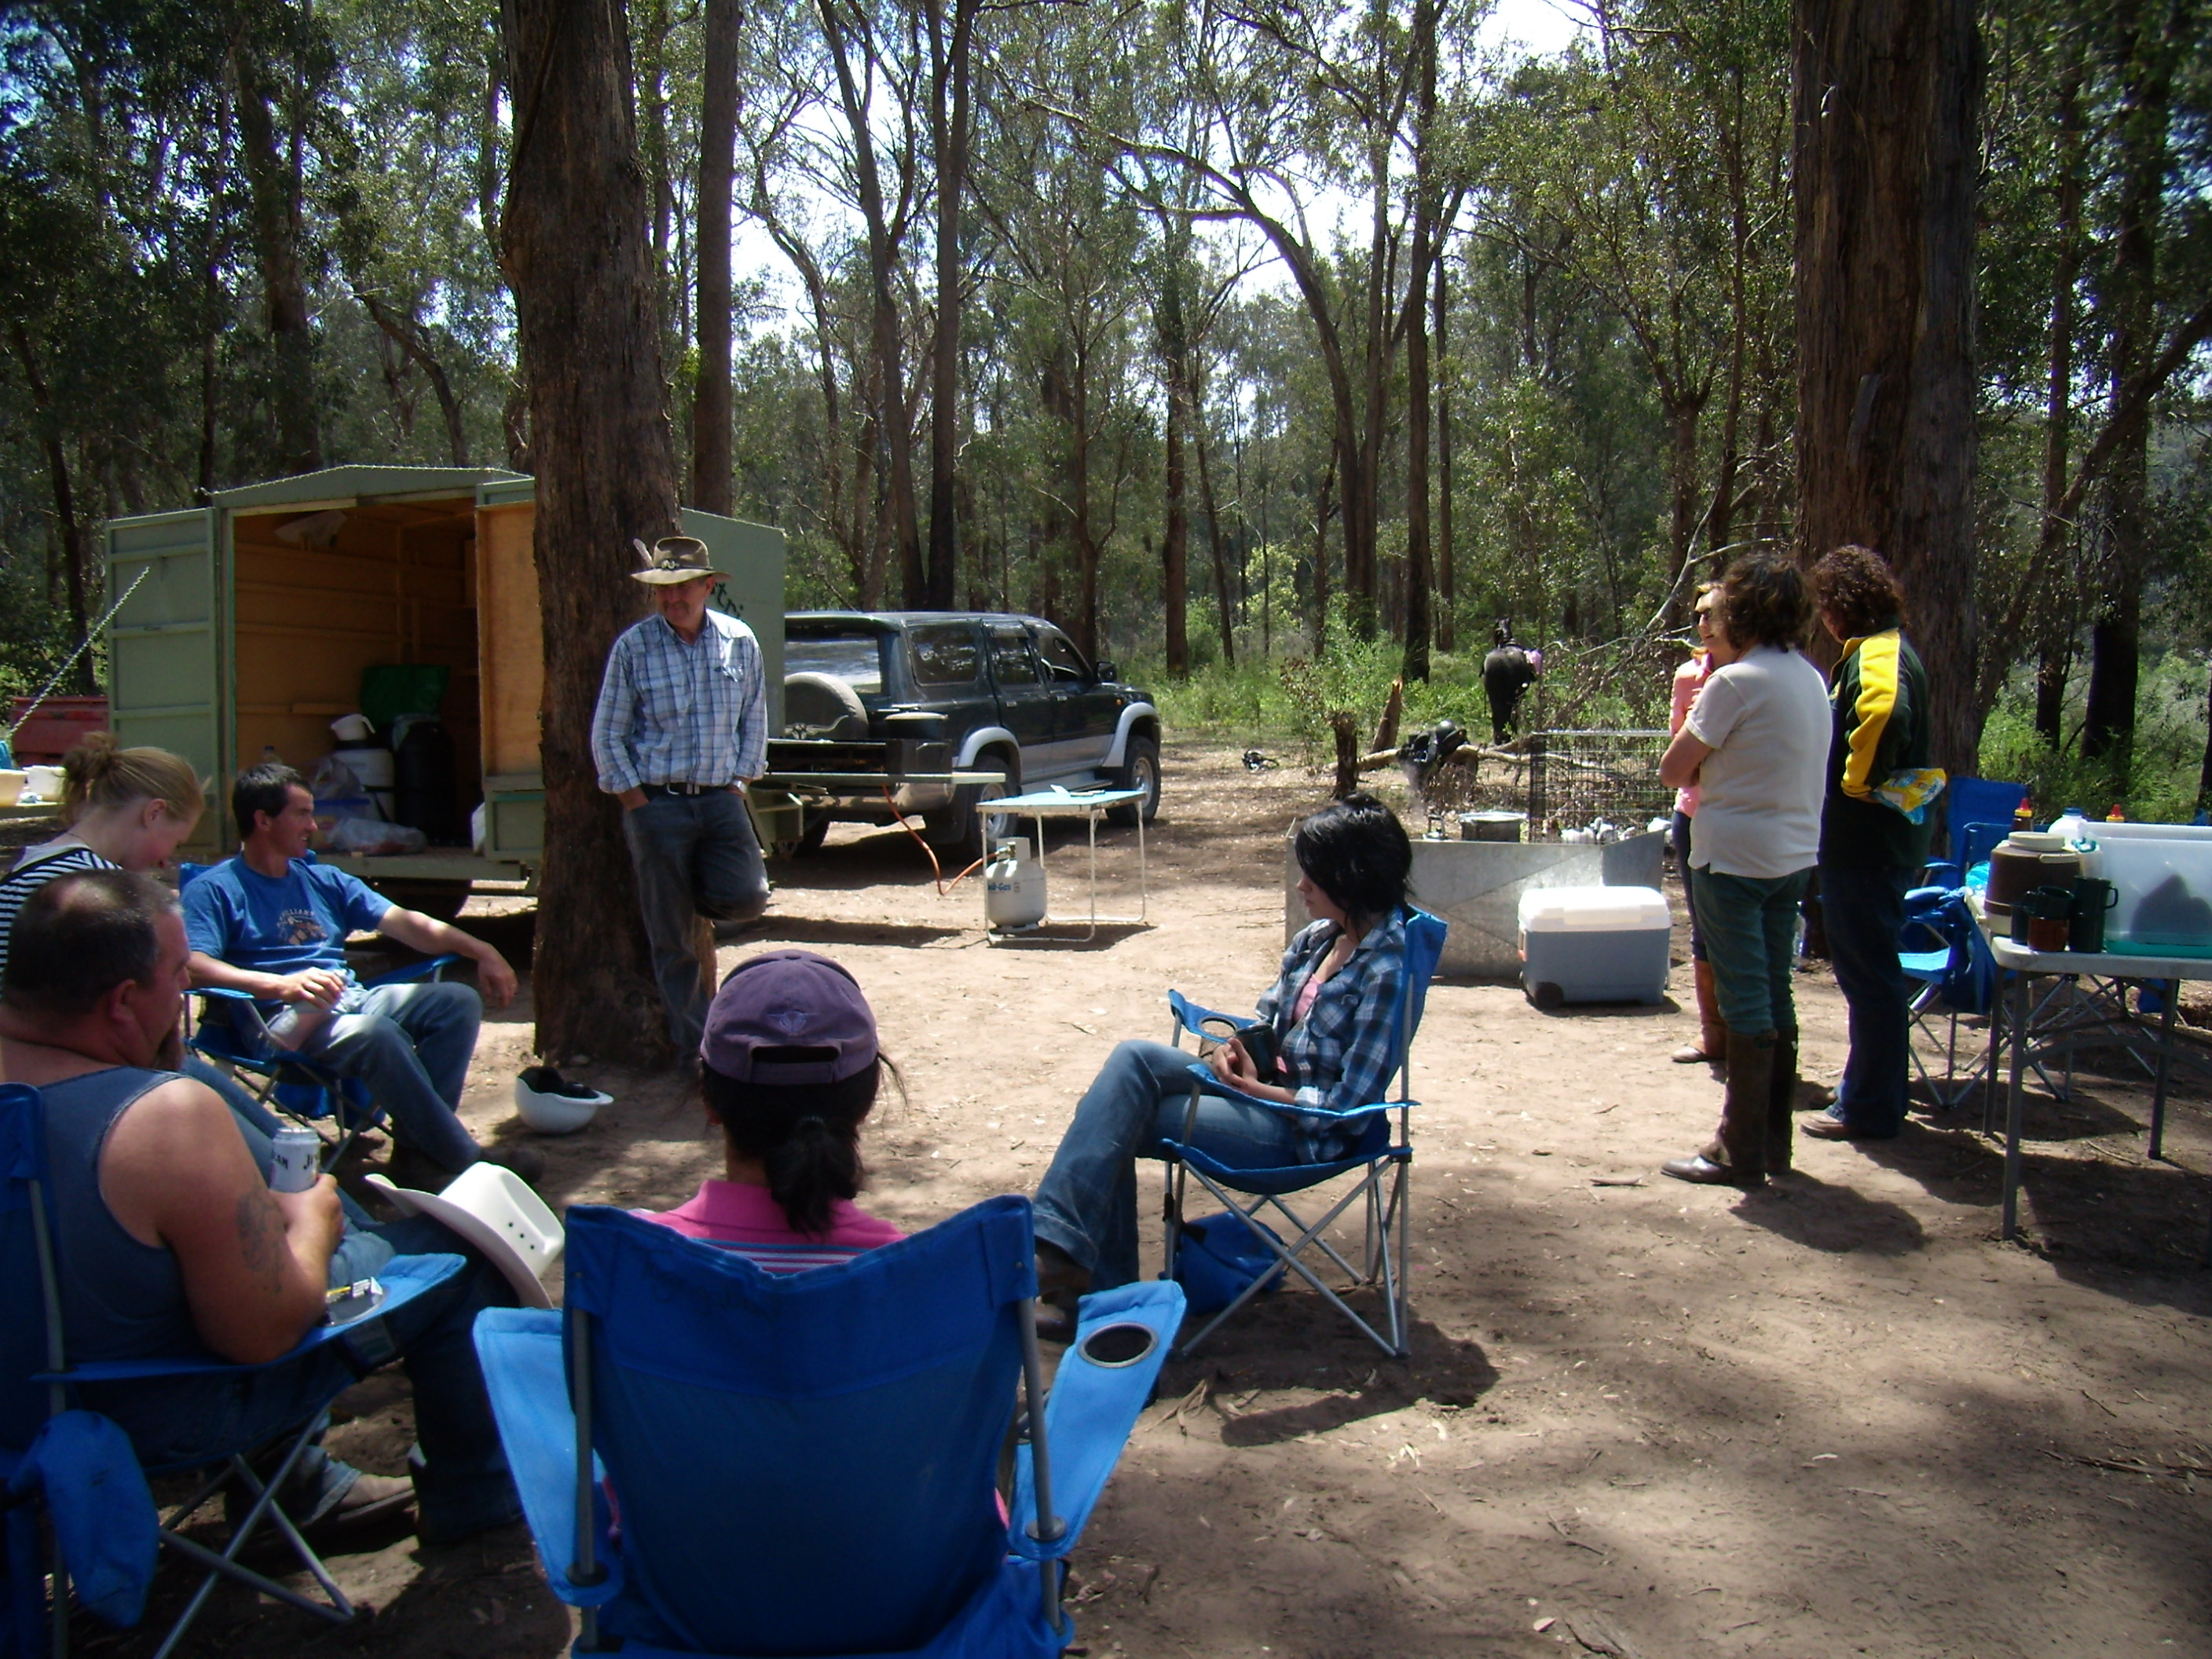
The crew relaxing down on the Avon River at Huggets Crossing
Office Bearers:
President : Dave Smith ph 51489344
Vice President: Steve Coleman ph 51482117
Secretary: Rhonda Hunter ph 51918191
Treasurer: Heidi Page ph 51483308
Toongabbie and District Riders Club meetings Third Tuesday of Month 7.30pm All welcome Supper - Fiona
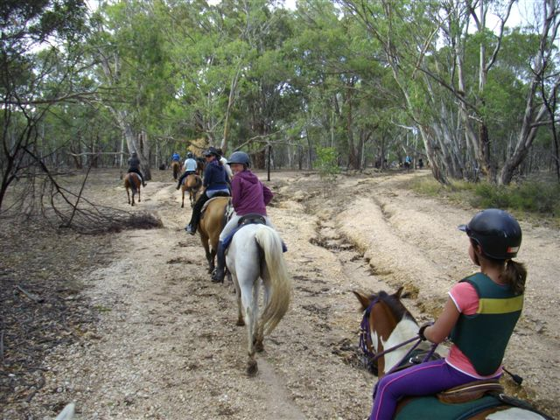

Club Rides are the First Sunday of the Month
Pre-ride talk 9.15 and 9.30 RIDE OUT.
Please make sure you arrive in enough time to saddle your horse and then have a cuppa.
FUTURE RIDE CALENDAR
July Saturday 30th We have decided to have a Xmas in July tea at the Moe RSL, it would be great to see all members come for a great night out, we need to confirm numbers to Heidi NOW on 51483308 Thank you.
August: Heyfield with Heidi Page, cattle yards start and $12 Roast at the pub for lunch. (no afternoon ride) Please arrive before 9am so numbers can be given
September: Greens Gully with Steve Coleman, Hunters on chuck wagon.
September:17th and 18th Boolarra Pony Club: Sandi Simon Confidence Clinic for more information contact Natasha Nash on 0404467056.
October: Glengarry area – Vicki to organise.
November: 6th Novelty Day .
November:20th Erica area Ian Naughton as lead rider, pub for lunch.
December: Xmas break up ride from Toongabbie Grounds

FOR SALE

15 moth old bay gelding, 15hh growth $1200 contact Allison Chalmers:51455544

2 Pony Club saddles $50 each unmounted. 51489344

Ride Report- Gormandale.
We had the wonderful opportunity to start a ride at the home of Carly Lansdown at Onleys road Dairy farm. Due to previous rains on the rich dairy area we parked our floats out on the driveway under the flora gums. It was the perfect spot to light a fire and our park our floats and chuck wagon. 20 riders headed off into the bush with Carly leading and Stan doing drag. We curved our way throughout bush and the plantation tracks, covering a large range of roads and tracks, dry, wet, soft, firm, all great to ride on at various gaits. We were able to enjoy views of the pastureland below on Merrimans Creek, and enjoy a beautiful BBQ lunch cooked by Dave back at chuck camp. Thanks to Carly for leading the ride, it was fantastic for Onleys in allowing us to park close by and sharing their backyard.
Cheers to all, Vicki Smith.
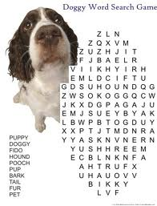

- GENERAL CLUB INFORMATION
- Only one ride can be attended before insurance and membership must be paid
- Ride out starting time is 9.30 am. Lunch may be at starting point or at another point to be advised.
- Ride fee is $6 adult member and free child member under 16. All Non Toongabbie members $10 Chuck wagon is attended by volunteers and a fuel rebate of $50 is paid by the club as well as ride fee wavered.
- Lead riders get their ride fee wavered or $10 subsidized for
a bought lunch (eg pub lunch)
- It would be great if each member could/would take a turn in towing the chuck wagon, which would be once every 2-3 years!
. All Cakes, Slices etc are all gratefully received on
rides to share, which is in addition to payment of ride fee.
- All riders are asked to be respectful of other riders on the trail ride and give everyone space. NO FAST RIDING PAST OTHER RIDERS.
- Newsletters are written by Dawn Gillies and assisted by Lauren Blake if you would like yours emailed instead of posted contact Dawn on gillies.dawn.d@edumail.vic.gov.au or ph 51924231
- All newsletters are posted on ATHRA Website go to ATHRA then Victorian Clubs then scroll down to Toongabbie.

