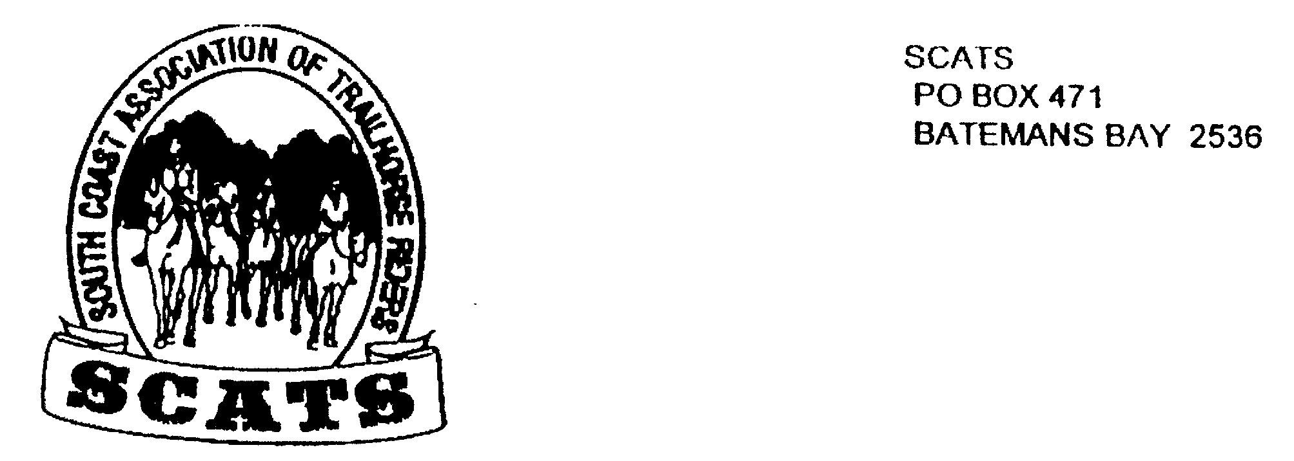
SCATS
PO Box 316
MORUYA NSW 2537
SCATS CHATS

Newsletter of the South Coast Association of Trail Horse Riders Inc.

July 2011

PRESIDENT: Kate Abel 0412 115 068
VICE PRESIDENT: Yvonne Willis 4472 3219
SECRETARY: Bronwyn Ludlow 4474 4291/0428 130 744
TREASURER: Terry Love 4472 3219
RIDE SECRETARY: Karen Scott 0428643133
TRAIL BOSS: John Davidge 0410 204 123

Welcome to Scats Chats with some fun happenings on the agenda!
SCATS TWENTIETH YEAR ANNIVERSARY party will be held on SATURDAY 15th OCTOBER! Members are encouraged to join in the organisation of this special occasion.
The indefatigable Kate has found that there have been 367 members of SCATS throughout the years since its inception in 1991. An invitation will be sent to all members past and present to party on the 15TH OCTOBER at Robert and Kate’s farm. Bring your horse and camping gear as this will include a day ride. A special events form will be sent to past friends who are no longer ATHRA members to enable us to include them in the ride. So keep the date saved! More info to come….

Day Rides
Unfortunately Bridget’s ride of the 10th July had to be cancelled due to high winds but we hope to hold it again at a later date.

Wamban Ride 14th August

Bronwyn has elected to take us out but note that this time it will not be from her property. Thank you, Bronwyn! Directions are as follows:
From the north, turn right into Campbell St at the roundabout at the end of Vulcan St, Moruya (From the south go straight ahead though the roundabout).
Continue along Campbell St, past Gundary oval. The road will veer a little to the left and become Luck St and then the Araluen Rd. Follow the road until you get to the Wamban Rd turn off. If you cross the concrete bridge over the river you have gone too far.
Turn left into Wamban Rd and continue along Wamban Rd until you reach the second timber bridge.
Turn right into the gateway just after you cross the bridge and drive along the driveway until you reach the clear area before the driveway turns left. There is plenty of room to park here. Please do not drive onto the area that looks “mowed”.

Arrive at 9.30 for a 10am start and BYO lunch etc. The ride fee is $5 and please remember to book in!

WEEKEND RIDE
Another great weekend camp looms! Be available on the 16th 17th and 18th September. The location at this stage is pending and will be decided at the next meeting. This will be a catered ride. For those who arrive on Saturday the ride will commence at 10am for a 10.30am start. The cost for the weekend is $35 pp including the $5 ride fee; Friday evening meal, Saturday breakfast, Saturday evening meal and Sunday breakfast. BYO lunches.

ACCESS FOR ALL MEETING
This meeting will be held at Andy and Julia Short’s home on the 30th July at 10am. The address is 34A Brown Close, South Heads.
Directions: Drive down South Heads Rd for 6km. Turn right onto Newstead Rd, then take third left into Brown Close. Phyllis and Kerry Reid will attend the meeting and all are welcome.

Charity Ride for Cancer
Vicki is sharing info from Cathy Woods for the following ride that she would like to attend. Cumberland is doing a charity ride in October and this will be held in Scone. Is anyone interested?
Let me know if you would like more details.
We are running the ride for one week from the 15th October to the 22nd October (Saturday to Saturday) and it will be held in Scone. The entry fee will be $700 for the early bird rate, and an entry form is available and our flyer which has a bit more information about the ride.
Basically we are running a fun ride for charity, (Cancer Council) and there will be 3 days riding, sunday to tuesday and a rest day for the horses on the wednesday. We have a few options for the riders for that day too. There will then be another 3 days riding from thursday to saturday, the last days ride will only be half a day.
All meals are included in the entry fee, and horse feed can be bought on sight at camp (hay, mitavite ecconomix and extra cool) or you can bring your own. There will be a choice of paddocks, either bring your own electric fence yard or use the communal paddock (provided your horse is not a kicker). You can sleep in your car/float or tent, whatever you like.
You need to be an ATHRA member to be eligible to attend. We are only taking 50 horses, so basically, first in with their entry form, waiver and money are guaranteed a place at this week, but we are planning lots of fun things to do, so it will be a ride not to be missed.
Let me know if you have any other questions, and I hope to see you there.

PLEASE REMEMBER! To book in with Karen for all rides PARTICULARLY SO if it is a weekend ride! The volunteering organisers need to know how many to cater for well in advance! Remember to phone in a week before a catered ride!

RIDE REPORTS

Biggest Trail Ride 4th June 2011

ATHRA and the American Competitive Trail Horse Association (ACTHA) had planned to conduct the Biggest Trail Ride in History to raise awareness to the plight of the American Mustang and the Australian Brumby. The idea of this was that every individual club would hold a Trail Ride and donations would go toward the cause. The date was set, 4th June 2011, and all was ready to go.
Unfortunately an outbreak of Equine Virus in the USA meant that ACTHA had to postpone their Rides. ATHRA encouraged Clubs to go ahead with their plans anyway.
The SCATS ride was held at Lesley’s place, just outside Moruya. 9 riders met on a bleak morning, with overcast skies threatening rain. Lesley and Karen had us a little worried as they recounted a recent ride on the same route where they had been monstered by a feral alpaca. We were wondering what was in store!!!
We were soon to find out. As we rode along a track which followed the property fence line the alpaca was spotted, and at first we thought he looked harmless. However, as we drew a sigh of relief, he put his head up and galloped at full speed towards us. I didn’t think they could go that fast!! The cautious ones amongst us rapidly dismounting, we tried to calm our terrified horses. The alpaca really wanted to get us!!
It was right alongside us and then to our horror it jumped the fence, well rather it pushed the fence over so it could sort of hop over it. We thought we would have it chasing us for the rest of the ride.
Luckily the alpaca did not follow us, it must have just been territorial and once we moved on it seemed satisfied and stayed near the fence.
We continued on through some open paddocks, along the pretty Candoin Creek and detoured past the Donkey Hill mines. We looped back down to the Creek, crossed over and rode past the old crusher just off Dwyers Creek Rd. Back on the road we headed back to Lesley’s place.
Just as we arrived back, it started to rain, not much but we were happy to get inside and have a lovely lunch of chicken, bread rolls and salad, followed by tea, coffee and yummy slices and cake.
It was a very enjoyable day, with the Ride Fees being donated to the worthy cause of raising awareness of the plight of the Brumbies.
Thanks to Lesley for opening her home to us for lunch.

Merricumbene Ride Report

After a long, slow trip to Merricumbene we quickly set up camp and were treated to a much welcomed BBQ and some tasty rissoles made by Robert – very much appreciated by all late comers. Thank you!
9.30am the next morning saw all riders setting off, crossing the Duea River then heading up a long winding ridge. It was hard going and rocky but still very enjoyable with the bush being easy to ride through as it wasn’t at all thick. The views over the properties below were remarkable. A steady climb along an old fire trail to the top saw the temperature drop and it became chilly. Time for a quick lunch then back onto the horses and taking a short cut we headed back down the mountain to camp where Deb had cooked up a delicious pumpkin soup and corned meat. Spoiled again, and again a big thanks!!
Sundays ride took us through the back country of the property. Once again easy going open bush…a joy to ride through. We came across an old hut which provided the opportunity for some nice photo’s then pushing on we crossed the river and followed another track which looped around through a neighbor’s property and back to camp.
A fantastic weekend was had by all and a big Thank you to all involved – especially our hosts Royden and Deb.

Happy Birthday

Kathy Ian Heycox
Grinrod
The Tomakin Club
Wednesday 17th August
At 6pm for drinks and a meal at 6.30pm.
Meeting starts at 7.30pm
Come along-it’s an enjoyable night for all!

Ez Jones Kate Abel

NEXT MEETING:

