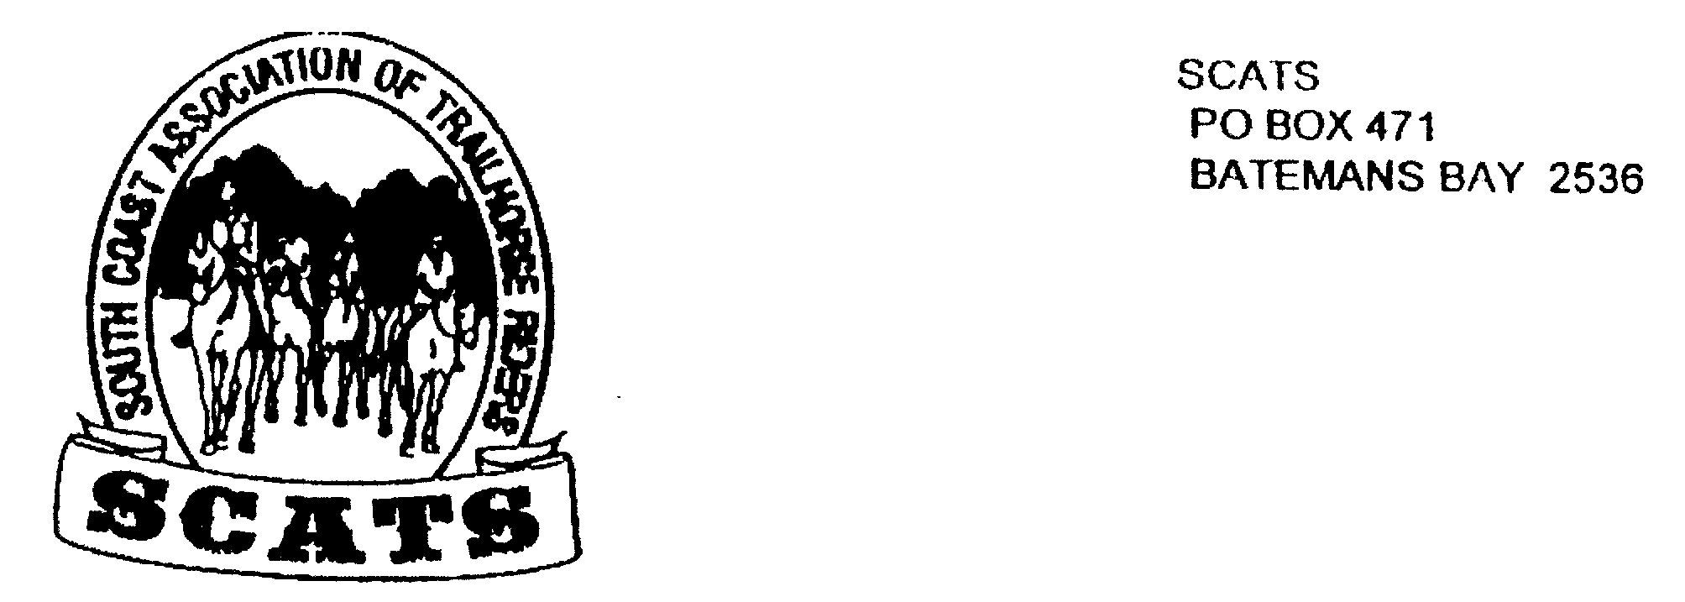
SCATS
PO Box 316
MORUYA NSW 2537
SCATS CHATS

Newsletter of the South Coast Association of Trail Horse Riders Inc.

August 2011

PRESIDENT: Kate Abel 0412 115 068
VICE PRESIDENT: Yvonne Willis 4472 3219
SECRETARY: Bronwyn Ludlow 4474 4291/0428 130 744
TREASURER: Terry Love 4472 3219
RIDE SECRETARY: Karen Scott 0428643133
TRAIL BOSS: John Davidge 0410 204 123

Welcome everyone and thank you to those who were able to attend the last meeting where we continued to organize the SCATS 20th year party. It’s going to be a good one! There will be more information later.

NEW MEMBERS
Welcome to Harold and Tom Franzen! We look forward to getting to know you!

BIRTHDAYS
HAPPY BIRTHDAY John! XXXX

NEXT MEETING
21st September at the Tomakin Club 6pm for a 6.30 meal and 7.30pm meeting. Come along- it’s a fun night!

Bimbamala Ride

16th 17th 18th September
Take note now that this ride is looming! This is a catered camp over and so it is important that you book in with Karen by Friday 9th September for catering purposes!
We have ridden at Bimbamala before. It is a beautiful property and a great place to camp and swim and of course ride! New members remember to bring your kit bag and chair!
The cost is $35 per person for 2 evening meals and 2 breakfasts and the $5 ride fee also. If you arrive on Friday byo lunch, also your own lunch for Saturday and Sunday.
Saturday’s ride will be 10am for a 10.30am start for those who will arrive early that morning.
Please remember that many hands make light work so be sure to chip in where you can!
Here are the updated directions from Kate.

Directions to Bimbamala

FROM BATEMANS BAY

150 mtrs south [before] East Lynn store turn LEFT onto Old Highway

- 5 klms LEFT into Barkshead Rd

- 5 klms LEFT into River Rd

- go across Shallow Crossing

- go past the first rd [Backhouse] turn RIGHT into 2nd rd Dury Rd

- RIGHT into Clyde Ridge

- 1 klm LEFT into Folders RD

- Pink tape will be at Folders Rd

- Through gate and downhill to camp site

- Please note approximate klms

REMEMBER TO BOOK IN WITH KAREN!

