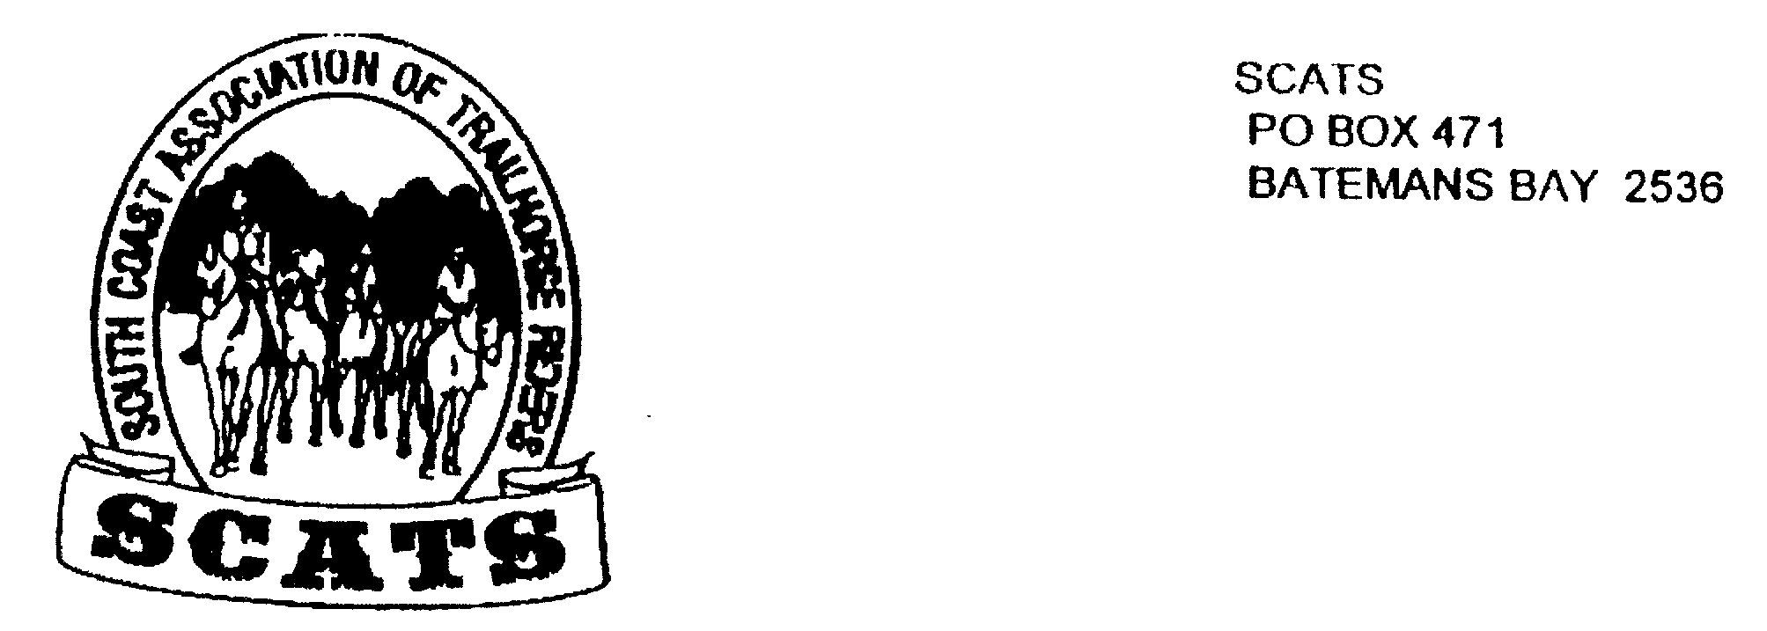
SCATS
PO Box 316
MORUYA NSW 2537
SCATS CHATS

Newsletter of the South Coast Association of Trail Horse Riders Inc.

October 2011

PRESIDENT: Kate Abel 0412 115 068
VICE PRESIDENT: Yvonne Willis 4472 3219
SECRETARY: Bronwyn Ludlow 4474 4291/0428 130 744
TREASURER: Terry Love 4472 3219
RIDE SECRETARY: Karen Scott 0428643133
TRAIL BOSS: John Davidge 0410 204 123

The South Coast Association of Trail Horse Riders and all its members will recall October 2011 as a most memorable month due to the twenty years anniversary party and so what better way to start the newsletter than with the birthday report!

The 20 Years On Dinner
Saturday 15th October 2011
Saturday 15th October saw some 60 + people, both past and present members come together to help celebrate 20 years of SCATS rides. Some of the people had spent the morning on what I am told was a lovely ride from the Mogo area to Robert and Kate Abel’s beautiful property on the banks of the Tomakin River.
The weather could not have been any better: after a bit of rain in the morning the day and the evening turned out to perfect.
Some of the riders and invited guests took up Abel’s offer to camp overnight. So by 5.30 the flat along the Tomakin River looked a bit like camp city with tents, trucks and floats set up.
The evening meal was well catered for by Jill, her husband Jim and Kate Abel. There were platters with an array of cheeses, biscuits and dips to start and easy the hunger, then a lovely warming carrot, orange and fennel soup, followed by fresh crusty rolls with silverside, roast chicken with a variety of Jill’s homemade chutneys and relishes. Then to top all of that there were mini Pavlovas with very tasty berries and cream, a chocolate fudge type slice and a birthday cake for Steve McGuire.
Entertainment for the night was a fantastic slide show of photos that had been collected over the last few months and put together by Robert; everyone enjoyed watching them turn over through the night. Also singing and music by Graham Osborne and Heather Butcher: this kept most of the crowd dancing well into the night.
After the dinner was just completed there were speeches to be made starting with John “Stag” Davidge thanking everyone for coming out to help celebrate, hoping that they enjoyed their day and the night, thanking past people of importance who helped make SCAT’S what we see tonight. President Kate followed with a few presentations, firstly to Lesley Whale for being a founding and current member of SCAT’S, a portrait of John Davidge painted by Rose Mary Bunn was awarded to John for many years of Trail Bossing. Kate then thanked our wonderful cooks for the evening, Jill and Jim. One last speech and again John took the floor thanking and presenting President Kate with flowers and an Apricot tree for her huge effort in getting this event together.
Sunday morning saw those that stayed awake partake in the two Kates (Abel and Young) cooked bacon and egg rolls with plenty of tea or coffee to help us all wake up.
Great food, great music and great company: what a way to celebrate 20 years! Here’s hoping that the next 20 years are as good! Lastly, a huge thank you to Robert and Kate for the great venue.

20th Anniversary Ride – 15th October 2011 – Maulbrooks Rd to Tomakin

After a rainy start to the day, the clouds disappeared as riders congregated at the starting point on Maulbrooks Road. One by one the riders arrived with trucks, floats and even on horseback.
As we were getting ready there was a little excitement as Harry’s horse, Jackson, somehow escaped and went for a little run around to check out the scenery and the horses in an adjoining paddock. It did not take long for the escapee to be recaptured and we were ready.
There were 18 riders in total including the Mehl family and visitor Cathy. Our trusty trail boss John led the group down Maulbrooks Rd until we passed the last houses then we “went bush” along a trail that looked like it was only used by horse riders and trail bikes. We rode downhill till we reached a pretty creek then up a very long fairly steep hill. Now that the sun was shining the view for the top was spectacular.
We ended up on a gravel road which we followed for a while. We had a lovely surprise as we rounded one of the bends in the form of an unexpected morning tea stop. The two Kates, Sue and Deb were ready and waiting, with hot tea and coffee, scones and cake.
Just in time for morning tea we were joined by Amber and Emma who had missed us at the start of the ride but had managed without difficulty to follow our trail and catch up.
When all had their fill, we remounted and continued on our way to Mogo. We rode around the Mogo Oval with one stop for John to tell us a funny story about Andy and a “wild” horse.
We then crossed the highway just south of Mogo and snuck around behind the primary school and came out a little way along Tomakin Rd. We crossed the road then rode in an easterly direction up high behind the properties on the northern side of Tomakin Rd. We were now on the “home stretch”, riding back down to Tomakin Rd opposite Mogo Zoo, we could see the open paddocks of Kate and Rob’s place. A short ride through the property and we had arrived at the camping/party area.
Riders were ferried back by various means (thanks guys) to their floats and made their way home or otherwise before returning for the SCATS 20th Anniversary Party. The ride had been great but the best was yet to come!!

Future Rides

Broulee Beach Ride 20th November
We will meet at the corner of George Bass Drive and Percy Davis Drive. This is indicated by the green shed on the side of the road. Park behind the green shed. Remember to BYO lunch and drink. The ride fee is $5. This is a 9.30 for 10am ride and will probably not be of long duration. See you there! And don’t forget to book in with Karen!

Christmas Party and Ride 10th and 11th December
This looks to be another weekend of fun, the venue being Rosemary Bunn’s place near Nelligen. This is a camp over with a short ride on Saturday starting at 9.30 for 10 {BYO lunch} followed by a short bus ride to the Nelligen Hotel for dinner and party! And fortunately the bus will see us back at camp for a good night’s sleep and breakfast the next morning!
The hotel menu and price will be available at the next meeting.

Corn Trail/Araluen Ride March/ April 2012 Save this month!
John is currently negotiating this ride which will be of a 4 day duration. It’s going to be a special ride so keep tuned!

Snowy River Festival 4th November
This is an annual event and is not far from Robert and Kate Abel’s property near Jindabyne. Robert and Kate have kindly offered camping or cabin on their property for any members who wish to go to the festival. However, this is not a horse weekend! People only! This is at 1454 Alpine Way. Ring Kate on 0412115068 if you would like to head up to the mountains and enjoy the offer.

Addresses
Members please send me your birth dates for the record. Preferably email them to me so that I can email you back, saving your correct email address. Problems arise if the minutest part of your address is left out. Thank You! My email is: sharpies@aussiebroadband.com.au

ITEMS FOR SALE
If you have any items for sale or wish to buy anything feel free to let me know and I’ll put it in the next newsletter.

NEXT MEETING
The next meeting will be at the Tomakin Club as usual on the third Wednesday in November, the 16th. Be there for drinks at 6pm, dinner at 6.30 and the meeting at 7.30! It’s a companionable, sociable night not to be missed!

THERE WILL BE NO MEETING IN DECEMBER!

Penny Cope Vicki Able Bridget Buchanan

