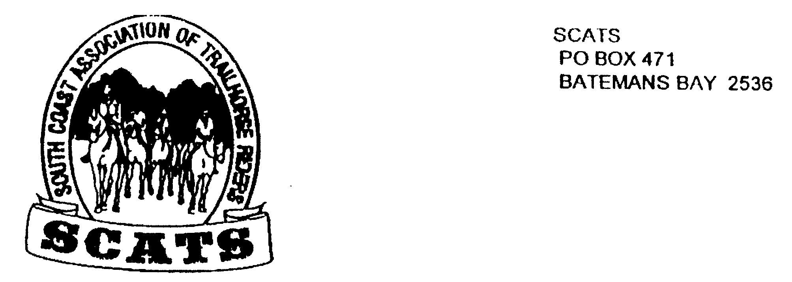
SCATS
PO Box 316
MORUYA NSW 2537
SCATS CHATS

Newsletter of the South Coast Association of Trail Horse Riders Inc.

December 2011

PRESIDENT: Kate Abel 0412 115 068
VICE PRESIDENT: Yvonne Willis 4472 3219
SECRETARY: Bronwyn Ludlow 4474 4291/0428 130 744
TREASURER: Terry Love 4472 3219
RIDE SECRETARY: Karen Scott 0428643133
TRAIL BOSS: John Davidge 0410 204 123

Future Rides
The next ride is this Saturday, 20th November: Broulee Beach ride.
The meeting venue has changed to the racecourse. This is 9am for 10.00 start. BYO lunch and the ride fee is $5.
PHONE KAREN TO BOOK IN NOW!

Christmas Party, ride, camp and dinner 10th and 11th December
This is at Rosemary’s property at Nelligen. Rosemary is organising a short ride for us on Saturday: 9.30am for 10am start, bring your own lunch and drink. Directions follow. This is a camping weekend. Thank you, Rosemary, for your kind hospitality.
Happy Hour is on the cards in the late afternoon followed by the courtesy bus ride to the Nelligen Hotel for dinner. This will cost $20 per person for members and is subsidised by the club. For non- members the cost is $40. This covers a three course meal and band, return bus trip to camp and also breakfast at camp the following morning. And so it’s looking like a fun weekend!

DIRECTIONS
From Batemans Bay take the Kings Highway to Nelligen.
Cross Nelligen Bridge.
Go past and do not turn into Black Flat Road on the right.
Turn right at Western Distributor Road.
At about 2 to 3km along vere to the left over a concrete ford.
Continue until you come to a gate on the left. This is the camp paddock.
Do not go past Pig Road on the right.

Memberships
Renewal of membership is due by 31st December. The cost is $60 for adults or $45 for juniors. The membership and waiver form is attached. Please fill both out and send in for the due date.

Meetings
There will be no meeting in December.

Next Meeting
The Tomakin Club on the 18th January 2012. That is the 3rd Wednesday of each month.

Erin Hendry Jane Vost for December!

