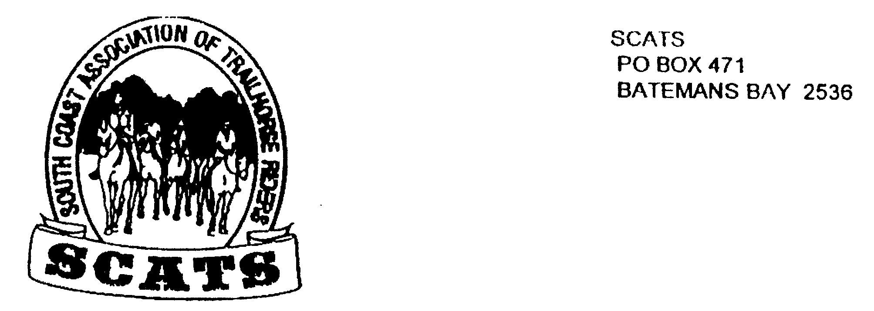
SCATS
PO Box 316
MORUYA NSW 2537
SCATS CHATS

Newsletter of the South Coast Association of Trail Horse Riders Inc.
February 2012

PRESIDENT: Kate Abel 0412 115 068
VICE PRESIDENT: Debbie Reid
SECRETARY: Bronwyn Ludlow 4474 4291/0428 130 744
TREASURER: Terry Love 4472 3219
RIDE SECRETARY: Karen Scott 44743133
TRAIL BOSS: John Davidge 0410 204 123
PUBLICITY OFFICER: Sylvia Sharpe 44743427/ Rosemary Bunn 0418483244

WELCOME!
After an enjoyable dinner the SCATS AGM was held at the Tomakin Social Club on the 15th February. Most positions were maintained. Thank you Debbie Reid for taking on the position of Vice President replacing Yvonne Willis who has, in many ways over the years, been an asset to the club.

In fact, all members of the club are an asset as it is the people who make it! The camaraderie around the campfire at night, the great rides with an awesome trail boss, the organisers who help cater, the fun we have, the interesting rides we take each other out on etc…etc! All of these things and more along with great friendships are what has always made SCATS what it is and each member is treasured! So get your boots on, we’re going riding!

RIDE REPORT
We had a great ride at Kate and Rob’s place in February and here is Raelene’s great version of the day!

Well how wrong the weather forecast was over the weekend, especially on Sunday, which was lucky for everyone who attended the Valentine’s Day ride. Nine people turned up for the adventure that Robert and Kate Abel had in store for us. Without the help from Royden and Debbie Reid three of us would not have had such a great day out. Morgan??? Was a little unsure with Royden’s choice for her to ride, but with a minor adjustment, was soon sorted without further complaint. I on the other hand was nervous about my little mare only to be proven wrong again .Sue on the other hand had total faith in her lent horse and rode without any problems. We headed towards Surf Beach via the Mogo Zoo with Robert showing us how professional he has become taking riders out; if only that was the case out at Brooman when my trusting horse followed him straight into ring lock, which lucky Robert must’ve just missed. We followed fire trails until we veered off down through some slippery creek crossing with poor Sylvia entertaining us with Romeo’s scary water antics, but again after the first, the next few were a breeze. Surprisingly Robert didn’t use any gadgets to guide us which show us all that at any age you can achieve anything. Although Robert did point straight down a gulley and I thought I’ll wait and see what happens. So with that everything went really well, especially getting into camp only to have a nice cold glass of champagne with prawns awaiting us. Tom and Melissa joined us with Tom’s mother Kaleen, and their lovely son little Shaun, who showed us the first steps to riding {woo up woo up}. Kate’s grandson and his little girlfriend also kept us amused during our chicken salad with their needs, whether it is a red chair or green chair, not to mention where the chairs are to be. So if that’s how our rides are about, it’s going to be a fun year. Hope everyone on the ride agrees it was a nice day out with good company. Thanking Kate, Robert, Royden and Debbie for making everything go smooth.

FUTURE RIDES

Weekend of 23rd to 25th March

The camp at Sue Rice’s place at Mc Gregors creek has been postponed until next year due to wet weather. Thanks for the effort Sue: a ride followed by entertainment with music sounds great! Next year!

Keep the above dates free however, as we will still have a catered ride on this March weekend.

Due to the unpredictable weather at the moment many places are waterlogged. The final location will be determined at the next meeting so please be there!

Sunday 15th April

Kathie Grinrod has offered to take us to Big Bit from her property at Nelligen. This is a day ride- byo everything. Start is 9.30 for 10a.m. with a $5 ride fee.

Directions: Turn onto the Kings Hwy at Batemans Bay and head towards Nelligen. Kathie’s place is before the Nelligen Bridge. Look out for the Nelligen sign and turn into the next road on your right, Old Nelligen Road. Drive about 3km in. There is a sign on the left side saying “Sproxtons”-drive in and park.

Weekend of 4th 5th 6th May
This will be a catered ride. More information to be had in the next newsletter.

Remember!
Don’t forget to book in for all rides! This is for catering and safety purposes!
Phone Karen Scott using her home phone number: 44743133
New Members
Welcome Karen Ryan from Moruya!
Ez and Barry Jones have renewed their membership.

Memberships
Members who have not rejoined the club please do so soon- we miss you!
The waiver is attached –there is no need to fill out an application form if you are rejoining.

Birthdays

NEXT MEETING
21st March at the Tomakin Social Club!
See you at 6pm for a meal at 6.30 and the meeting at 7.30pm. It’s a fun night, don’t miss it!

