TOONGABBIE & DISTRICT RIDERS CLUB
March NEWSLETTER 2012
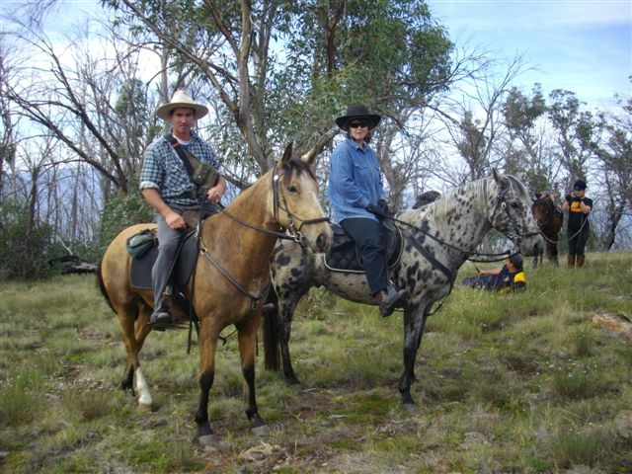
Office Bearers:
President : Dave Smith ph 51489344
Vice President: Neil Price ph 51918255
Secretary: Fiona Henderson ph 0407 814 255
Treasurer: Heidi Page ph 51483308
Publicity Officer: Lauren Blake ph 51483308
Toongabbie and District Riders Club meetings Third Tuesday of Month 7.30pm All welcome, Next meeting on 17th April Supper- Fiona



March ride report by Meghan McDonald

Every first Sunday my dad Wayne MacDonald goes for a horse ride with the Toongabbie & Districts Riders Club. My dad and I have been working on a young horse so I decided to come for the experience. We all rugged up thinking it was going to be a crappy wet slow day but then as we started saddling up in Heyfield on the side of the road because it was a late decision the sun came out and stayed out for our trail ride. The trail ride was fun and good for all the horses seeing all new animals and things to them, we went through new tracks that I haven’t been on before and had a few jokes on the way. We were meant to be going for a camping trip but there was flash flooding so we couldn’t go it was too wet.
We were expecting no one to turn up but there was about seven of us there riding. And Dave the chef stayed behind so when we got back we had hot and cold drinks and lunch all ready for us.
After sitting having a chat a few others came to say hello and said that they had been bull riding and it was funny to see and we should come another time to go watch.
It was a great day and thankyou to Dave for cooking a great meal and Heidi for taking us all on the ride

Club Rides are the First Sunday of the Month
Pre-ride talk 9.15 and 9.30 RIDE OUT.
Please make sure you arrive in enough time to saddle your horse and then have a cuppa and meet the gang and listen to the trial boss, before we ride out.
CLUB POLO SHIRTS AND VESTS COMING SOON!
Club Hats and Stubbie Holders for sale, ask for yours at the next ride
FUTURE RIDE CALENDAR
March 3rd & 4th :Ride got cancelled at wron wron of wet weather, but we had a ride at heyfield.
April 1st : Yallourn Nth, Merv to lead, Dave on chuck wagon, map attached. And please if it is wet stay on the road and don't get off as the edges are soft and you might get stuck.
April 27/28 : Endurance ride at the club grounds.
May 6th : Leroy- Traralgon Sth, Pam to lead.
June 2nd And 3rd : Combined ride Stratford club hosting, Valencia creek camp. Please let Stratford Club know if you will be attending with attached form, so they know for catering purposes.
July 1st : Glengarry Nth, Macka to lead.
August 5th : Hazelwood Nth, Fiona to lead.
There was a working bee held at the end of the month at the grounds, also our new sign has be put up at the front gate and looks grate! Thanks again Lou Boldiston for your talented work.
Our monthly raffle is kindly donated by Glengarry Equine and Canine supplies located in the Main Street of Glengarry, so please pop in and have a browse to help support our locals. Last months winner was Kristy Macklin, well done!
John Bates has a 2 wheel jinker for sale, please phone Rhonda for details on 51918191
There is another Trail Boss training day on 14th & 15 April at Lang Lang if any members would like to participate, the club will pay the $50 that it costs, please let Dave know if you are interested.
For Sale - 3 PONY STRAIGHT LOAD FLOAT.
Double entry side doors, 4 pop up roof vents, sliding windows with screens, barn doors,
padded adjustable chest bars, new rimms, swing up jockey wheel, elec brakes, front tackbox
with 2 doors, bridle hooks and 3 saddle racks. Excellent condition, great float.
$13,200 Please call 51924147 or 0410036018
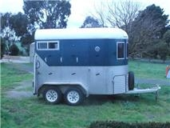
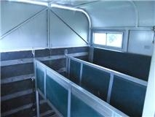
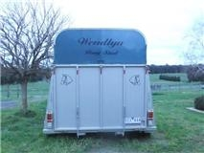

GENERAL CLUB INFORMATION
- Only one ride can be attended before insurance and membership must be paid
- Ride out starting time is 9.30 am. Lunch may be at starting point or at another point to be advised.
- Ride fee is $6 adult member and free child member under 16. All Non Toongabbie members $10 Chuck wagon is attended by volunteers and a fuel rebate of $50 is paid by the club as well as ride fee wavered.
- Lead riders get their ride fee wavered or $10 subsidized for
a bought lunch (eg pub lunch)
- It would be great if each member could/would take a turn in towing the chuck wagon, which would be once every 2-3 years!
. All Cakes, Slices etc are all gratefully received on
rides to share, which is in addition to payment of ride fee.
- All riders are asked to be respectful of other riders on the trail ride and give everyone space. NO FAST RIDING PAST OTHER RIDERS.
- Newsletters are written by Lauren Blake if you would like yours emailed instead of posted contact Lauren on bukshot2@tpg.com.au or ph 51483308
- All newsletters are posted on ATHRA Website go to ATHRA then Victorian Clubs then scroll down to Toongabbie.

