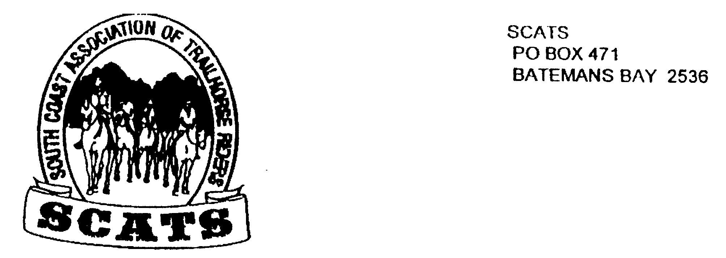
SCATS
PO Box 316
MORUYA NSW 2537
SCATS CHATS

Newsletter of the South Coast Association of Trail Horse Riders Inc.
March 2012

PRESIDENT: Kate Abel 0412 115 068
VICE PRESIDENT: Yvonne Willis 4472 3219
SECRETARY: Bronwyn Ludlow 4474 4291/0428 130 744
TREASURER: Terry Love 4472 3219
RIDE SECRETARY: Karen Scott 0428643133
TRAIL BOSS: John Davidge 0410 204 123

Welcome to another SCATS newsletter!

Mogo Ride Report
The ride from Wayne Evan’s property at Mogo on the 25th of March proved to be a fun day with perfect weather. Eighteen riders went out led by Leslie on what was a lovely scenic route until someone mentioned an old hut. That was when John and Leslie put in more great team effort and took us downhill for a good old bush ride through gullies and hills. It was in a steep, muddy, creek crossing whilst bush bashing through some green and supple young wattles that the fun started! Except for one rider who had an altercation with two wattles that separated her from the saddle just when her horse got poked in the belly by a stick!
Thanks to Robert there are always yummy snakes to make you feel better!
The ride took us through parts of the Mogo forest that where hadn’t been before and through which we tried to find the old hut.
After that we had lunch in an ideal setting and discussed the big ride coming up after which we had a pleasant meander back. It was a lovely day. Thank you, Leslie and John for taking the ride.

FUTURE RIDES
April Ride Sunday 15th
Kathie Grinrod has offered to take us to Big Bit from her property near Nelligen. We will meet at 9.30 for a 10am start. BYO everything.

Directions
Take the Kings Hwy from Batemans Bay. Drive towards Nelligen and when you see the Nelligen sign take the next dirt road on your right, “Old Nelligen Road.” {If you cross the bridge you’ve gone too far}. Drive about 3km in. There is a sign saying “Sproxtons” on the left hand side. Drive in and park. Book in with Karen by Thursday 12th.

Weekend ride in May
Friday May 4th to Monday May 7th
This ride is from the Corn Trail to Araluen and will be a moving camp. We will be starting at the bottom and riding up the corntrail. Back-up will be provided thanks to John’s organizational skills and voluntary help. This will be a catered ride. The cost is $80 per person including ride fee.
The cut off day for booking is Wednesday 18th April which is the night of the meeting. Phone Karen!
Note that if you put your name down for a catered ride and do not come YOU STILL HAVE TO PAY!
Come to the meeting to find discuss details.

June Ride

This is for the 3rd June and is from Robert and Kate’s place at Mogo. The address is 312 Tomakin Rd and is the second driveway on your right after the zoo coming from Mogo.

Bring morning tea and drink but otherwise this is a catered lunch ride at the cost of $10 including the ride fee. It’s a 9.30 for 10am start.

Book in with Karen by 31st May. If you cancel you will still have to pay!

July Ride

This ride is to be held on 8th July and will be a Bimbie ride. Directions will be in the next newsletter. It is 9.30 for 10am start and BYO. Ride fee is $5. Book in by 6th July.

The next meeting will be at the Tomakin Club on the 18th April . Meet at 6pm for a 6.30 meal and a 7.30 meeting.

Further discussion will take place on changes of venue for meetings in order to accommodate members who travel, and to experience varied cuisine!

Happy Birthday Royden!

