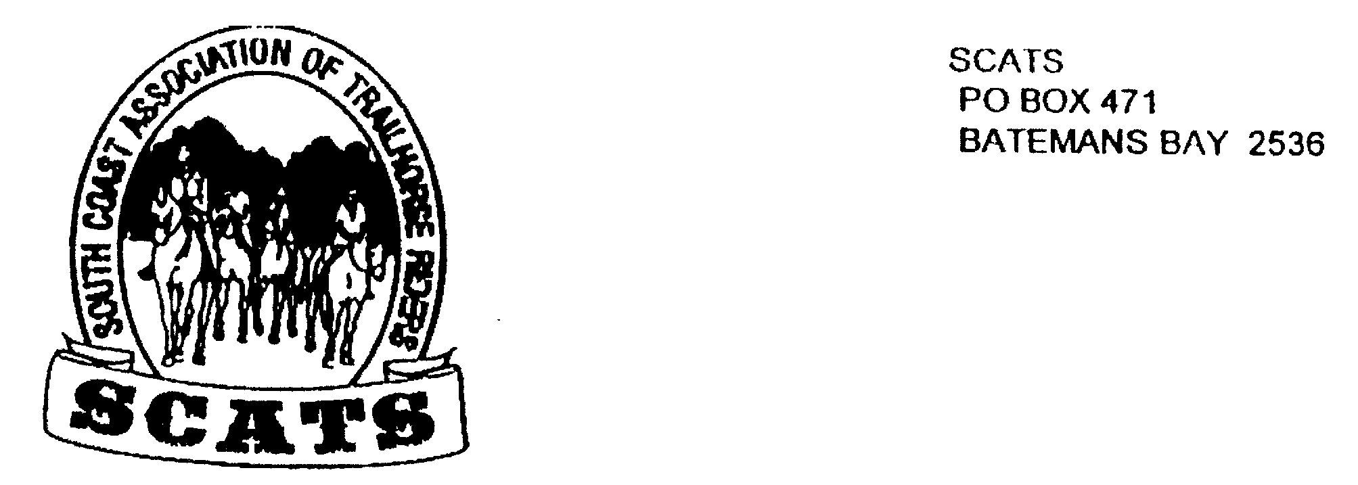
SCATS
PO Box 316
MORUYA NSW 2537
SCATS CHATS

Newsletter of the South Coast Association of Trail Horse Riders Inc.
April 2012

PRESIDENT: Kate Abel 0412 115 068
VICE PRESIDENT: Debbie Reid
SECRETARY: Bronwyn Ludlow 4474 4291/0428 130 744
TREASURER: Terry Love 4472 3219
RIDE SECRETARY: Karen Scott 0428643133
TRAIL BOSS: John Davidge 0410 204 123
PUBLICITY OFFICER: Sylvia Sharpe 44743427/Rosemary Bunn 0418483244

Here’s a good way to start the newsletter!

Sunday 15 of April dawned as a beautiful Autumn day. Eight riders and horses gathered at Kathy's at Nelligen. Most gathered all seem to have had similar problems with Greasy Heel, Seedy toe and Rain Scalds. They are something a bit new to me, even though I have been in Auzzie a long time. Where I had horses in NZ the average rainfall was 60 inches, you could sometimes bog a duck, but had never come across these little beauties. Must be why this is the lucky country, if you are in to vet supplies anyway. Any way where were we, Oh yeah riding. We started out with a scenic look at the property, what a beauty it is. Miles of good pasture, there was plenty of rein stretching as at every opportunity the horses would drop their heads to grab a bite to eat. We past a wee cottage that is for rent, top spot, top views over Cyne Mallows. Kathy proudly told us that she had a 21day booking coming up. Good for her, but I felt that was a tad long for me to be contemplating my navel. We came across a large black snake who didn't seem worried about us at all, bit different to some of our mob, horses didn't seem to care. The day was very warm and a few horses were showing signs of the fresh feed that has been about. Katy's horse started out with a brand new pair of rubber boots on it's rear hoofs, however she had a blowout in one but carried on gamely on one. On to Old Nelligen Road for a bit, then off on to the power lines, heading north. The motorbikes had cut a groove in the dirt, that may have suited them, although their foot pegs must have been in the dirt as they were quite deep. But it didn't suit the horses, sort of two legs out of bed. As we approached a nasty little wash out down into a bit of a creek, I heard a bit of a commotion and looked back in time to see Kathy do the classic Nelligen dismount, which is sort of what happens when your saddle decides it wants to be under the horse. The dismount was a joy to watch, however the landing was a bit messy and needs a bit of work .All was well and off we went, turning on to a fire trail, and onward and up wards to Big Bit lookout. Big climb up to the lookout, my horse wants to know why they put them on top of hills, and has threatened to bite the next forestry bloke he sees. The view was to die for, well that may be a bit heavy, but it was magnificent, perfect day, you could nearly see for ever. Then a knee jarring descent to find some shade for lunch. Highlight of the day, Karen was sitting on a log eating her lunch, don't know what was in it, but next thing she is laying on the ground, she reckoned the log bucked. The return was uneventful, but enjoyable. On our return to H Q we were treated to tea and bikkies in the garden, except for some one who shall remain nameless, but rides a horse called Harold, they spotted stubbies in the fridge, say no more. Thank you Kathy, most enjoyable outing, and good on those who made the effort to go, I know sometimes we have commitments but I have never regretted any ride I have done with the club, even if I am a blowin. Cheers Harold

ARALUEN RIDE
Friday 4th to Monday 7th May

A moving camp
As you know this is getting close for all those who have booked in. The ride will start at the bottom of the corn trail. The first night’s camp will be on private property at Monga. The following night, Saturday, camp will be in Araluen. We will pass the pub on the way so bring some cash with you! The campsite is 2 and half km past the pub. Unfortunately the hotel cannot cater for us so we’ll be eating at camp. Sunday night camp will be at Merricumbene.
The cost is $100 per person to cover catering costs and ride fee.
Remember everyone is expected to help with various jobs at the campsites.

GEAR
On the morning of the 4th deposit all your camping gear at Bruce Reid’s place on the eastern side of the highway(Bay Removals).
Do this between 7am and 7.30 am.
Then go to Mogo oval where we will all meet at 8am sharp!
Bring to Mogo only what you need on the day! That is: horse, saddlery, lead rein, your lunch, saddle bag, saddle blanket and drink etc. Everything else will have been left at Reids’.
From Mogo we will travel in convoy to Ray Johnson’s property 7km past Terry Love’s place. Floats will be left there and the ride will commence.
THINGS TO REMEMBER
Try to travel as light as possible, share yards if you can and don't bring heavy feed buckets or star pickets. The lightweight laundry buckets from woolies are good as they pack inside each other and hold heaps of stuff. Don't forget your chair, plate & mug etc.
Make sure your fence electrifier (and torch) has good batteries, use hobbles as well if your horse escapes.
You will need six feeds per horse. Bring chaff rather than hay. Bring a horse rug. A spare front and back horseshoe carried in your saddlebag isn't a bad idea. Use your thickest saddle blanket (avoid a sore back) Do not take the keys to your vehicle with you on the ride, better to hide them somewhere safe at the start.

Enjoy the ride!

Future Rides
Mogo 3rd June
This will start at Kate and Robert Abel’s place at 312 Tomakin Rd. From Mogo take the Tomakin Rd. Turn in at the second driveway on the right past the zoo. Bring your own morning tea and drink. Lunch will be catered at $10 including the ride fee. The ride will commence at 9.20 for a 10am start.
Book in with Karen by 31st May.

Bimbie Sunday 8th July
This will be a 9.30 for 10am start. BYO everything. $5 ride fee. Directions will be in next newsletter.
Don’t forget to phone Karen to book in!

COBARGO HORSE SALES
18th annual quality horse and equipment sale. Sell or buy! Items for sale will be catalogued from 4pm to 5.30pm on Friday or 8.30am till 10.30am Saturday at the pavilion.
Gear enquiries: Richard or June 64937263
Horse enquiries: Pauline 64938401 or Robyn 64923197
SATURDAY 12TH MAY 2012 at Cobargo Showground.

NEXT MEETING
CHANGE OF VENUE!
The next meeting will be held at THE MORUYA GOLF CLUB!

The third Wednesday of each month.
Be there around 6pm for drinks followed by a meal. The meeting will commence at 7.30pm on Wednesday 16th May. This is traditionally an amenable night so please join in!

