
January Newsletter 2013

Welcome to our first newsletter for 2013. I hope everyone had a happy and safe Christmas and New Year.
Whinbury Hill- Mt Moriac
Our first Ride for 2013 saw us staying at Gill Beaurepaire’s Whinbury Hill. Although the group was small, we had two wonderful rides through the Otway Forest. There was plenty of time on Saturday afternoon to lounge around before a BBQ dinner. Although the plan was to head to bed early, it was well past midnight before the last of us hit the sack. Up early the next day, some of us saddle our horses and took a quick spin around the cross country course before hitting the trails for a few hours. Upon returning to camp, there was no hurry to pack up. Instead we held our meeting by the dam while munching away on some lunch/afternoon tea.
A very enjoyable start to the year!
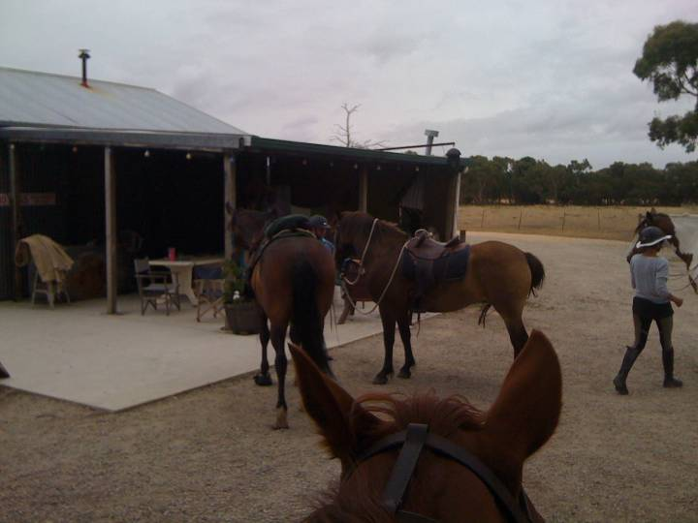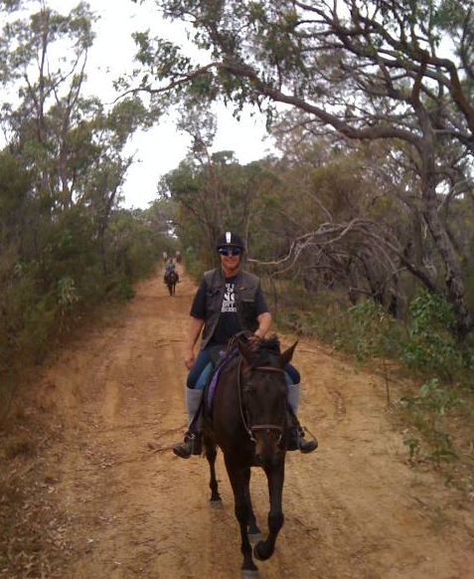
Getting ready to ride out Jane on Benny
Membership

Don’t forget memberships are now overdue. The membership fees for 2013 are:
Adult: $80 Social (non rider): $40
Under 18: $55 Associate: $30

Membership can be paid by cheque or bank deposit:

Smythesdale and District Trail Riders Club
BSB: 083532 Account: 650997455

Alternately cash can be paid on the next ride.
Please note that membership must be paid before you can join us on a ride in 2013
25 Mile Ride

Preparations have started for our annual event. I will be sending out entry forms and information flyers soon. Feel free to pass the information on to friends, family and horsey acquaintances. If you are able to place flyers at your local feed store/saddlery please let me know and I’ll send some to you. We will be holding an auction at the Sunday night dinner to raise money for the club. Let me know if you have anything you would like to donate. It doesn’t have to be new or horsey. It may be a great way to find a home for that unwanted Christmas gift! We are also looking for volunteers to help out over the weekend.
The cost for the 25 Mile Ride this year will be $55 for all entrants. This will cover camping (Friday to Monday), 3 days riding and lunch and dinner on Sunday.

Ride Calender

Please contact the ride organiser to let them know your intention of attending a ride.
A lot of effort goes into running a ride and it is common courtesy to give as much notice as you possibly can. It makes it very difficult to finalise arrangements when you’re not sure how many are coming.

Date | Location | Details | Cost | Ride Organiser
9th and 10th February | Lake Bolac Reserve | Camping beside the lake. Showers and Toilets available.  Medium paced ride over flat farm land. Bring your bathers and a fishing rod! | $15 per night per campsite (up to 3 Adults) | Raelene Green  (Tania Graham)
2nd-4th Feb | Snake Island | Riding from Welshpool across to Snake Island, staying two nights and riding back again. Further details available on request  THIS RIDE IS BOOKED OUT | $250 includes all meals and horse feed | Fred Rouse. (contact Tania Graham for further details. Enquiries taken for next year)
8th-11th March | Smythesdale Gardens | 25 Mile Ride
22nd March- 6th April | Hinomunjie High Country Ride | Riding starts from Cobrungra River near Mount Hotham. Riding across the Bogong High Plains to Benambra then on to Corryong via Tom Groggin Station.  THIS RIDE IS BOOKED OUT | $1150  includes all meals and horse feed | Fred Rouse.
13th-21st April | ‘Ranga’s Run’ Garibaldi to Smythesdale | Please see attached flyer for details. Expressions of interest need to be received by 30th January 2013. Please note this is an invitation only ride as places are limited. All Smythesdale members are invited to attend. | TBA | Wendy Hocking  0438 428863  Fiona Clark  0408 986112
April Club Ride | TBA | TBA

Tania Graham
taniagraham347@hotmail.com.au 0413304490

