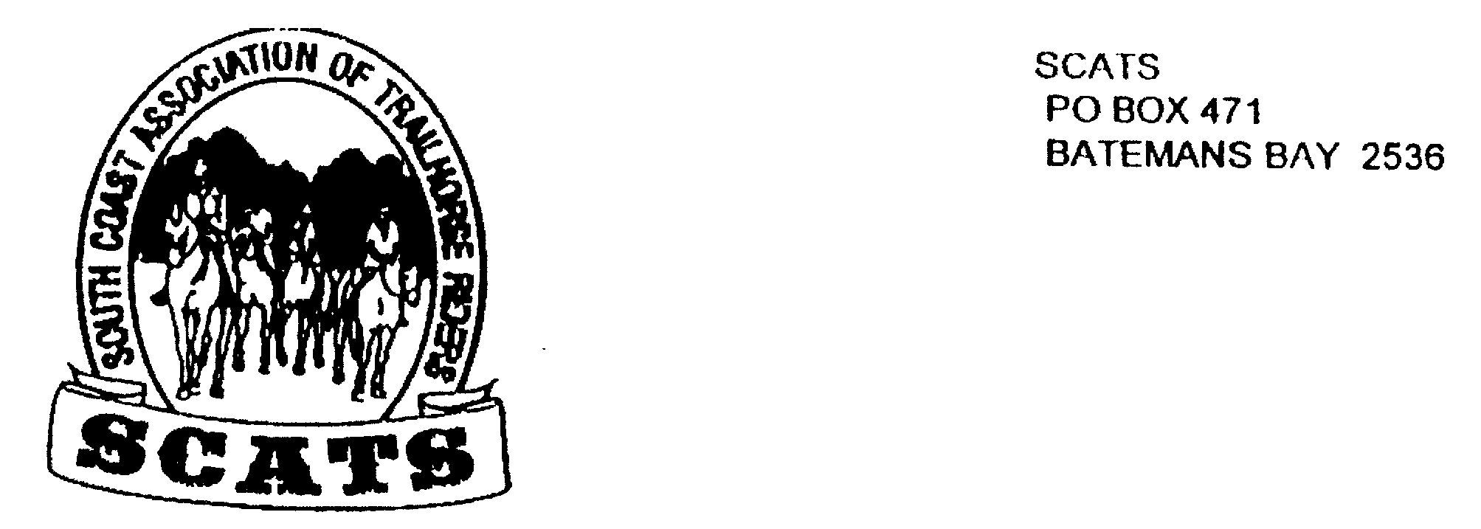
SCATS
PO Box 316
MORUYA NSW 2537
SCATS CHATS

Newsletter of the South Coast Association of Trail Horse Riders Inc.
February 2013

PRESIDENT: Kate Abel 0412 115 068
VICE PRESIDENT: Debbie Reid
SECRETARY: Bronwyn Ludlow 4474 4291/0428 130 744
TREASURER: Terry Love 4472 3219
RIDE SECRETARY: Karen Scott 0428643133
TRAIL BOSS: John Davidge 0410 204 123
PUBLICITY OFFICER: Sylvia Sharpe 44743427/Rosemary Bunn 0418483244

Welcome to 2013 – I hope everyone has enjoyed the Christmas and New Year Festivities and maybe even a few rides. ☺☺☺☺

I hope everyone is keen for a year of riding and socializing as we are hoping for a busy Ride Calendar this year, with the possibility of being able to enjoy some new areas and tracks.

Our Annual General Meeting is to be held prior to the February meeting – please see time and venue details at the end of the Newsletter

Firstly here are a couple of reports to finish off 2012:-

RIDE REPORTS

Race Course Ride – 2nd December 2012

The day before had been incredibly hot and I had serious doubts that the ride would be held. However the next morning was cool and overcast, a big difference to the day before.

About 14 riders met at the Race Course for a morning ride. Led by Tammie we rode though the bush behind the race course and speedway and looped back around towards the end of Malabar Drive. At one point we were quite high and we stopped to take in an amazing view over the township of Moruya and the River.

We continued bush bashing until we reached a lovely trail that led us back to the Race Course via a Lagoon and wet lands.

On arrival back at the Race Course we knew we were to have a sausage sizzle, but we were not quite sure exactly where it was to be held. We shouldn’t have worried! Tammie had stopped at her house, sorted out her horse and was back with the Ute, BBQ and all.

With Harold helping with the cooking it wasn’t long before we had enjoyed sausage sandwiches, kebabs and salad and a cuppa or cool drink.

Most of the riders were happy to call it a day or had other pre-Christmas functions to attend but I believe Harold and Leonie stayed on for a lap up the beach and back.

Thanks to Tammie for leading the ride and arranging the food and to all the assistant chefs who helped with lunch.

Christmas Party 2012 – Majors Creek Pub – 15th- 16th December 2012

About 20 people - members, friends and partners, made the trip up the hill to Majors Creek for the Club Christmas Party.

Arriving through the afternoon, everyone eventually congregated on the Pub verandah after having organised their various sleeping arrangements. Some brought tents, some just swags whilst others decided to opt for the comparative luxury of the rooms or converted train sleeping compartments.

A few drinks were enjoyed on the verandah before we headed into dinner. The main meal was roast pork or pork belly (yum!) with roast veggies and there was a selection of deserts for later on.

After dinner, Kate had some rather naughty games for everyone to play, which created plenty of laughter and silliness. Later, there was dancing by the jute box where we shared the dancing space with some of the locals.

As the night wore on, everyone gradually retired to their assortment of sleeping arrangements, after having had a great time.

The next morning we all arose, shook off the cobwebs and headed inside for a coffee or cup of tea before a wonderful recovery brekkie of bacon, eggs, toast, mushrooms and tomato.

After breakfast it was time to wish everyone a Merry Christmas and head off home.

ATHRA WEB SITE

ATHRA have announced that their new Web Site will go LIVE on 5th February 2013. Information in relation to accessing and updating each Club’s Web Page is to be distributed to Secretaries shortly.

FUTURE RIDES

Snowy Mountains Ride – from 21st February 2013 (proposed start date)

A final decision is still to be made but it is felt that the best venue will be Old Camp. Don’t worry about directions, these can be provided at a later date.

If you are interested in joining in for the Snowy Mountains to Ride please contact Karen to let her know by 8th February (next Friday). A brief email regarding this has already been sent to all members.
Karen's Mobile No. is 0428 643 133.
Once the numbers are known, decisions can be made regarding organisation of meals, roster, equipment to be taken etc.

As this ride will be self- catered no Ride Fee will apply.
If felt necessary a mini meeting may be planned to discuss some of the above.
Access For All Ride –Wolla to Alpine – 9th – 10th March 2013

At this stage members have discussed participating in the ride to support Access For All - more information next meeting.

Anzac Weekend – 25th – 28th April 2013 – CLAIM THIS DATE!!!!

John has proposed a ride form Moruya to Bendethera – there will be more discussion next meeting but if you are interested please make sure this week end is left free!!!!

Birthdays

Happy Birthday for December, January and February - Jayne, Tammie, Barry and Jan

Apologies if I have forgotten anyone - we may not have your birthday recorded.☹

ANNUAL GENERAL MEETING – 20th FEBRUARY 2013

Venue – The Oaks Ranch, 238 Old Mossy Point Rd, Mossy Point

Meet at 6.00 pm for the AGM to be followed by the General Meeting. All Executive Positions will be declared vacant so please have a think and if you are interesting in a Club Position this is your opportunity!!!

See you there!!

