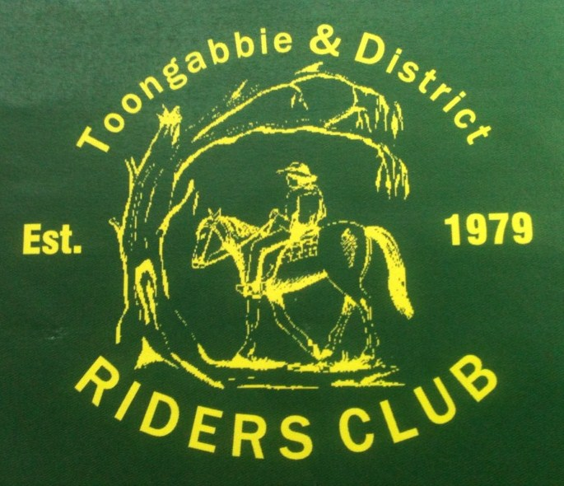
TOONGABBIE & DISTRICT RIDERS CLUB
FEBRUARY NEWSLETTER 2013
2013 Office bearers
President : Dave Smith
Ph 51489344

Vice President: Neil Price
Ph 51918255

Secretary: Fiona Henderson
Ph 0407814255

Treasurer: Christy Sheppard
Ph 0427 566 662

Publicity Officer: Fiona Henderson
Ph 0407814255

Club Rides – 1ST Sunday of the Month
MARCH RIDE WILL BE A 2 DAY CAMP AT WON WRON, NAPIERS ROAD. PROPERTY WILL BE OPEN FROM FRIDAY AFTERNOON, RIDING OUT BOTH DAYS FROM 9:30AM. BYO EVERYTHING – HORSE FENCING, CAMPING GEAR ETC. NO MEALS WILL BE SUPPLIED

Riders Club Meetings
They are held every Third Tuesday of the month from 7:30pm at the Recreation Reserve Rooms
All welcome and supper is provided
Next Meeting: Tuesday 19th March
Supper: Steve Coleman

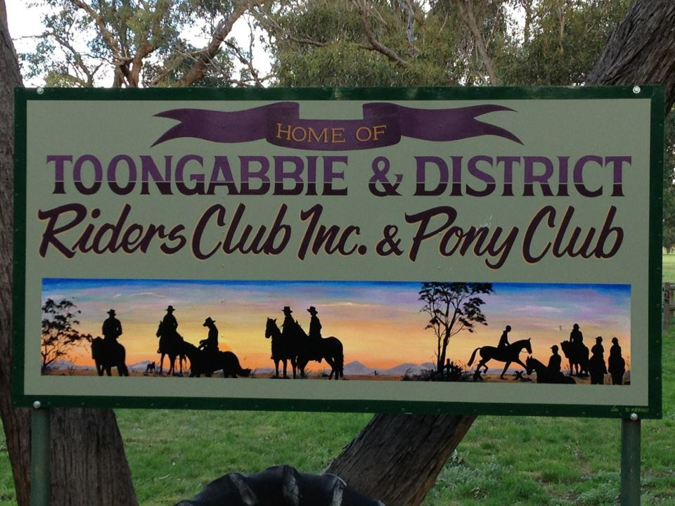

Club Merchandise – Available at each Monthly event
Hats $12
Stubby Holders $5

Vests – Can be ordered direct from Totally Workwear in Argyle Street, Traralgon
$35 adult reversible
$25 kids fleece






February Ride Report:
What a great ride we had led by Heidi at Leroy Traralgon South, the sun was out and looking forward to the ride.
A few campers got a surprise to be woken up by horse floats and with 24 riders you could imagine the crowd but they didn’t mind, we rode out with lots of conversation going around it was good.
With light drizzle rain here and there the smell of the forest was so refreshing with great views, all the horses behaved so well it was an enjoyable day for all. Coming to the end of the ride we couldn’t wait to get back as Macka was cooking up a storm for all of us with some help from Karen they did a fantastic job!!!! And scones oh my god they were good lol
Everyone kicking back reflecting on the day having a chat we held the raffle and it all came to an end was great to see so many faces attend.

Thanks to Glengarry Horse & Country Outfitters for donating a Gift Voucher and a big thanks to Jimmy & Karen Cant for helping plan the ride and donating some free range eggs.
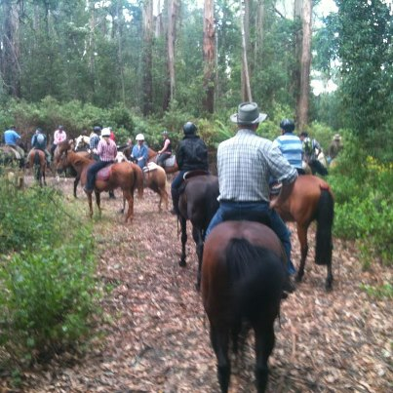

Andrew Hill Horsemanship Clinic wrap up:
Another successful weekend at Toongabbie’s 2 day clinic with Andrew Hill. 9 Club Members participated as well as some fence sitters, and I can assure you that they all walked away with new horsemanship skills and plenty of homework to do. A big thank you to Heidi Page for organising and look forward to the next clinic.
If you are interested in attending our next clinic, please contact Fiona so we can organise a date.
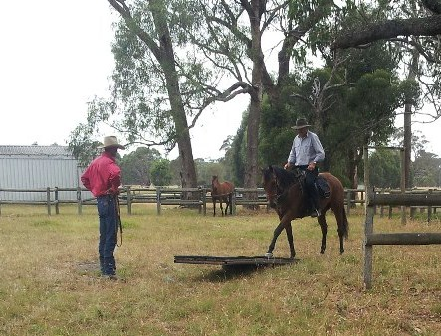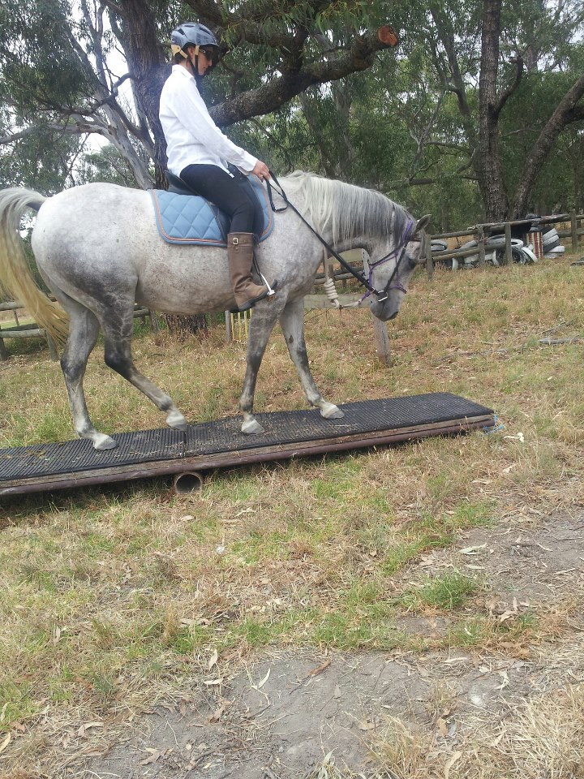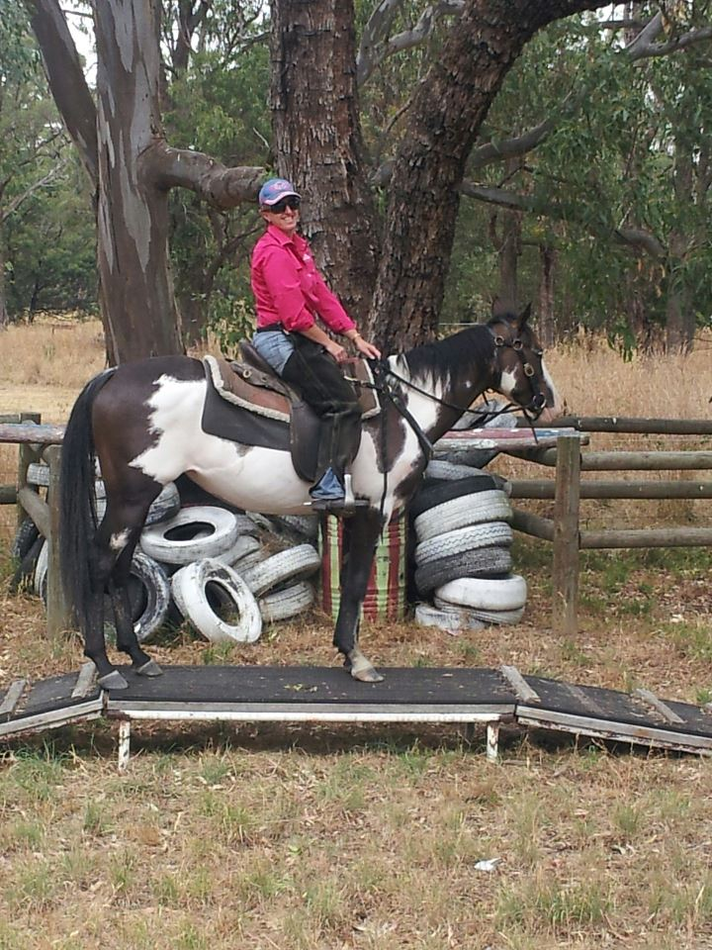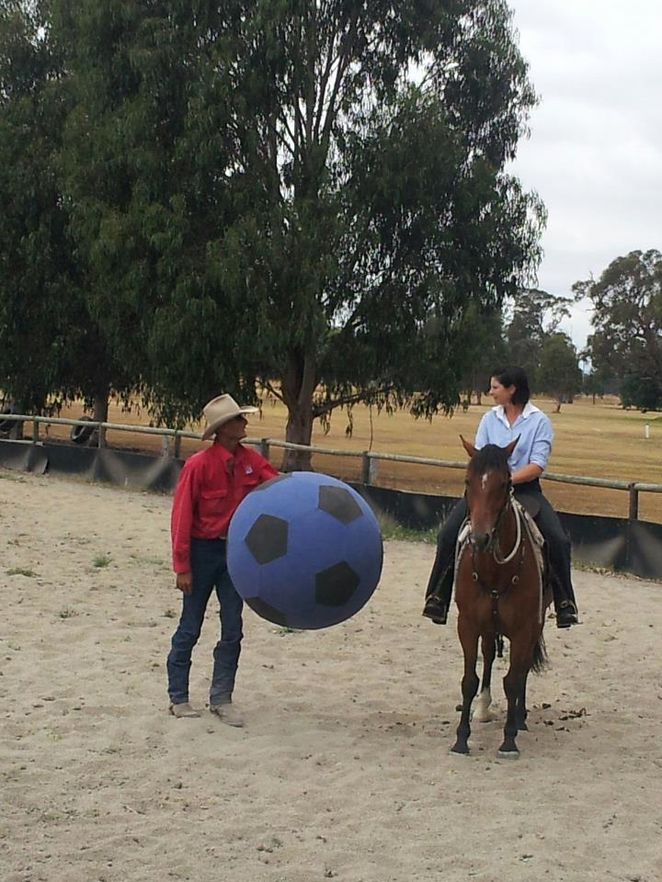
Club president Dave Smith Club member Belinda Paulet Club Member Heidi Page Club Secretary Fiona Henderson

March Camp 2nd & 3rd: March ride will be a 2 day camp over at Charlie & Robyn Jones property, Napier Road, Won Wron. Property will be open from Friday afternoon, please BYO horse fencing, camping and cooking gear, food etc. We will ride out both days from 9:30am. Saturday ride will be a full day, so please bring a pack lunch and Sunday will be a morning ride. Cost - $5 per head to cover use of shower & shed – Map attached
March 9th & 10th : Willow Grove Trail Riding Club presents the Port Albert to Rosedale heritage packhorse ride. To register please contact Sue Jordon on 0429 331 202 – Flyer Attached
Fire recovery clean up: As you are aware, Heyfield and surrounding towns have recently been affected with bush fires. Steve & Ann Maree Coleman and a handful of club members assisted the Gilders property by putting together a new stock yard/wing area on the weekend. Thanks to the members that attended and I’m sure the Gilders family were very appreciative.
Wanted to buy: Belinda Ludlow is looking for a quite gelding between 14h - 15h that she can trail ride and take her daughter riding. Needs to easy to handle, shoe, float etc. and suitable for someone who is getting back into riding.
(would not matter if the horse was over 10 years old).
If you know of such a horse that is for sale please give Belinda a ring on 0409 760703 or 51760703
can email brendon@australianpaper.com.au


FUTURE EVENTS CALENDAR
March 2nd & 3rd – Overnight camp at Won Wron, Charlie & Robyn Jones property, Napier road, our signage will be up from Friday afternoon – members only camp. BYO horse fencing, feed, camping gear, everything. You are welcome to arrive Friday afternoon, riding out both days from 9:30am. Please bring $5 per head to cover the powered shed and shower costs.
March 9th & 10th – Annual packhorse heritage ride from Port Albert to Rosedale
March 19th - Club meeting at 7:30pm from Toongabbie Recreation Reserve
April 7th – Seaspray – Dawn Gillies to lead – Dave & Vicki to tow chuck wagon
April 16th - Club meeting at 7:30pm from Toongabbie Recreation Reserve
May 5th – Gormandale Area – Carly Lansdown to lead – Lisa Paige & Kristy Mackin to tow
May 21st - Club meeting at 7:30pm from Toongabbie Recreation Reserve
May 25th & 26th – combined ride camp at Nyora – tractor rally site
June 2nd – Toongabbie Area
June 18th - Club meeting at 7:30pm from Toongabbie Recreation Reserve
July 7th – Boolarra Area – Pub Ride
July 16th - Club meeting at 7:30pm from Toongabbie Recreation Reserve
August 4th – Willung Area – Possibly Steve Coleman to organise – Jason & Rhonda to tow
August 20th - Club meeting at 7:30pm from Toongabbie Recreation Reserve
September 1st – Coongulla – Lisa Page to lead – Janette Crutchfield to tow
September 17th - Club meeting at Toongabbie Recreation Reserve
October 6th – Tyers area – Neil Price to lead – Christy Sheppard & Troy to tow
October 15th - Club meeting at 7:30pm from Toongabbie Recreation Reserve
November 2nd & 3rd – Overnight camp – To be advised
November 17th – Annual Novelty Day
November 19th - AGM & Club meeting at Toongabbie Recreation Reserve
December 1st – Xmas break up at Toongabbie
GENERAL CLUB INFORMATION
- Only one ride can be attended before insurance and membership must be paid
- Ride out starting time is 9.30 am. Lunch may be at starting point or at another point to be advised.
- Ride fee is $6 adult member and free child member under 16. All Non Toongabbie members $10 Chuck wagon is attended by volunteers and a fuel rebate of $50 is paid by the club as well as ride fee wavered.
- Lead riders get their ride fee wavered or $10 subsidized for a bought lunch (eg pub lunch)
- A Chuck Wagon roster will be coming out in January’s newsletter, please advise us if there is a particular ride you’d prefer to tow and cook.
- All Cakes, Slices etc are all gratefully received on rides to share, which is in addition to payment of ride fee.
- All riders are asked to be respectful of other riders on the trail ride and give everyone space. NO FAST RIDING PAST OTHER RIDERS.
- Newsletters are written by Fiona Henderson if you would like yours emailed instead of posted contact Fiona on fionah@team.aceradio.com.au or 0407 814 255
- All newsletters are posted on ATHRA Website go to ATHRA then Victorian Clubs then scroll down to Toongabbie.

