
June Newsletter 2013

May Ride Report
We saw quite a few new faces at Winslow last weekend. There was a last minute change in venue as the Woolsthorpe reserve was unavailable due to the club rooms flooding. Winslow Pony Club proved to be a great alternative with 26 horses, 6 carts (and 1 bike!) heading out on Saturday morning. Billy led the way with Maggie in harness, meandering through country roads in the area. Kim provided us with some delicious soup at lunchtime. With a choice of pumpkin or bacon and veggie, many of us couldn’t resist trying a little bit of both!
We had a great night at the Woolsthorpe pub with live entertainment form a local band- The Wild Roomers. They were rapt to see so many of us get up and dance while dragging some of the locals onto the floor as well.
Thanks Billy for a great weekend- we should head your way more often.

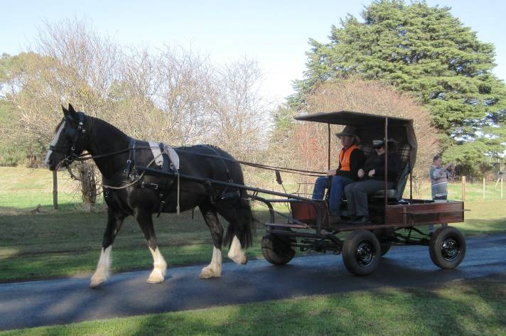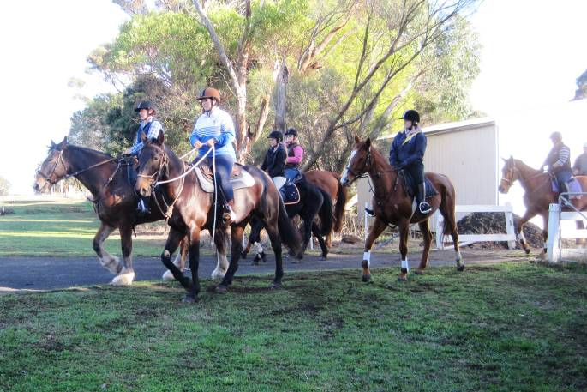
Maggie pulling her new cart while Billy gives Jane Riders heading out
a driving lesson

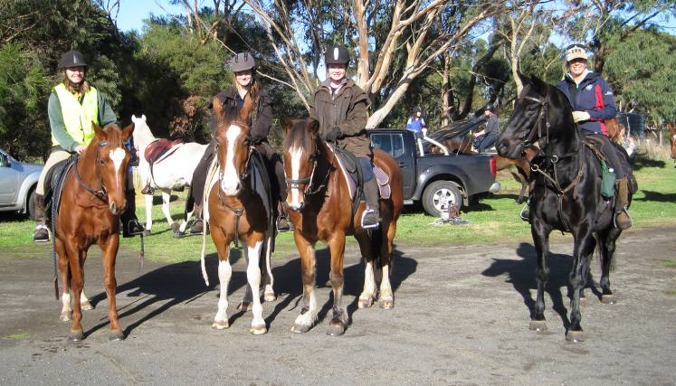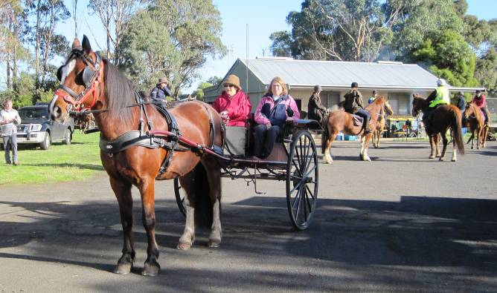
Kim, Trina, Ness and Cheryl Helen joining Sylvia for the ride

June
It has been decided not to hold a ride in June. I have listed other rides being held by other clubs and you would be more than welcome to join in.
July- ‘Horsless Event’ – Saturday 13th
Although we have dropped our ‘S’ them for our horseless ride, we will be doing something ‘Spooky’! Meeting at the Smythesdale Gardens, we will be herded onto a bus and head for the Aradale Asylum for a Ghost tour (considering that we are all horse crazy, maybe that’s where we should be anyway!). We will stop at Beaufort for dinner. Warm clothing is a must considering the time of year and some of the tour is outside.

The cost will be $30 per person plus your meal at the pub ($17). The pub has provided us with a set menu so they can have it ready when we arrive. You can choose between Fish and Chips, Chicken Schnitzel or Roast Lamb. All served with vegies or salad. Please let me know when you book.
Places are limited to 50 so book early and pay your $10 deposit to secure your spot. The tour is not suitable for children under 8 and parental discretion is advised.

Aradale Ghost Tour- Ararat Lunatic Aslyum
$30 per person ($10 deposit required before June 19th)

4.30pm Bus Leaves Smythesdale Gardens (Do Not Be Late!).
5.30pm Dinner at Beaufort Pub (set menu- $17 per person)
7 pm Back on the Bus
8pm Tour begins (approx 2 hours)
11.30pm Bus returns to Smythesdale (approx)

Camping is available at Smythesdale Gardens and I’m sure there will be a story or two around the campfire when we return!

For those with internet access they have a website- http://www.aradaleghosttours.com.au/ and a page on facebook

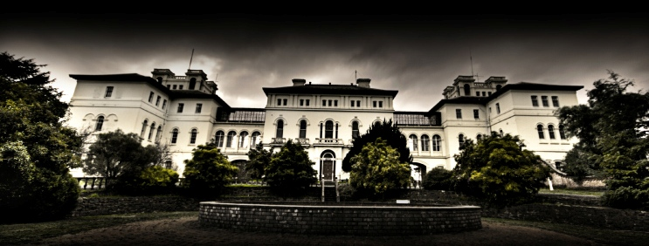
AGM – August 10th
Although it is still a few months away, our AGM is coming up. Billy has been in his role for 3 continuous years and it is time for him to step down. To spread the workload I would like to split the secretary/treasurer’s role, which means all committee positions will be available. Please think about nominating yourself for a role. Most of our rides are organised by club members so there really isn’t that much to do. If you would like further information, please contact Billy or myself. I will include a brief description of each position in next months’ newsletter.
After a casserole dinner (everyone brings a dish to share), we will be holding one of our famous auctions. As the club is quite financial, the money raised will go towards ‘The Ride to Conquer Cancer’, a charity bike ride raising funds for cancer research at Peter MacCallum Cancer Centre. If you have any items you would like to donate to the auction, they would be greatly appreciated. It doesn’t have to be new or horsey and if you can’t make it to the AGM weekend please let me know and I’ll arrange someone to come and pick the items up.
Horse for Sale
Harvey- 15.3h, 12 yrs old.
Great for a lady who wants a quiet trail horse. Easy to float, shoe, catch.. everything.. Has been on Smythesdale rides in the past. He is very sweet natured and would suit a beginner . He can be a little slow, especially for a TB. Is use to yards and hobbles. Not really suited to jumping, however has done some dressage days. Selling as unfortunately don’t have the room to keep him. Asking $3000.. Must go to a good home. Please phone Sharon Thompson- 0407360377.
Ride Calender

Please contact the ride organiser to let them know your intention of attending a ride. A lot of effort goes into running a ride and it is common courtesy to give as much notice as you possibly can. It makes it very difficult to finalise arrangements when you’re not sure how many are coming.

Date | Location | Details | Cost | Ride Organiser
15th and 16th June | Balmoral | Casterton Trail Riders. Camping along the Glenelg River. For further details please Contact Bill or Brenda Bath 0355701327 |  | Contact Bill or Brenda Bath 0355701327
22nd and 23rd June | Raglan | Mt Cole Trail Riders are hosting an accreditation weekend. Cost includes lunch both days and Dinner Sat night. Further details on ATHRA website.  If interested please contact Cecilia | $60 (includes meals and camping) | Cecilia Myers 0410563008
Sunday 23rd June | Jancourt | Warrnambool Trail riders. Day ride in the Jancourt Forrest. Very pretty area. Please contact Ruby or Eva. Register by Wed 19th June |  | Ruby King 0447565300  Eva Vella 0407816352
Sat  13th July | Smythesdale Gardens | Our ‘Mystery Bus Trip’ will be taking us on a ghost tour of the Aradale Asylum near Ararat. A bus will be leaving the gardens at 4.30pm, stopping at Beaufort for dinner along the way. Camping at the grounds will be available. We did decide to drop the ‘S’ theme but feel free to wear or bring something ‘spooky’! Must book by Wed 19th June | Ghost Tour: $30 per person.  Pub Meal: $17 (set menu). | Tania Graham 0413304490  Kim Chant  0429194274 52334558  Billy Gapes 0427692238 55692238
9th- 11th August | Smythesdale Gardens | Annual dinner and AGM. We will ride both days and have a casserole dinner and auction on the Saturday. Please bring a dish to share (doesn’t have to be a casserole, can be a dessert) and something for the auction if you can.
September | TBA | Options include: Firth Park (near Trentham), Carlisle River, Barongarook,
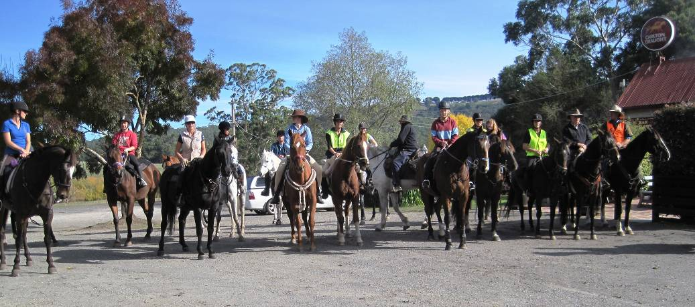
April 2013- Gellibrand Pub.

