
April/May Newsletter 2013

April Ride Report
I’m pretty sure this was our first ride at Gellibrand where it didn’t rain! Riding the 4 wheeler, Doreen led us through the back roads of Gelli where we saw some beautiful (and some interesting) properties. We stopped at the site of the old Birnam Station for lunch then headed down the Beechy Rail Trail back to camp. The night stayed warm and we made use of the beer garden until well after midnight. On Sunday, Tara lead the group through some great sandy tracks for a few hours. Upon returning, we held our monthly meeting while eating chips and gravy!
(Sorry- no photo’s as I left my camera in the back of Mick’s ute!)

In Memory

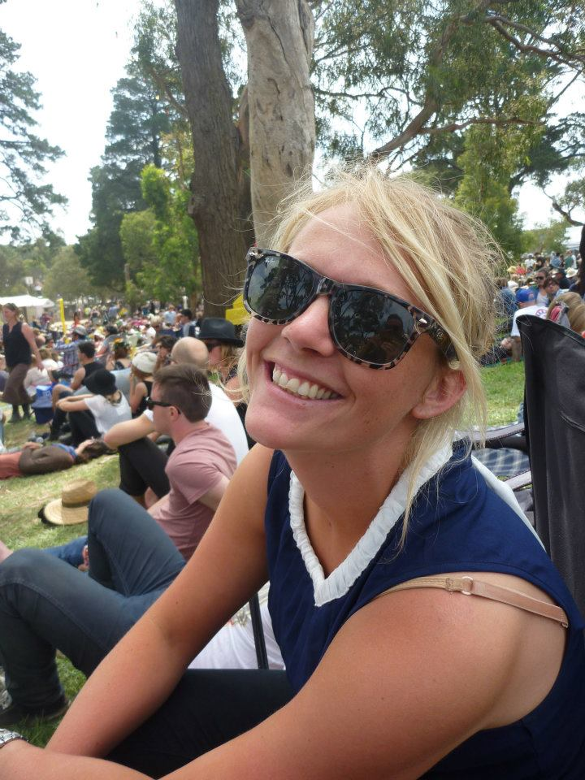
Many of us were saddened to hear the news that Rebecca Lang had passed away after a 6 month battle with cancer. Bec will be remembered as a beautiful young women who left an impression on everyone she met. It was quite clear at Becs funeral that she had touched the lives of many and had achieved so much in a life that ended far too soon.
Our thoughts are with Christy and her family through this difficult time.

Ranga’s Run
Fiona and Wendy did a fantastic job organising this 8 day ride around the Smythesdale region. It was great to catch up with some interstate friends I haven’t seen for a while. It was also good to see quite a few Smythesdale members join in, even if it was only for a day or two. Camped at Smythesdale for the last few nights, we all hitched a ride across to the Rec Hall for our ‘Red’ themed farewell dinner. Thanks to the ladies who went ‘Op shopping’ on the Thursday and managed to buy every second hand red dress in ballarat! There were some brilliant hair styles on display too!
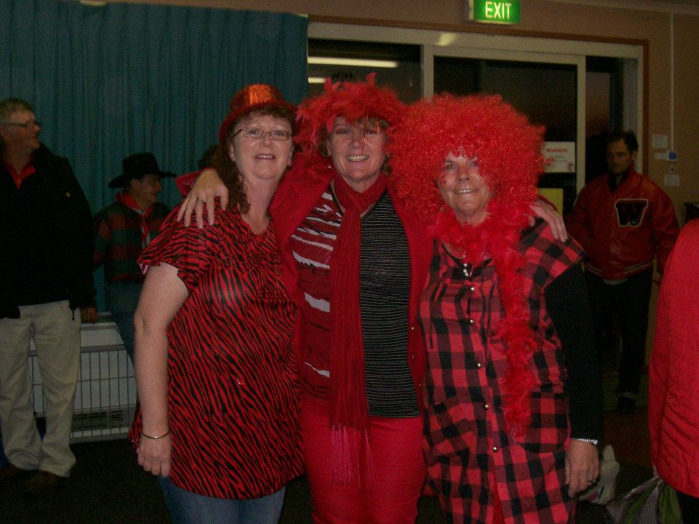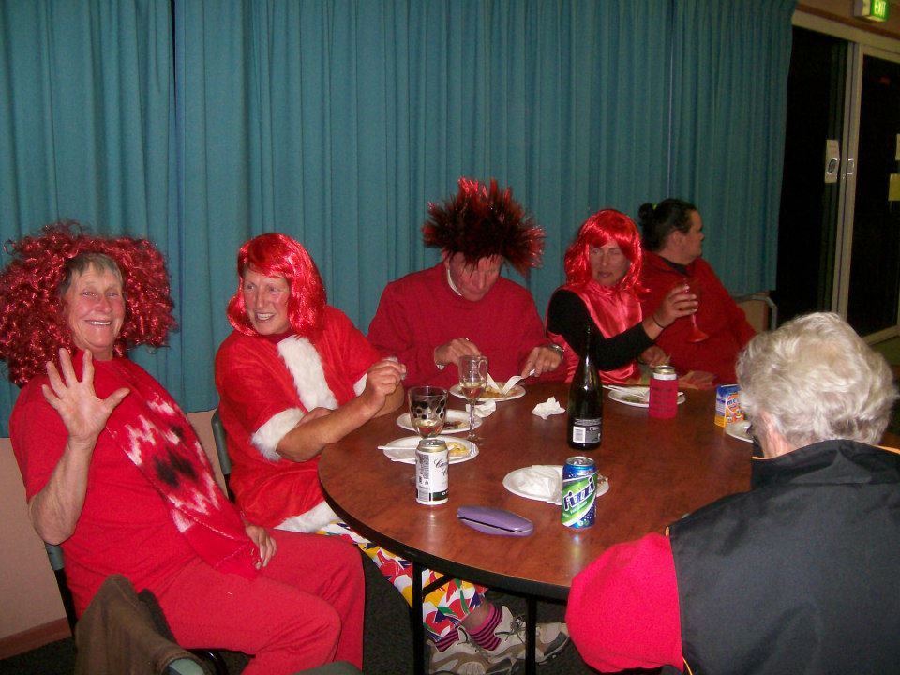
(I had to ‘steal’ these photo’s off facebook, as mine are in the back of Micks ute!)
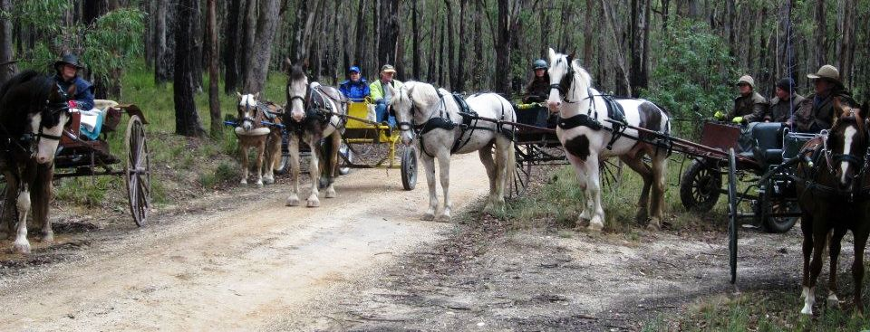

May Ride- Friday 24th to Sunday 26th

This will be a joint ride with the Lakes and Craters Harness Club. We will be camping at the Woolsthorpe Reserve (Wickham St, Woolsthorpe) where kitchen facilities and toilets are available (sorry- no showers).
Fees to be $5 per person per night.
Saturday muster is at 9.30am with ride out at 10am. Approx 25km, medium pace. BYO Saddle bag lunch.
Sunday’s ride will be approximately 15km, riding out approx 10am- depending on how many sore heads we have!
Please contact Billy if you intend to ride on 0355692238 or 0427692238.

We will be having tea at the Woolsthorpe pub on Saturday night. This is a small country pub and we need to know numbers by Friday, 17th May. Those that don’t book may miss out on a meal.
It is guaranteed to be a great night with live entertainment.

Ride Calender

Please contact the ride organiser to let them know your intention of attending a ride. A lot of effort goes into running a ride and it is common courtesy to give as much notice as you possibly can. It makes it very difficult to finalise arrangements when you’re not sure how many are coming.

Date | Location | Details | Cost | Ride Organiser
24th-26th May | Woolsthorpe  Reserve | Joint ride with Lakes and Craters Harness Club. Camping at Woolsthorpe Reserve. Kitchen facilities available. (no showers) Tea at Woolsthorpe Pub Saturday night. | TBA | Billy Gapes  55692238  0427692238
29th June | Smythesdale Gardens | Mystery Bus Trip! This will be our annual horseless event. Camping at the grounds will be available. The bus will leave at 5pm and visit various pubs. Theme will be ‘something beginning with S’! | Club will pay the bus hire. Meals/Drinks are at pub prices. | Tania Graham 0413304490  Kim Chant  0429194274  0352334558
9th- 11th August | Smythesdale Gardens | Our Annual dinner and AGM. We will ride both days and have a casserole night on the Saturday. Everyone needs to bring a dish to share (doesn’t have to be a casserole)

Tania Graham Bill Gapes
0413304490 0427692238

