
March Newsletter 2013

25 Mile Ride

Our 25 Mile ride was a huge success. A big thankyou goes to all those who helped out for the weekend, especially Joan and her helpers from Port Fairy who drove down just to help with the catering!
Although the weather was quite warm, it didn’t deter the 46 riders from mounting their steeds and heading into the bush. By lunchtime the temperature had climbed to 32 degrees and the Snake Valley Pub was looking very inviting!
It was a dilemma choosing what to do first- quench the thirst with a drink from the bar or dull those hunger pains with a fresh salad roll and cake! In the end we all achieved both and clambered up onto our horses to head back to camp. The brief shower on the way home was appreciated but not as much as the water fights and showers once the horses had been washed and fed. Approximately 80 people sat down to a delicious spit roast dinner followed by pav, fruit salad and cheesecake for dessert. We then got down to the serious stuff as Gary and Billy did their best to get the highest prices at our auction.
All in all a very triumphant weekend with $2600 raised for the club.

I have attached a sample of photo’s from the weekend. CD’s are available at $5 each. If anyone has any photo’s they would like to share, please let me know and I will add them to the CD. I need these by April 8th si I can have the CD’s ready at Gellibrand.

April Ride 26th-28th.

This ride has been on our calender for the past few years now. Once again we will be camping outside the Gellibrand Pub. There is a paddock for the horses but please bring some fencing so it can be sectioned off. Camping fees are $10 per night which includes use of the showers. Ride out will be 10am with a 9.30am muster on both Saturday and Sunday. Please bring your own saddlebag lunch for Saturday’s ride which will be approx 4-5hrs. Sunday will be a little shorter at 2hrs.
Be prepared for wet weather as it rains approx 360 days a year at Gelli!
The pub puts on a great feed and is also a cosy place to hang out after a days ride.
Please let me know if you intend on coming either by phone or email.
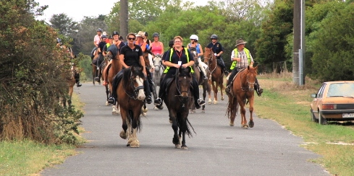
Heather and Sam leading the way

Ride Calender

Please contact the ride organiser to let them know your intention of attending a ride. A lot of effort goes into running a ride and it is common courtesy to give as much notice as you possibly can. It makes it very difficult to finalise arrangements when you’re not sure how many are coming.

Date | Location | Details | Cost | Ride Organiser
22nd March- 6th April | Hinomunjie High Country Ride | Sorry- Booked Out |  | Fred Rouse.
13th-21st April | ‘Ranga’s Run’ Garibaldi to Smythesdale | Please note this is an invitation only ride as places are limited. All Smythesdale members are invited to attend. | TBA | Wendy Hocking  0438 428863  Fiona Clark  0408 986112
26th-28th  April | Gellibrand | Camping at Gellibrand Pub. Riding through the beautiful Otway Forest. Showers available. | Approx $5-$10 per night | Doreen Johnstone/ Tania Graham
24th-26th May | Woolsthorpe | Joint ride with Lakes and Craters Harness Club. Camping at Woolsthorpe Reserve. Kitchen facilities available. (no showers) Tea at Woolsthorpe Pub Saturday night. | TBA | Bill Gapes  55692238  0427692238
June | TBA | This is usually held on the long weekend. Options include Glendhu Station, Mt Cole.  If anyone has any other suggestions please let me know as we will vote at our April ride (if you can’t attend please let me know your preference).
July | TBA | Our traditional horseless gathering. Suggestions so far include  Werribee Park (can go to the zoo/mansion),  Mystery bus trip/pub crawl (it has been a few years since we harassed a bus driver!)  Kryal Castle (could even stay the night)  Open to other suggestions.

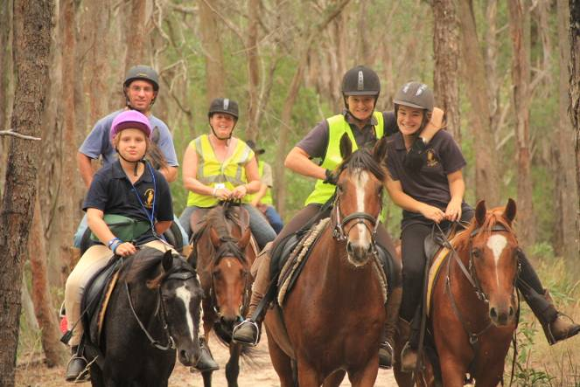
Kim and Ness with Joan, Brendan and Sophie from Port Fairy

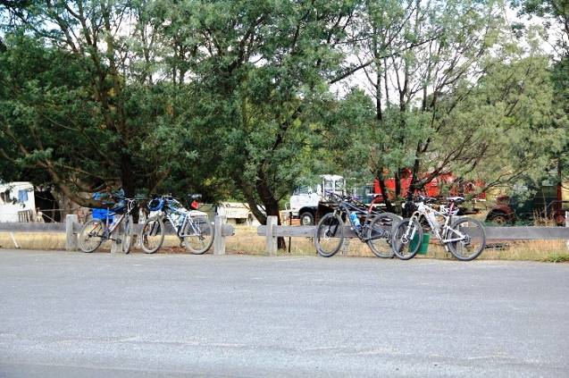
These kicking steeds had to be tied up separately!

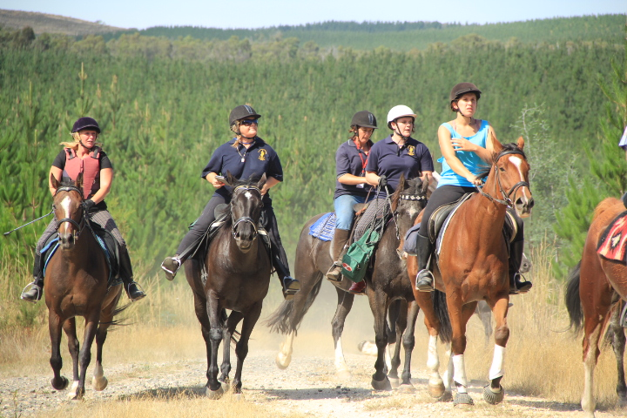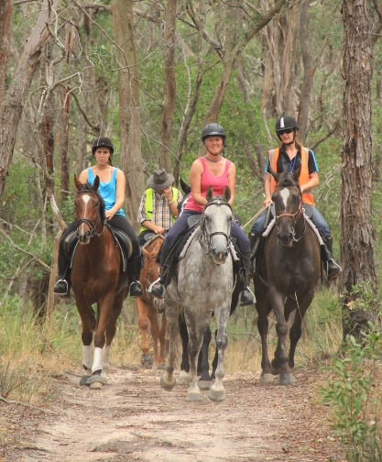
Riding through the pines John (behind) keeping the girls out of trouble

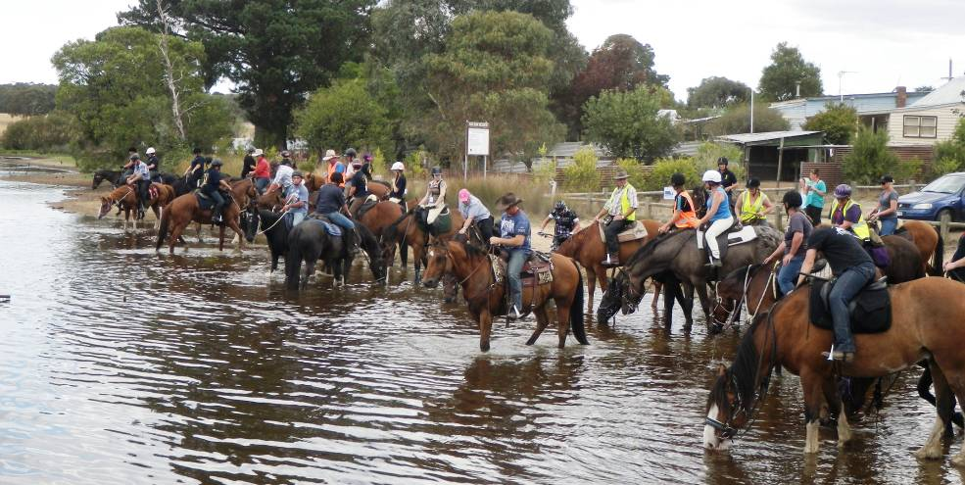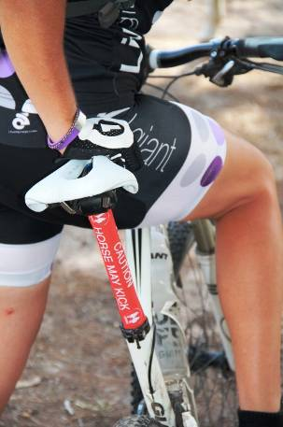
Horses cooling off after lunch Caution!

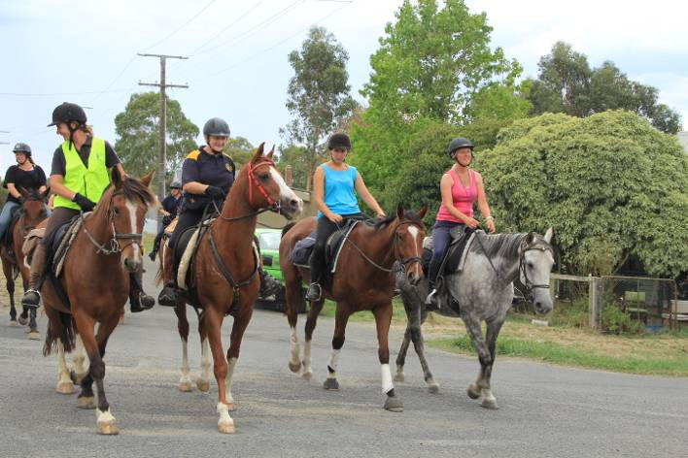
Riding through Snake Valley

