
July Newsletter 2013

July Ghost Tour
Much too many people’s disappointment no ghosts were sighted on our tour of Aradale, but we all had a fantastic time. There was a lot of chatter as we waited for the bus at Smythesdale- many of us hadn’t seen each other for months. Our driver, Kyle, gave us a run down on bus rules before herding us on and driving us safely to the Beaufort Pub. Our meals were eagerly devoured and washed down with a beverage or two (non-alcoholic of course!) We arrived at Aradale and were greeted by a few strange tour guides who quickly divided our group in two. The larger group headed off while our smaller group listened to some interesting facts about the asylum. Some of us were given torch duties and it wasn’t long before we stepped into the darkness. The old buildings hold many secrets and our tour guides were an encyclopaedia of knowledge as they answered our curious questions. The two hour tour went quickly as we scrambled up and down stairs, peered into abandoned rooms and visited the onsite morgue. I think even the ghosts were scared of us- the crazy horse group who were allowed to get back on the bus and leave the haunted asylum!

Doreen Johnstone
It is with deepest sadness that we announce the passing of our friend and riding companion Doreen Johnstone. Doreen lost her battle with cancer on Saturday 13th July 2013. She gave us the pleasure of riding from Gellibrand on more than one occasion. The lunches that, together with her family, she arranged were memorable.
Whenever Doreen came on a weekend ride she brought with her a smile and a sense of happiness. Her amazing strength has been an inspiration to us all. Even as her health was failing she put together one more ride. Despite not being well enough to be on a horse she led the ride on the four wheel motorbike and then found strength to join the riders for dinner. Our deepest sympathy goes to Ruffy, Tara and Kye.
Doreen we will all miss you.
“Love you long time, girlfriend”
(Written by Jeanette Welsh)
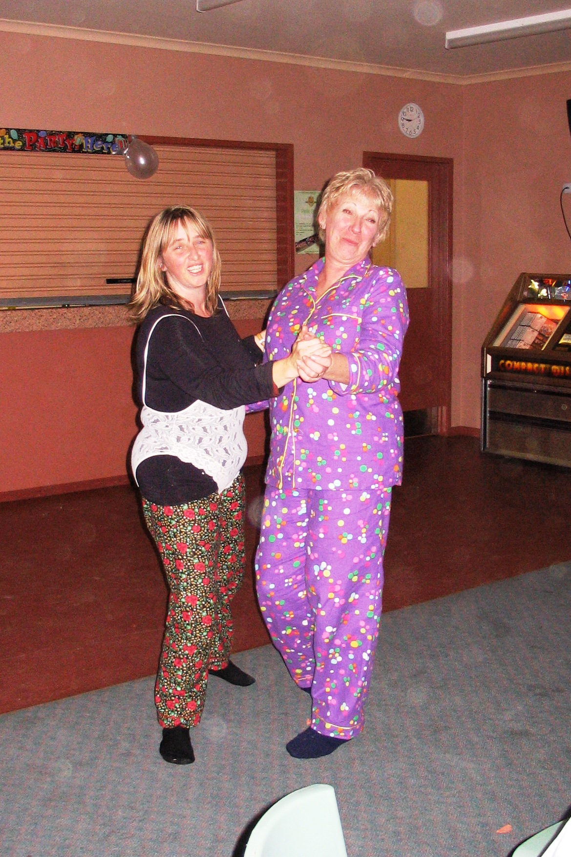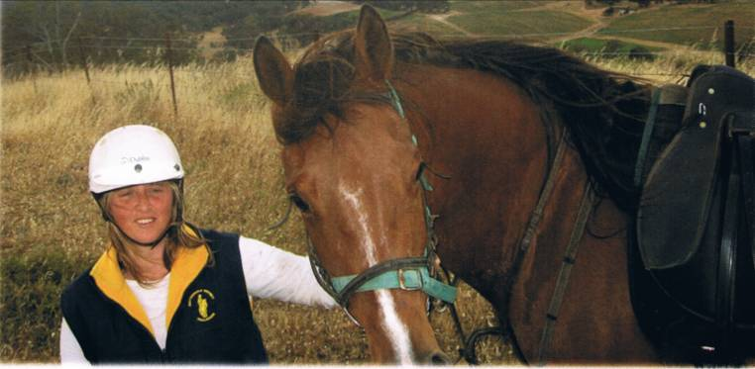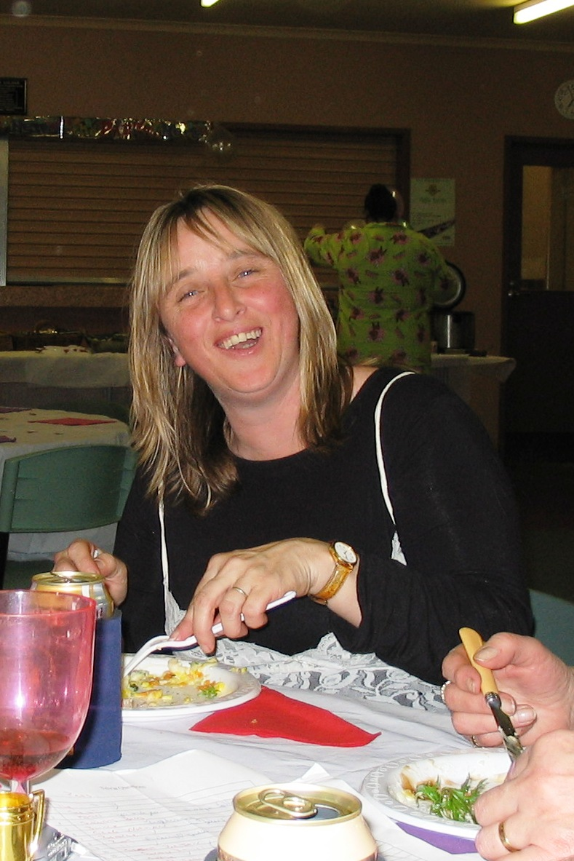

August- 10th and 11th- AGM

Our AGM ride will be held at Smythesdale Gardens on the second weekend in August. On Saturday we will ride for approx 10-15km before returning to camp for the meeting at 4pm.
Billy has been in his role for 3 continuous years and it is time for him to step down. To spread the workload I would like to split the secretary/treasurer’s role, which means all committee positions will be available. I would also like to suggest adding two new roles- a Newsletter coordinator and a Ride coordinator. This would share the workload between more people. Please think about nominating yourself for a role. Most of our rides are organised by club members so there really isn’t that much to do. If you would like further information, please contact Billy or myself.
After a casserole dinner (everyone brings a dish to share), we will be holding one of our famous auctions. As the club is quite financial, the money raised will go towards ‘The Ride to Conquer Cancer’, a charity bike ride raising funds for cancer research at Peter MacCallum Cancer Centre. If you have any items you would like to donate to the auction, they would be greatly appreciated. It doesn’t have to be new or horsey and if you can’t make it to the AGM weekend please let me know and I’ll arrange someone to come and pick the items up.

Ride Calender

Please contact the ride organiser to let them know your intention of attending a ride. A lot of effort goes into running a ride and it is common courtesy to give as much notice as you possibly can. It makes it very difficult to finalise arrangements when you’re not sure how many are coming.

Date | Location | Details | Cost | Ride Organiser
9th- 11th August | Smythesdale Gardens | Annual dinner and AGM. Casserole Dinner and Auction Sat night.  Saturday- ride out at 10am (muster at 9.30)  Please bring a dish to share (doesn’t have to be a casserole, can be a dessert) and something for the auction if you can. | Bring some money for the auction! | Tania Graham  0413304490
September | TBA | Options include: Carlisle River, Barongarook, Berringa
October | TBA | Possibly Raglan/Mt Cole area but details to be confirmed

Tania Graham 0413304490
Billy Gapes 0427692238

Committee Member Positions and Duties

President
The President is the principal leader of the club and has overall responsibility for the club’s administration. The President should help the committee prioritise its goals and then try to keep the committee on track by working within that overall framework.
At the operational level, a major function of the President is to facilitate effective management of committee meetings.
Basically you would give the ride talk at each ride muster and ensure the ride organiser has everything planned.

Secretary
The Secretary is responsible for the smooth running of the organisation. The main duties include maintaining club records and handling correspondence and other communications.
All I can say is Paperwork! Although, the ATHRA forms are pretty easy to fill out. The main duties include maintaining the list of club members, filing ride reports, sending forms to ATHRA (new members/visitors) and taking the minutes at the club meetings. It is an advantage to know a thing or two about computers but you don’t need to be an expert.

Treasurer
The treasurer ensures adequate accounts and records exist regarding the organisation’s financial transactions including accurate and up-to-date records of all income and expenditure
You don’t need to be an accountant for this role. You will need to record all money coming in and going out, write out any cheques required and provide a monthly report.

To share the work load and take the pressure off the secretary, I suggest we add two new roles-

Ride Coordinator
Ensure the monthly rides are organised. This would normally only require a few phone calls to the person hosting the monthly ride to ensure everything is on track. You would also be a contact person if anyone had any queries about a ride. May involve booking facilities/venues and applying for any permits required. Would also include filling out the pre and post ride reports and ensuring everyone signs the ride register.

Newsletter Coordinator- writing and sending out club newsletters. Info for these will be provided by the secretary and ride organiser. If members had something to add to the newsletter you would be the person to contact.

You don’t need to attend every club ride to be on the committee. Breaking up the secretary/treasurer into four separate roles would spread the work load and make it easier on each person. Don’t forget you can only be in the same role for a maximum of 3 years so you won’t be trapped with the job forever.

