
August Newsletter 2013

AGM- cancelled
What a shame we had to cancel our AGM, mainly due to a lack of response. I’d like to thank those who let me know if they could make it or not.
The weather didn’t look too promising leading into the weekend, so it was decided to cancel the ride too. This has been rescheduled for September as listed below.

September Ride- Smythesdale- 14th and 15th
Camping at Smythesdale Gardens (you are welcome to arrive Friday night)
Ride Muster at 9.30am with ride out at 10am (both Saturday and Sunday)
Rides will be medium pace (walk, trot and canter) through the undulating bush surrounding Smythesdale. Saturday’s ride will be approx 4-5 hours (bring your own lunch) and Sunday will be approx 2 hours.
We have rescheduled our AGM for 4pm on Saturday, with a charity Auction to be held in the evening after dinner.
This weekend is ‘cater for yourself’ but keep in mind BBQ and kitchen facilities are available.
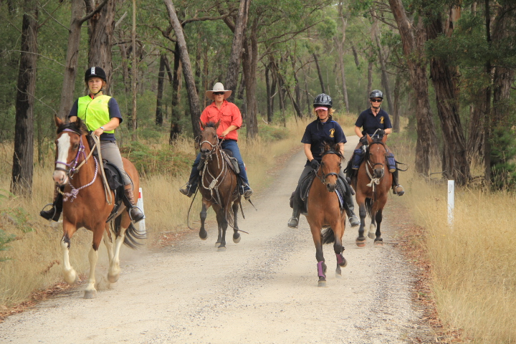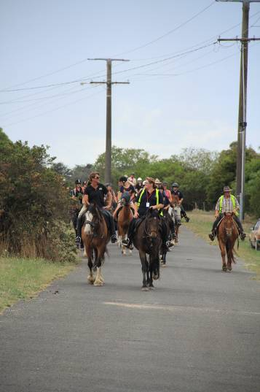

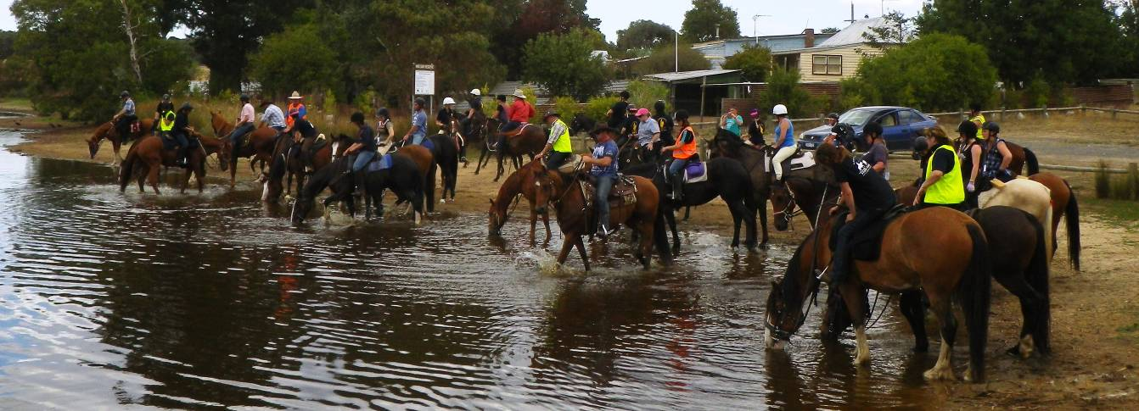

Smythesdale 25 Mile Ride 2013
Ride Calender

Please contact the ride organiser to let them know your intention of attending a ride. A lot of effort goes into running a ride and it is common courtesy to give as much notice as you possibly can. It makes it very difficult to finalise arrangements when you’re not sure how many are coming.

Date | Location | Details | Cost | Ride Organiser
7th-8th September | 76 Flemings Road, Grenville Vic (30min from Ballarat) | Grenville Endurance Ride (Non-ATHRA event)  Have a go at Endurance! Distances start at 5km.  Please see flyer for further details.  (Link is attached to Smythesdale’s facebook page) | See flyer. Starts at $20 | Janeen Smith 0407546995
14th-15th September | Smythesdale Gardens | Sat and Sun- muster at 9.30am, ride out 10am. Medium paced rides, Sat- 4-5hours, Sun-2hrs.  Take your own lunch on Saturday.  AGM- 4pm Saturday, followed be an auction to raise money for charity.  BYO weekend- bbq and kitchen facilities available. | Bring some money for the auction! | Tania Graham  0413304490
20th-29th September | Dunkeld to Moysten | Charity Ride- All Burnt out  8 days of riding in the Grampians area. Please contact Sue ASAP as registration closed on 15th August. | TBA (approx $100-$150) | Sue Pollock  suepols35@gmail.com
12th-13th October (TBC) | TBA | Possibly Carlisle River/ Raglans
18th-20th October | 500 Yambuna Bridge Road, Kotupna 3638  (near Echuca) | Wakiti Resort Trail Ride (non ATHRA weekend)  Entry includes all meals from Friday dinner to Sunday lunch plus entertainment Fri and Sat night  See attached Flyer for further details | $140 | 03 58673237 wakiticreekresort@activ8.net.au
15th-17th November | Forrest | ATHRA Regional Camp  Riding Saturday and Sunday, cost includes camping, meal Sat night plus entertainment and afternoon tea on both days.  Registration form needs to be returned by 1st Nov. | $60  (RSVP by 1st Nov) | Jo Simms 0417527789  Jennifer Vasilj 0433555134

Tania Graham 0413304490
Billy Gapes 0427692238

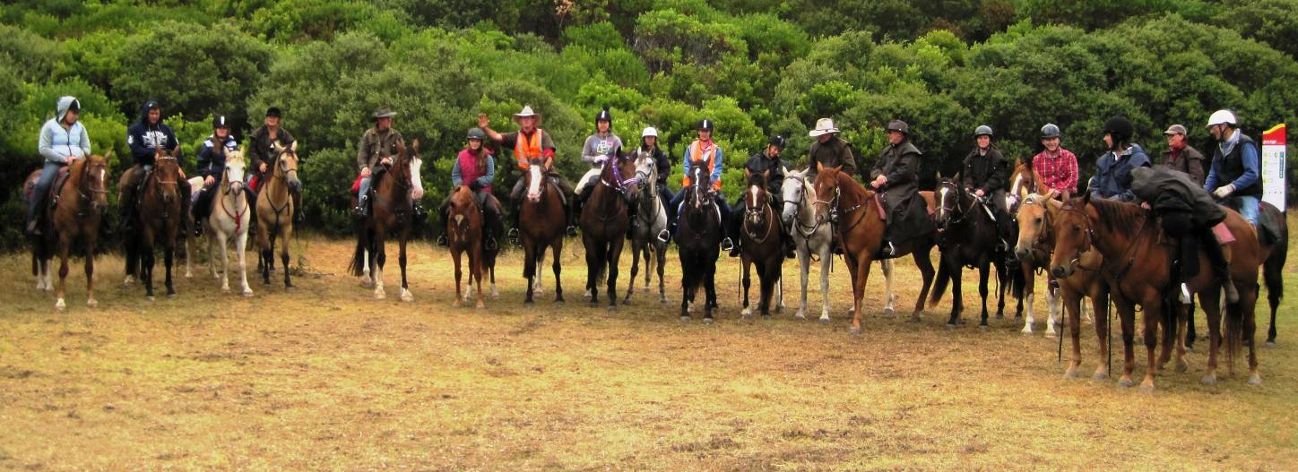
Killarney 2012
Committee Member Positions and Duties

President
The President is the principal leader of the club and has overall responsibility for the club’s administration. The President should help the committee prioritise its goals and then try to keep the committee on track by working within that overall framework.
At the operational level, a major function of the President is to facilitate effective management of committee meetings.
Basically you would give the ride talk at each ride muster and ensure the ride organiser has everything planned.

Secretary
The Secretary is responsible for the smooth running of the organisation. The main duties include maintaining club records and handling correspondence and other communications.
All I can say is Paperwork! Although, the ATHRA forms are pretty easy to fill out. The main duties include maintaining the list of club members, filing ride reports, sending forms to ATHRA (new members/visitors) and taking the minutes at the club meetings. It is an advantage to know a thing or two about computers but you don’t need to be an expert.

Treasurer
The treasurer ensures adequate accounts and records exist regarding the organisation’s financial transactions including accurate and up-to-date records of all income and expenditure
You don’t need to be an accountant for this role. You will need to record all money coming in and going out, write out any cheques required and provide a monthly report.

To share the work load and take the pressure off the secretary, I suggest we add two new roles-

Ride Coordinator
Ensure the monthly rides are organised. This would normally only require a few phone calls to the person hosting the monthly ride to ensure everything is on track. You would also be a contact person if anyone had any queries about a ride. May involve booking facilities/venues and applying for any permits required. Would also include filling out the pre and post ride reports and ensuring everyone signs the ride register.

Newsletter Coordinator- writing and sending out club newsletters. Info for these will be provided by the secretary and ride organiser. If members had something to add to the newsletter you would be the person to contact.

You don’t need to attend every club ride to be on the committee. Breaking up the secretary/treasurer into four separate roles would not only spread the work load but also make the these roles less daunting. Don’t forget you can only be in the same role for a maximum of 3 years so you won’t be trapped with the job forever. You also have the option of stepping down after 12 months at the next AGM.
Grenville Endurance Ride
September 7th & 8th 2013
76 Flemings Road, Grenville Vic.

We welcome and encourage all riders to come along and participate in our Introductory, Social & Training rides.

Saturday Events...
5 km introductory ride $10.00 Start time 2pm
20 km Social ride $20.00 Start time 2.30pm

A $10.00 (day membership) will apply to entry if non VERA (Victorian Endurance Riders Association) member. AHSA & PCAV members are exempt from day membership fee, membership confirmation required.
Awards for all completions along with best managed Pony Club mount in the 5km & 20km rides – Proudly Sponsored by Beaufort & District PC
Ride Entries & Pre Ride vetting for all rides Saturday 12pm – 5pm

Pre - Nominations by phone or email, a $10.00 surcharge will be applied to those who do not Pre – Nominate.

Sunday...
40km Endurance Ride $40.00 Start time daylight
80km Endurance Ride $80.00 Start time 6am

Pre-nomination by phone or email:
Janeen Smith Hans Peuker
0407546995 0408 532 907
03 53347054 03 5341 4525
taylors.glen@bigpond.com marybank@westnet.com.au

 https://www.facebook.com/#!/pages/Grenville-Endurance-Ride/221050178038568


“all burnt out”
CHARITY RIDE AND DRIVE
You are invited to the Grampians this spring to participate in a fund raising event for the new Victorian branch of the Royal Flying Doctor Society.
The ride/drive will be from 21st-29th September, travelling from Dunkeld to Moyston. Please note: this area of the beautiful Grampians was not affected by the fire last summer.

Please be aware:
- All riders, carriage drivers and carriage passengers must be ATHRA members
- Backup drivers are volunteers and do not need to be ATHRA members
- We will be camping in a bush camp (1 night),
on private properties (2x2 nights) and at Dunkeld
& Moyston footy grounds.
- Dogs are permitted but must be under control in camp and are not allowed to accompany the riders/drivers
- Depending on the season, water may be in short supply. Be prepared to carry horse/human water to some camps

To receive a registration kit, the Expression of Interest below must be received by FRIDAY 15TH AUGUST.
Send to: Sue Pollock, PO Box 30, Camperdown, 3260
Email: suepols35@gmail.com
-----------------------------------------------------------------------

Expression of Interest-“All Burnt Out” Charity Ride.

Name/s:

Postal Address or email:

Home phone: Mobile:

Number of participants:

ATHRA members: Non-ATHRA members:

