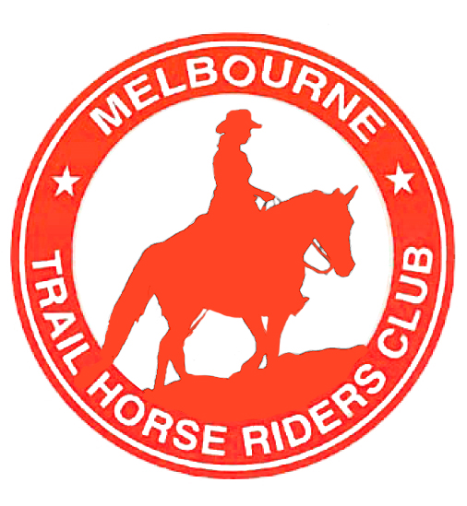

MELBOURNE TRAIL HORSE RIDERS CLUB INC.
IncorporationNo:A0004356B

TRAIL TALK
August 2013



Rides coming up:

Aug 31st – Sept 7th: Mallee: (Nominations closed) Bruce McClean

Sept 22nd: Kinglake Pub ride: (Notice to follow asap) Tim Brudenell

Oct 12th & 13th: Peninsular ride (With a special general meeting re: new model rules for MTHRC, pg 7 & 8)
Nov 2nd – 5th: BNT onging ride, Jamieson to Toolangi: Mitch Kemp
Nov 16th & 17th: Presidents BBQ, location TBA

WELCOME!
To new members:
Heiny Achermann
Emma Holm
Chris Haber
Rose Pignataro
Phillip Marshall
Kailie Mudge
Lisa Veugelers
Diane Symonds

Please make our new members feel welcome.

President:
Tim Brudenell

Vice-president:
Mitch Kemp

Secretary, Public relations
& Newsletter:
Katie Kemp
Katiee.mthrc@gmail.com

Treasurer:
Sue Helliwell
Welcome to our newly revamped Trail Talk newsletter, to be sent out bi-monthly.
In this edition: Ride Reviews from Tinamba, Macedon & Maldon 40th Anniversary.
Photos, classifieds and horsey fun!!!! J

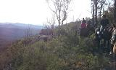

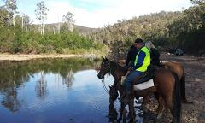

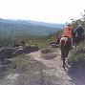
Mt Hendrick views

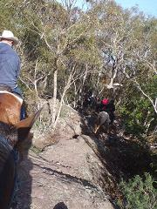

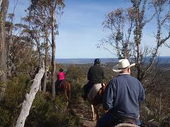

Queen’s Birthday Weekend
8th-10th June
Tinamba / Maffra : By Tania Kirby

The Queen's Birthday long weekend ride at Maffra looked like a great way to ease myself back into some more riding trips away with the MHTRC, as I had been out of the picture for many years. My body was quite a bit older, my horse new and relatively untried on the trail and I wondered if any of the members would remember me from way back when.
Well, I couldn't have picked a better trip to go! The weather was sensational, it was prior to all the much needed rain we had, so the tracks were not slippery either.
Some riders had arrived at the Happy Days Bed and Breakfast on the Friday night and had enjoyed a fabulous meal at the Tinamba Hotel, which by the way, is above and beyond any regular 'steak 'n' chips country' pub, being beautifully renovated and having a 5-star Chef in the kitchen. Happy Days B and B is also a great set-up. Nice rooms, a cosy lounge area and a fully equipped kitchen with all the trimmings AND an indoor pool and spa area AND a lovely big paddock for the horses. This was looking like being a really tough riding weekend!
On the Saturday morning, we all loaded our steeds into their floats and headed off into the hills. Once saddled and on board, I thought I might be able to take note on where we went for future rides, but Katie nipped off down a bridle trail, weaving through the bush, popping out on the road now and again, then back onto trails and generally taking us on a fantastic ride. The terrain was hilly but not too steep so the ponies had to work a bit and the footing on the track excellent, sometimes clattering over granite out-crops, mainly on softish ground. Every so often we would come out of the trees to the most magnificent vista of mountain ranges and valleys, everyone stopping to 'ooh and aahh' and someone (Heiny) bursting into bouts of yodeling as he was enjoying himself so much. He was so genuinely amazed at the type of trail riding we were doing and his great mood was soon passed onto all of us, realizing how lucky we are to have this sort of country to ride in. Emma, who is from Sweden and has a show jumping background (and it sure does show in how she sits on a horse, like she has velcro on her jodz!) also loved this country, who wouldn't?
After I had a very embarrassing dismount, off my 17hh horse, landing flat on my back with a huge 'thud' from catching my heel on my water bottle, then trying to get up really quickly before anyone saw me and thought I was complete idiot, we had a very civilized lunch break at Huggetts Crossing, with Mitch and Riley in the backup truck supplying us with hot cups of tea and biscuits.
After lunch we continued on for a couple more hours through the bush, coming across the occasional motor-bike riders, but considering it was a long weekend and beautiful weather, it wasn't too busy with bikes and four-wheel drives. The only possibly sticky situation was negotiating a fallen tree across the track, which we had to walk under. Normal sized horses had no problem, but my giganotosaurus just squeezed under, for a second I thought she was going to get stuck, like a truck under a bridge!
All in all, we couldn't have asked for a more perfect ride but Katie told us that the next day would be even better!

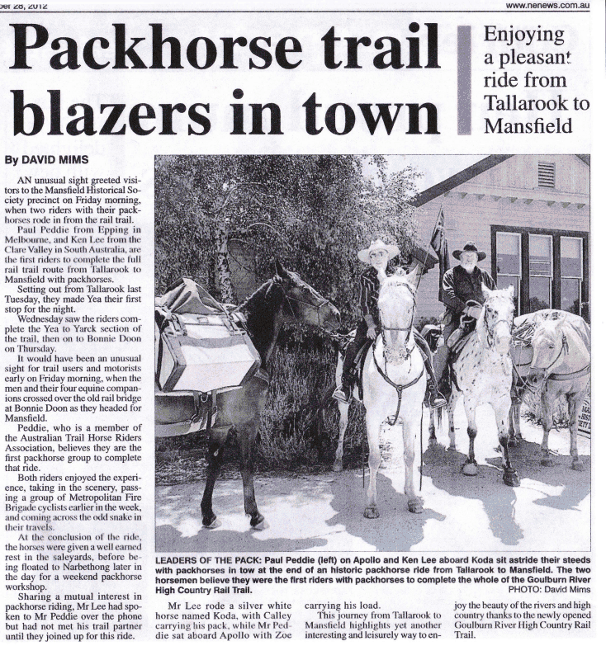

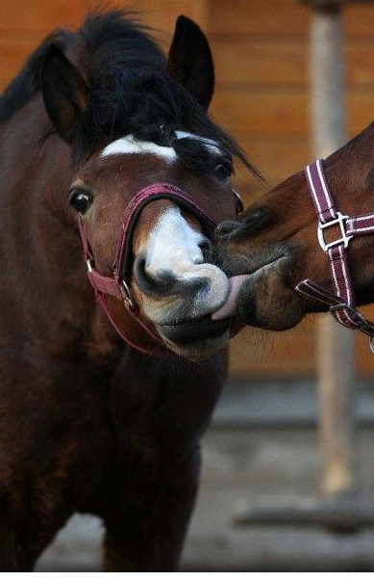

Funny Horse Quotes:
It's a lot like nuts and bolts - if the rider's nuts, the horse bolts! ~Nicholas Evans~

When someone says “Hey!” Say “Straw is cheaper, grass is free, you live on a farm you get all three!”

He knows when you're happy
He knows when you're comfortable
He knows when you're confident
And he always knows when you have carrots.
~Author Unknown ~

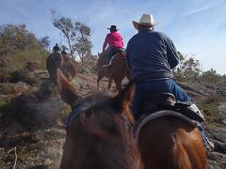

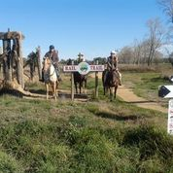

A lovely horse is always an experience.... It is an emotional experience of the kind that is spoiled by words. ~Beryl Markham

In riding a horse we borrow freedom. ~Helen Thomson

A horse doesn't care how much you know, until he knows how much you care. ~Pat Parelli

Page 3 of 10

.

Saturday night saw us at the pub for another delicious meal, some good company and a nice drop or two, then to our nice cozy rooms with the electric blanket on '3'….who wants to be in a tent?!

Sunday saw Phil saddle up his cracker of a little horse and join us but unfortunately Gordon's horse pulled up a bit sore so he decided it was best not to ride. Again we headed off in the floats; parking somewhere up Kentucky road and off we went, following our fearless leader into the bush. How she navigated her way so well around an area that is unfamiliar to her deserves full credit in my opinion. The highlight of the ride was clattering over the rocky outcrops to get to the top of Mt Hendrick with the stunning views. On the way up, much to the delight of Emma, we came across an old man wombat who seemed quite unperturbed that we were tromping through his back yard and casually meandered out of our way. OK, so the other highlight was riding back down the hill throughout the most amazing steep sided, rocky gully, affectionately named Bird Sh*t Gully, because the white cockies roost there in the large old gum trees at night and leave lots of it. We also had a stop at Pearsons Point, overlooking Lake Glen Maggie, another sensational view, where young Riley was in awe of two young boys who had ridden their BMX bikes from Maffra (and back again) just for fun. Later that afternoon, Linda's Rebel showed off and performed a few bows for us - clever boy.
Sunday night was spent at the Sports Club in Maffra by some of the group and a few stayed back for a quiet night in as it was really easy to stay in the lovely little lounge room at Happy Days.

On Monday, we had a half day ride along the Maffra Rail Trail, stopping at the at the reserve for a cappuccino then heading back to Happy Days to pack up and head home.

Thanks to Katie and Mitch for organizing such a great weekend, kudos to Katie for not getting lost! And thanks to Sue and the Stratford Trail Riders for showing Katie such fabulous rides.

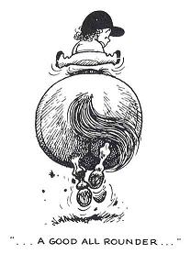

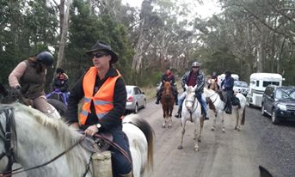

A smart horse makes you work harder, but gives you the gift of knowledge.

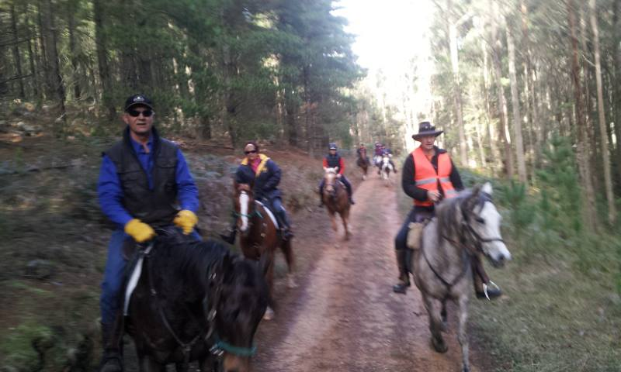

When you get bucked off, the easiest way to explain it is you dropped your hat and got in a hurry to pick it up.

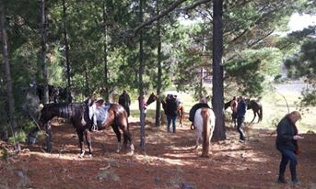

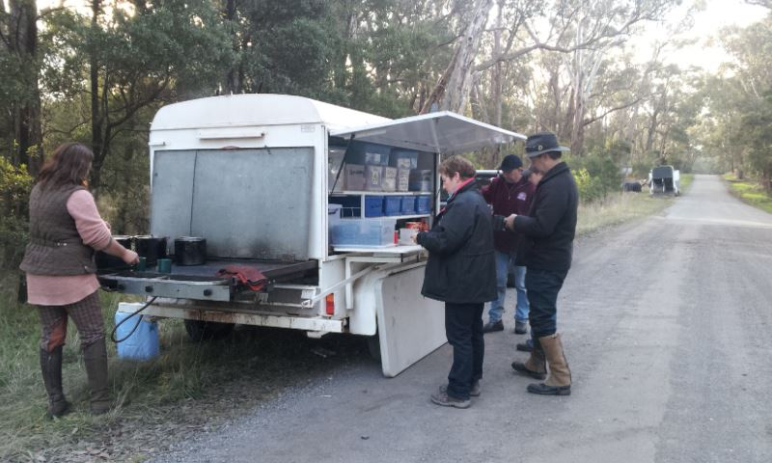
Macedon Pub Ride 30th June
By Katie

As morning broke I looked out the window and to my surprise, it was sunny, although I did ponder if Mt Macedon was sunny also or in cloud cover?
We packed the car and left Riley with his babysitter and loaded up our neddies, It was a nice change to not have to drive very far I got to admit, only took 45 minutes.
As we drove towards Woodend, we came over the hill to discover Mt Macedon in sunshine (yippee, I thought to myself.) We were the first ones at the meeting point, but soon after, floats started to roll in and we had a total of 12 riders ready to head out. It was great to see some new faces as well as some faces that I haven’t seen for a while.
Bruce was our leader and he lead us through some lovely undulating trails, weaving in and out of pine forests, with some opportunities for a little canter.
After a couple of hours we made our way to the Macedon Family Pub, we made sure the neddies were comfortable and we all headed inside to the warm bistro, where we were met by Michelle & Paul Moulden, Gerry, Bob, our babysitter and Riley for lunch.
We had plenty of time to sit and enjoy our yummy food, before mounting up and heading back to our floats. The ride home was very relaxing through the pine forests with some little opportunities for a canter.
As we rode along I could hear lots of laughing and chatting behind me. It took about an hour and half to get back, and when we arrived back at the floats, Bob and Sharon had the chuck wagon out with Tea, Coffee, Biscuits and Fruit cake, I don’t know how, but I managed to fit more food in.
A cup of tea was just the ticket.

Thank you to Bruce for leading such a fantastic ride, and thank you to Bob and Sharon for the yummy treats when we got back.

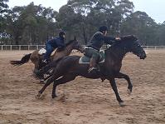

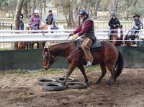

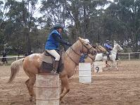

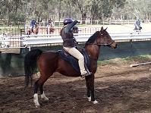

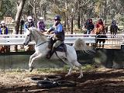

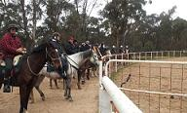

Ride Review - MTHRC 40 Anniversary
Games and Ride weekend – Maldon
By Denise & Beauty

With such enthusiasm in the related mail and information regarding the MTHRC 40th Anniversary games and ride weekend, we expected a bumper time, and a bumper time was had.
As usual, Antonio and I arrived on Friday afternoon and we certainly were not the first. There were already about 10 campers and horses spread around one of the best ever possible horse weekend camping areas you can find.
The Maldon Campdraft ground has acres available for nightlining or electric yards as well as a number of purpose built horse yards. There is a small arena and a big one as well as a cross country course, I spotted around the perimeter.
There are also toilets, a hot shower, kitchen and hall. The perfect venue for all the festivities the MTHRC committee had organized for the 40th anniversary celebrations.
Friday night was quiet and Antonio and I noticed everyone had disappeared, probably into Maldon for a pub dinner. Being a bit lazy about unhitching our car we cooked up our own dinner and had an early night.
The grounds started filling gradually and surely and by 10 am there were 30 registered competitors for the 7 planned games. Having never done anything like this before I was filled with nervousness and trepidation. I did not need to be. Even though I now know Beauty has “Drum Phobia” and didn’t do too well in any of the events, it was still heaps and heaps of fun. I loved the “Bending” race best and having a couple of unofficial goes after the first one, was amazed how quickly Beauty got the hang of bending around the poles at a canter. There may be hope for us yet ........ maybe next year I could dream of winning a much sought after blue, red, green, even a white ribbon!
After a few games we retired to our respective camps or the fire by the kitchen for lunch. Katie and Mitch had organized a guest speaker, Katie’s boss - Dr Bruce Syme from Vets All Natural Animal Health Centre, who kindly shared his time and expertise in such friendly and informative manner answering all sorts of questions.
We once again mounted steeds in ready for the rest of the competitions. The challenge factor in the games increased with most riders confidently competing in the flag and barrel race, walk trot gallop race, and the finale Trail Boss Challenge.

Maldon 40th Anniversary Celebration night
& Trail Ride

Dinner was included in the weekend and was delicious. Roasted meats and veg for main course provided by Coast to Coast the Golden Roast and sticky date puddings YUM YUM (hand baked by Susie Helliwell, and bread and butter pudding YUM YUM, hand made by Katie). The MTHRC Celebrated Club Chef, Bob Pride was invited as a club life member and on this night, was NOT allowed to be working. Lots of other club members and families, although horseless, came along to share dinner and camaraderie.
The hall was lined with memorabilia and photos of 40 years of MTHRC. Who knew that Gordon Lyttle sported a dashing mustache 23 years ago! Mitch gave a speech and shared his experiences of MTHRC he has had from 8 years of age, as well as welcoming and introducing a number of life members of MTHRC who were able to attend the dinner. A raffle finished the formalities and a great social evening beside the stunning open fire was enjoyed until the early hours of the morning.

Sunday 28 rode off down the Maldon road before turning left into the Maldon Historic Reserve on to brilliant soft dirt tracks and trails. Lucky Mitch knew the way and when we reached the Maldon Steam Train railway line (we were a little early to race the train!) he suggested that there was the opportunity to set your own pace up to the next intersection, so Antonio and Linda had a bit of a burn, later as Beauty and I arrived, you could see remains of the thrill on their faces.

We were back at camp around 12.30 which gave us all time to leisurely pack up before we headed on the 2 1/2 hour drive. As luck would have it the rain began just as we finished all horse duties and unpacking. A great end to a great weekend.

Thanks to Katie and Mitch for all the hard work they put into organizing all facets of the weekend. Congratulations to the committee as well for pulling together such a great event, one where riders from 7 ATHRA clubs came together. Thanks also, on behalf of us punters, to all those who volunteered, especially with the games, restoring dropped poles, clicking stop watches, and generally stewarding and keeping us all honest.

Be great to see the games weekend as an annual event on the MTHRC calendar and just in case, just popping out now to try Beauty around a few of those barrels. A carrot on top might help!!!

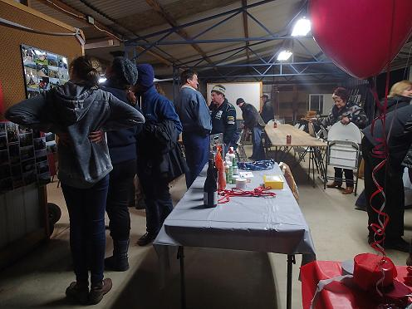

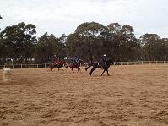

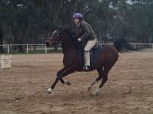

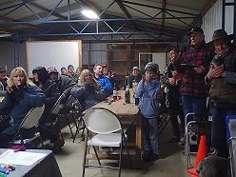

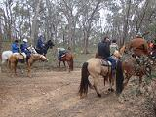

Melbourne Trail Horse Riders Club Inc.
A0004356B
President: Tim Brudenell
Vice President: Mitch Kemp
Admin Secretary: Katie Kemp
Secretary: Susan Helliwell
Treasurer: Susan Helliwell 0438 362 240

16th August 2013
Dear Members,
On 26 November 2012, the Associations Incorporation Reform Act 2012 (and its associated Regulations) replaced the Associations Incorporation Act 1981.
As from 26 November 2013, there are additional items that every incorporated association’s rules must address. One of the items is a “Statement of Purpose” which must be included in the association’s rules.
The easiest way to update our rules is to adopt the Incorporations model rules which complies with all the new laws and then modify where necessary to suit our Club’s needs.
Attached are the proposed model rules for perusal by members and following is a notice of special general meeting including the special resolution for adoption of the proposed changes to the model rules.
Regards,
Susan Helliwell

Notice of a Special General Meeting

Melbourne Trail Horse Riders Club Inc. A0004356B hereby gives notice (being not less than 21 days) of special general meeting to be held on:
12th October 2013 at our Peninsular Ride Weekend
Time 4.30pm
Place 655 Arthurs Seat Road, Arthurs Seat, VIC 3936
To propose a special resolution to approve adopting the model rules, which comply with the Associations Incorporation Reform Act 2012, and in addition, the following modifications:-

12 Annual subscription and fee on joining
(1) From time to time, the Committee will determine —
(a) the amount of the annual subscription fee (if any) and
(b) the date for payment of the annual subscription.
(2) The Association may determine that a lower annual subscription is payable by associate members.
(3) The Association may determine that any new member who joins after the start of a financial year must, for that financial year, pay a fee equal to—
(a) the full annual subscription; or
(b) a pro rata annual subscription based on the remaining part of the financial year; or
(c) a fixed amount determined from time to time by the Association.
(4) The rights of a member (including the right to vote) who has not paid the annual subscription by the due date are suspended until the subscription is paid.

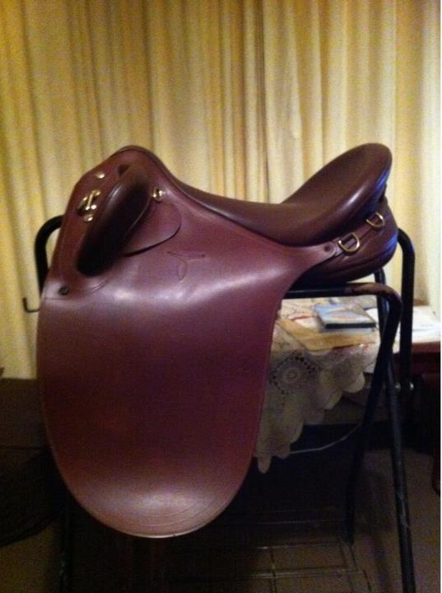

Stock Saddle For Sale
Bates Kimberly Poly 17.5 in Leather, Brown. Easy change gullet system & CAIR. Bought brand new in July 2012. Only ridden in a few times, owner has changed discipline.
$1300.00 ono
Please email Katie if you would like more information. katiee.mthrc@gmail.com

Those lucky/talented enough to score a ribbon at the
40th Anniversary weekend.

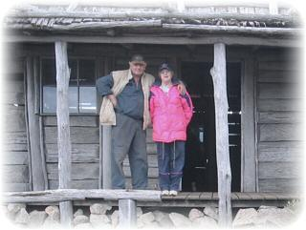
The wonderful Marjorie who we all know and love has been placed into full time care due to an age related illness.
Many of us have fond memories of Marjorie over her years with MTHRC and her time as Secretary of ATHRA Victoria through the 1990’s and beyond.
We will always remember her for her happy, friendly kind heart and how she always took all the new members under her wing (Including myself some 19 years ago.)
We wish Marjorie the best for the future and hope we will see her again soon.

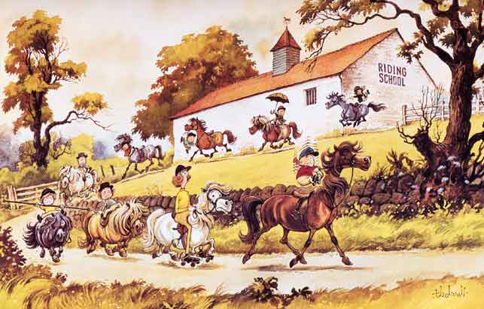
.
Thought I’d end with a funny Thelwell picture; who remembers these,
ha-ha!!!!

Hope to see you on the trails….

Regards: Katie

Barrel Race:
1st: Dave Azzopardi
2nd: Jaclyn Crick
3rd: Jude Schahinger
4th: Linda Bottom

Walk, Trot, Gallop Race
1st: Jude Schahinger
2nd: Kailie Mudge
3rd: Phil Marshall
4th: Bethany English

Trail Boss Sprint:
1st: Adam McLinden
2nd: Nikki Hearne
3rd: Jaclyn Crick
4th: Hamish McLinden

Flag and Barrel Race
1st: Jaclyn Crick
2nd: Jude Schahinger
3rd: Gill Frost
4th: Nikki Hearne

Trail Class Challenge
1st: Adam McLinden
2nd: Paul Moulden
3rd: Serena Middleton
4th: Katie Kemp

Keyhole Race:
1st: Katie Kemp
2nd: Nikki Hearne
3rd: Dave Falzon
4th: Jaclyn Crick

Bending Race:
1st: Jaclyn Crick
2nd: Bethany English
3rd: Linda Bottom
4th: Adam McLinden

