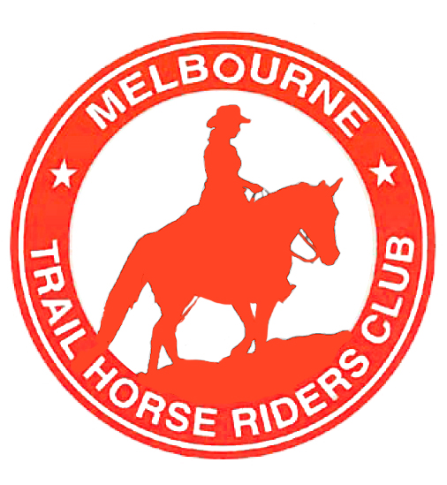

Jamieson (now possibly Mt Stirling) 25th – 27th Jan Gary Swingler

AGM: 12th Feb Katie Kemp
Coach & Horses, 33 Maroondah Hwy – Ringwood.

Strath Creek: 15th / 16th Feb Mitch Kemp

Mt Worth: 22nd /23rd March Sue Helliwell

Pyrenees ongoing, catered, 4 day ride; 25th – 28th April Mitch Kemp


President:
Tim Brudenell

Vice-president:
Mitch Kemp

Secretary, Public relations
& Newsletter:
Katie Kemp
katiee.mthrc@gmail.com

Treasurer & memberships: Sue Helliwell

MELBOURNE TRAIL HORSE RIDERS CLUB INC.
IncorporationNo:A0004356B

TRAIL TALK
January 2014



Rides coming up:

In this edition: Ride Reviews from the BNT ride, Presidents BBQ, Howitt High Plains,
and our Christmas ride at Erica.
Plus: Photos, classifieds and horsey fun!!!! J

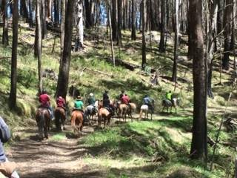

Heading out on day one.

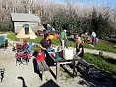

Settling in for our first night at Keppels hut.

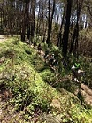
One of the pretty trails

Bicentennial National Trail Anniversary ride
2^{nd –} 5th November 2013
By Adam, Jaclyn & Hamish

We were invited to come along to the MTHRC cup weekend ride along the BNT by Katie and Mitch and I must say it was an unbelievable weekend.
As we were coming from the other side of Victoria we decided to head to Anderson Mill for the Friday night before hand, so we didn’t have as much travelling to do before the first day.
Katie and Riley were already there setting up their camp for the night, and finalizing the chuck wagon with all the yummy food.
Mitch and Gordon were out clearing the tracks up to Keppels Hut for most of the day.
That night we were joined by John and Jo Kasch, who bought pizza for us. After eating pizza and a few chats around the fire, John and Jo left and we went to bed, as it was an early start in the morning to get to Snobs Creek for the start of the ride.

Saturday morning, we were up early and headed off to get to the meeting point.
Once we got to the start point, all the riders were already there unpacking all their gear, and piling them into a corner ready to load into the back up float. Once everyone had gathered all their stuff, the horses were tied up and the riders drove their vehicles to a secure location 40 mins down the road, whilst half a dozen people stayed behind, to watch the needies and make the lunches, with the yummy meat, spreads and fruit Katie provided.
The back up vehicles then drove us all back to the horses and off we went on a much anticipated ride, lead by Mitch through some of the most picturesque countryside, riding through beautiful forest and hilly tracks with sensational views along the way. Even the burnt parts of the forest were very pretty, the contrast between the silver dead trees, with the green regrowth coming through, it was superb.
Lunch today was at Royston River Hut, and after everyone had a little bite to eat, the horses had a drink we were on our way.
Our destination for the first night was Keppels Hut. With the gates having only been open the previous Thursday, there wasn’t another sole to share the tracks with.
Once we got to Keppels Hut we discovered that Gordon, Katie, and Finny had set up the chuck wagon, pulled all our gear out of the float ready for us to set up camp, set up the horse yards for us and had the fire going with a billy boiling.
Once we all found our special spots on the manicured lawn next to the hut, Katie and Linda set up the nibbles, we had oysters, salmon, dip, biscuits, cake, chips, and Katie’s magnificent homemade Anzac biscuits.

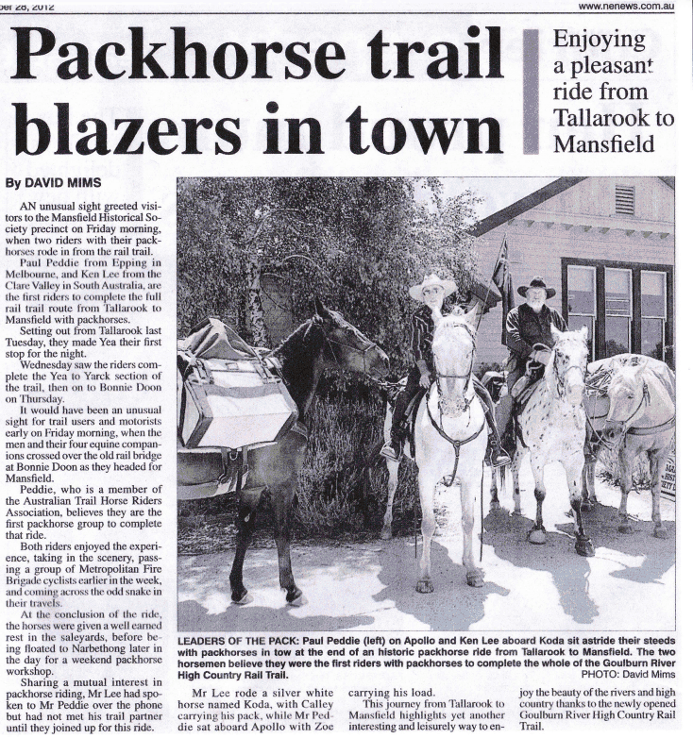

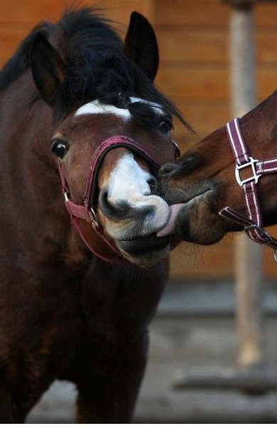

Funny Horse Quotes:
It's a lot like nuts and bolts - if the rider's nuts, the horse bolts! ~Nicholas Evans~

When someone says “Hey!” Say “Straw is cheaper, grass is free, you live on a farm you get all three!”

He knows when you're happy
He knows when you're comfortable
He knows when you're confident
And he always knows when you have carrots.
~Author Unknown ~

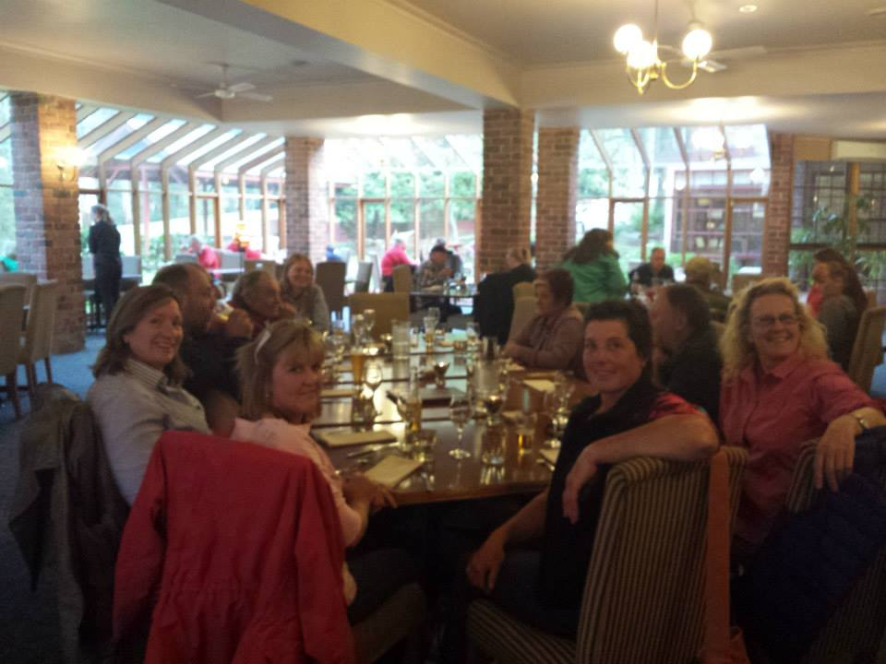

Everyone enjoying dinner at the Black Spur Inn

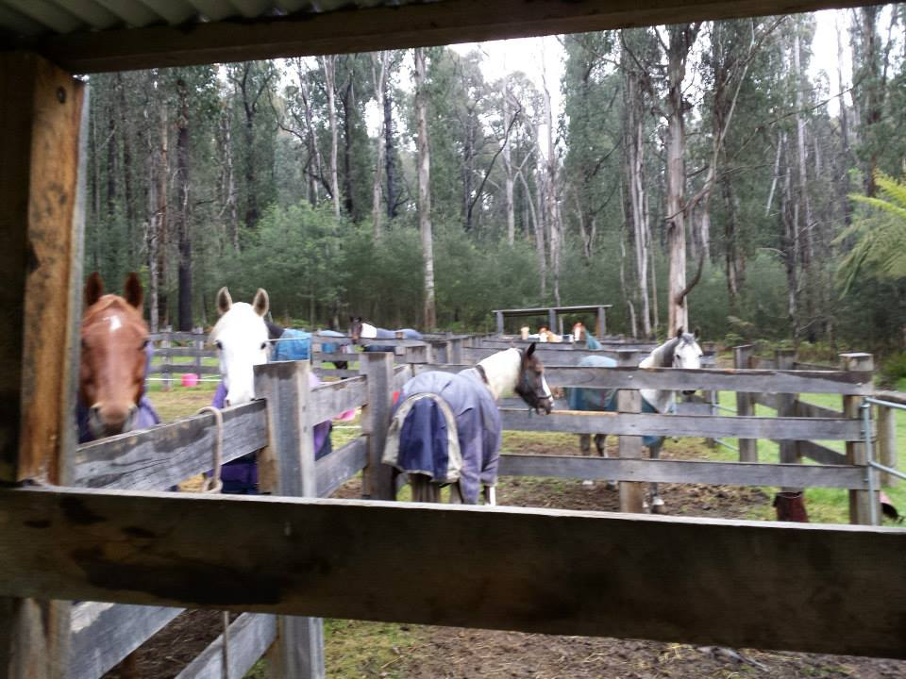

All the horses asking ‘Where’s our food’?
At Anderson Mill.

In riding a horse we borrow freedom. ~Helen Thomson

Page 3 of 10

.

Horses settled for the night, we settled near the camp fire with a delicious bowl of spaghetti bolognaise, followed by self saucing puddings.
I did ponder what the poor people were doing at this stage.

Sunday morning arrived and so did the weather, although all you had to do was wait a few minutes and it would change again. Ha ha!!
A fairly early rise this morning as the ride out time was 9am and we had a fair distance to cover. Horses were fed and watered, we packed up our gear loaded it into the float and hopped into a yummy beaky.
After breaky, Katie pulled out all essentials for a yummy lunch, for us to put together.
With horses saddled and lunches in saddle bags we headed out down Keppels Track and along Lady Talbot drive.
In amongst the silver trees and re growth it was a very pretty sight, especially walking along side the Taggerty River.
We had lunch at a pretty little camping spot next to the river.
After lunch the heavens opened up as we headed down the rest of Lady Talbot drive into Marysville, down past Gallipoli Park, through the town then up through a newly constructed track, called Sawmill Track this took us through green forest and ferns straight to Anderson Mill.
Once at Anderson Mill, we made use of the great yards there and the horses were very happy with rugs on and bellies full.
The backup cars took us to pick up our own cars and floats, to bring them back to our camp.
Once back at camp Katie was cooking up a storm and it smelled awesome, we had the best corned beef I have ever had, along with steamed veggies and white sauce.
Then after all that, we got served homemade bread and butter pudding, that she had cooked in the camp oven. Yummmmmo!!!!
After feeling like we were about to explode, and the dishes done, we all retired to the camp fire, and some of the girls had showers in Ken’s gooseneck.

Monday morning was very relaxed, as ride out was to be 10.30am most people slept in.
This morning was a wee bit wet; Katie had planned a hot breakfast, sausages, toast, bacon, spaghetti, baked beans, were just the ticket for a cold morning.
We all packed up our stuff, saddled our neddies and sorted our lunches ready for the days ride. Today was a relatively short ride to John and Joe Kasch’s property.
At lunch time we were met by the man himself John Kasch, who then led us along scenic tracks to his property at Narbethong.

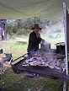
Katie cooking up a storm for breaky.

.
Riding: The art of keeping a horse between you and the ground. ~Author Unknown

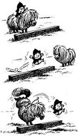
Once there, we settled the horses into their paddock or yards and once again were ferried back 20mins to get our vehicles.
This afternoon at the Kasch’s property was very relaxing, chatting under the trees, sunny skies and munchies.
Tonight we were booked in at the Black Spur Inn for dinner, some people stayed at the Hotel; I was a wee bit jealous of them actually.
After showers we all descended into the restaurant for dinner, joined by the Kasch family, Sue Baillie, Julie’s partner and Tania’s husband.
It was a very entertaining night, delicious food and awesome company, after dinner Katie got her speakers out and played some dancing music. After a long night we headed 1km up the road back to the Kasch property (except for those staying at the Inn.)
Tuesday bought sunny skies and warm weather.
Everyone rose in their own time, some with sore heads and some bouncing like they were 10 years olds. Horses fed and we headed to where a group of people where hovering, once we got there we realized why.
They were all ogling at Joe and Tania’s Land cruiser/ bedroom/kitchen; it was amazing, so much so, Katie used it as the breakfast station.
John was our leader today and he led us through more picturesque forest, up and down hills, through creek crossings.
Sue and her little horse Rocket went a bit of a gutser in one of the creeks, no one hurt, just a bit wet and some laughing.
Lunch was in a secluded spot under a row of pine trees. After about an hour we headed back through the forest, back to the property, people packed up and slowly headed off home.
We stayed another night, just because we didn’t want to go home yet.
It was a fantastic long weekend, everyone had a ball, we had wonderful company and Adam and I will be back riding with MTHRC again soon.

Thank you to;
Mitch our trail boss
Katie the marvelous cook
Gordon, Finny and Hamish for looking after everyone
Plus John & Jo Kasch for the use of their property and leading us through their special part of the world.

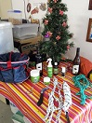
The wonderful goodies donated by everyone.

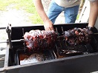
The meat looking fabulous!!

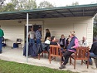
They start rolling on in!!!

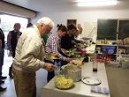
Dinner is served.

Presidents BBQ 23rd & 24th November
By Julie Caddy

The President's BBQ/Xmas party and ride were held on Saturday 23rd and 24th November at Yarrabubba Rec Reserve, Bunyip State Park.
Several riders arrived on Friday night and camped at this great facility, the Nar Nar Goon Pony club grounds and we had the use of the day yards, toilets, BBQ and club rooms for the weekend.
On Saturday morning the rest of the party animals arrived and we enjoyed a terrific ride out from the grounds led by ride leader Susan Helliwell on Spud. The weather was wonderful with LOTS of lovely rain falling throughout the day (W. Gippsland being famous for it's verdant appearance!), but this didn't deter us, and we followed Susan out of Yarrabubba reserve, crossing a little creek, through some bush and on some of the local roads and tracks onto Mortimers Rd, Pooley's road and to Yarrabubba track in the Bunyip State Park. We had lunch at Mortimers reserve and after the discovery of a leech on one of the ladies; a thorough personal check was undertaken by some of us! After lunch we rode up Steege's track, down Windy Point and Triangle track back to Mortimer's Reserve, then home via Dawson's track. Spud tried out his homing navigation skills through the bush, but deferred to Susan's higher intelligence on the matter.

Back at Yarrabubba Rec Reserve, with the horses back in their accom for the night, we had a terrific Xmas party and raffle. Mitch cooked Lamb, Beef and Pork to perfection on the spit roaster and Susan, Lisa Veuglers and Fay provided wonderful salads, Linda Andrews made all the wonderful cheesecakes, Katie Kemp made a spectacular chocolate ripple cake, and Susan made Sticky date puddings. Sue Baillie helped Susan, Ken Hammond, Dean and Fay clear the pony club's jumps out and set up the kitchen, and then return the jumps afterwards.

A terrific raffle was held with Bob (lucky Sharon!!) winning the nightline which Mitch had donated, and other yummy prizes were won by lots of ticket holders, with the prizes being donated by Sue Baillie, Susan, Lisa V, and Katie's employer Vets All Natural..

Tim, the Club President, cooked a wonderful hot breakfast for all on Sunday morning.

I left before the ride on Sunday due to a shoe on my horse coming loose, but I believe the riders enjoyed another excellent day exploring the wonderful tracks and trails of the Bunyip State Park.

Many thanks to Susan Helliwell for planning and leading the ride, and to Susan and all the other contributors of food, raffle prizes and effort to make this another fantastic weekend event which was free for club members and virtually free for everyone else!!

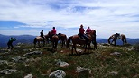
Spectacular Views

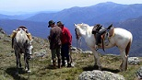
Mitch and Ken

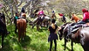
Lunch time

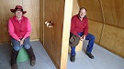
Sue and Ken trying out the new toot!!!

Howitt High Plains Ride – Dec
By Fay & Bailey
For me, the trip to Mt. Howitt began on Friday 29th, travelling from Chelsea in the early afternoon to arrive at Glenmaggie for an overnight stopover with friends, then travelling on to Licola Saturday morning. From there, Ken, Susan and I travelled in convoy to Howitt Hut, approx 80ks from the small township of Licola. Although the unmade road seemed to be a hard all weather surface, there were occasional corrugations and pot holes which demanded our attention as the road appeared to continue on forever. “Are we there yet??” ……. and then all of a sudden we were!

On Saturday afternoon and evening we shared The Howitt Hut camping area and large horse paddock with Kevin Higgins who was running a commercial horse riding adventure for approx 30 patrons. He advised us that the beautiful weather we were enjoying was due to change on Wednesday ~ torrential rain and the likely hood of snow on Thursday ~ and that he would be adjusting his riding plans to suit the severe weather prediction and advised us to do the same.

Our riding group headed out from camp mid Sunday morning with Gordon and Linda leading us across a huge open plain of grass tussocks which was crisscrossed with narrow meandering rivulets that the horses easily leapt. The ride continued on through areas of mottled snow gums whose twisted trunks and branches curved over the tracks and shaded us from the heat of the day. At times the single file track disappeared but Gordon had ridden this route on other occasions and had our complete confidence in his navigation skills! The further we travelled the more interesting the terrain became and the views of valleys and rugged rocky mountains that suddenly appeared as we emerged from sheltered tracks can only be described as awesome and breathtaking. Photos had to be taken and most of these shots did justice to our trip. The high plateau of Mt Howitt and the perfectly clear weather gave us further spectacular views of the rugged surrounding mountain terrain. The views were truly unbelievable and stunning.
Some of the tracks we followed were tricky; narrow, rocky and twisting, which at times ran fairly close to serious edges and left little margin for error as we navigated up and down them. Concentration took precedence over chit chat as we steered and urged our horses in the direction we needed to take. At times there was much exertion for the horses to maintain momentum, leaping up slabs of rock that formed stairways whilst dodging and bending around trees that had grown in the most inconvenient of places. And then out of nowhere a sheltered grassy area appeared which gave the horses a place for a breather and a pick.

During our return trek to camp over the top of Mt. Howitt, Gordon remembered there was a pool of water somewhere on the rocky plateau ~ and sure enough he found it and the horses drank their fill.

Mention must be made of the Vallejo Gantner Hut, which was where we stopped for lunch at Macalister Springs. A short distance from the hut was a free standing toilet structure which overlooked some amazing landscape. A ramp led up to the elevated structure and to the door that opened onto two ‘toots’ that were set back from the window which offered the spectacular view whilst ‘going about your business’ (so to speak.) These toilets were only divided by a shallow wall that gave just a little privacy while sharing the view! Apparently the newly constructed toot had its official unveiling on the day before we arrived. (It smelt new!!!) Anyway, it had our attention!

Monday was spent discovering more of the countryside from the saddle, whilst Tuesday was our camp relocation day. On our descent to our next camping area we stopped at Bryce’s Gorge car park to ride into Guys hut and then further on to see a couple of pretty waterfalls before having lunch back at the floats. By mid afternoon we arrived at our new camp site and soon afterwards a few members enjoyed a short ride before the horses were turned loose in another sizable fenced paddock.

The evenings were enjoyed sitting around the camp fire, participating in and listening to the inevitable banter that comes from good company, good food and a few beverages. Most of the night skies were littered with stars and the daybreaks were all colourful (and too early!!!)

The dawn of Wednesday proved Kevin Higgins correct, so the call was made to conclude the trip and to pack up our camp in between heavy downpours of rain. Disappointedly we made our homeward trek down the saturated track under very grey skies and wet conditions ~ such a contrast to our arrival on Saturday!

Our thanks go to Gordon and Linda for planning and leading such a wonderful trip in that amazing high country above Licola, and also to Mitch for cutting and collecting most of the firewood. Hopefully we will return to the area in 2014 and continue the unfinished adventure! Fay.

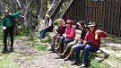
Gordon telling stories out the front of McAlister Springs Hut.

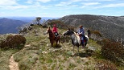
Sue and Bill

A horse doesn't care how much you know, until he knows how much you care. ~Pat Parelli

A smart horse makes you work harder, but gives you the gift of knowledge.

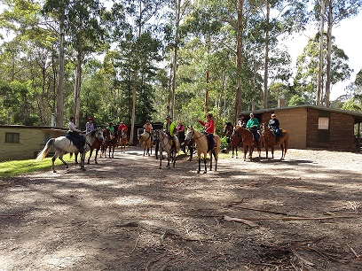
The group ready to head out on day two.

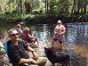
Mitch, Lisa, Wendy, Jennie and Jake enjoying the river.

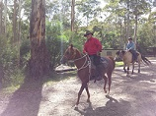
Brian and Wendy heading out.

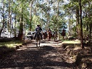
Life member Len Stocker leading the group out for the day.

Xmas Ride – Erica 27th – 31st December

Boxing day was hot and humid, and once we finished doing our grocery shopping in Moe, we headed to Erica.

Once we arrived at Caringal Scout Camp we found our camp spot, got the horse comfy and then headed to the mess hall / kitchen to unpack our esky’s into one of the big fridges available.
I couldn’t believe the mess hall when we walked in, newly refurbished kitchen with three ovens, three fridges, huge walk in pantry and enough cooking utensils to cook the Army.
Heaps of tables and chairs, plus two reverse cycle air-conditioners, which was just what we needed.

Slowly people started arriving Julie, Wendy, Gary and Jennie where the first ones to arrive the Thursday night.
Come Friday half a dozen more people drive in, ready for a great three days of riding.

I must say the riding up there is magical, fantastic ferns, bracken, trees, and river crossings, just awesome.
We rode into Coopers Creek for lunch on the Sunday and was met there by Dean, Katie and Riley who had a billy boiling and some nibbles going, just the ticket.
The days were around the high 20’s but we didn’t notice so much as we were mostly in amongst the forest.

As it was pretty hot in the evenings, so most people retreated into the mess hall under the air-conditioners and some went down to the river for a little dip.

Caringal Scout camp is the ultimate location for this time of year.
Everyone sitting around the mess hall, making dinner, chatting away, it was great.
The last night we all went to the Rawson Pub for a yummy meal, well we hoped it was going to be yummy anyway, bit of a letdown, should have stuck with the steak I think.
Anyways it was still a great night.

The 31st came and everyone packed up and left to go to their own new year’s parties.

Must say a huge thank you to our ride leader Mitch Kemp for leading us through some magical country.
Hope we can have our next Xmas ride there.

Classifieds / Services
Horse Lovers Dream - Mornington Peninsula
A rare opportunity for the horse enthusiast to acquire this magnificent 7 acre property on “The Hill” of the Mornington Peninsula, comprising approx 5 acres of lightly treed grazing land divided into 4 paddocks, each with water trough or dam. Features include, riding menage (30mt x 70 mt), undercover round yard, saddling and feeding yard and float parking, two wash bays (one indoor with hot water), two stables, workshop and tack room, and a further machinery shed with concrete floor. The property is well maintained throughout with 5 huge water tanks, excellent fencing and established garden.

Whether you are looking for a new home or a low maintenance weekend holiday retreat, this property sits in the middle of the Mornington Peninsula with easy access to the “Red Hill” lifestyle, coffee shops, vineyards, orchards, bakeries, markets, beautiful peninsula beaches and local townships.

Uniquely, you may never have to float again with hours of riding on the Peninsula horse trails, right out your gate. This recently renovated home is 4 bedrooms, 2 bathrooms with undercover parking for 3 cars. Also included small orchard, chicken shed and run, wood shed and protected vegie garden.

For photos and further information check out website
http://www.kayburton.com.au/property/655-arthurs-seat-road-arthurs-seat or call Antonio on
9494 884 920

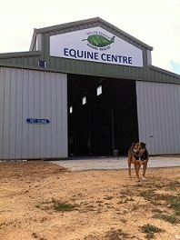

Vets All Natural Animal Health Centre has a brand new equine hospital, located in the outskirts of Castlemaine.
We offer now offer;

Digital radiology
Video linked endoscopy
Ultrasound examination – repro and tendon scanning
Stud work, artificial insemination
Full blood analysis – in house haematology and biochemistry
Power Dentistry with master equine dentist - Darren Lynch – sedation, pain relief and nerve blocks. Full extractions while standing, dental x-rays
Chiropractic manipulation with Don Hoffman
Farrier
Basic surgical procedures
Full lameness work up
Intra-articular injections

Please call (03) 5472 5477 if you would like more information or to make an appointment.
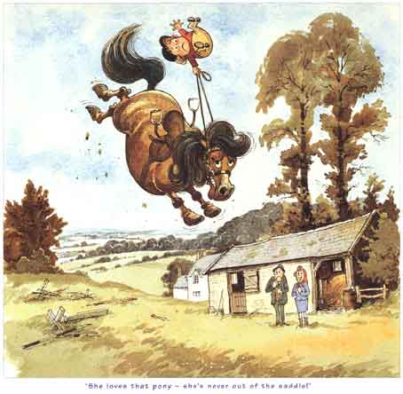

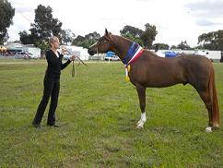
Simla Jafar

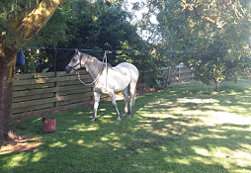

Simla Jafar

AT STUD
Simla Jafar
Purebred Arabian
S26320

Supreme Led Exhibit and multi champion in his first show season
Liver Chestnut 15HH 5YO
Sire Fenwick Phantom
Dam Jomain Alexis
82% Crabbet Bloodlines
Jafar has a great temperament and is a pleasure to handle and ride. He is smart, sensible and a great trail riding horse.
Standing for his first season to outside mares
Inspection welcome
Service Fee $900 LFG
Mobile 0438190162
Bush Horseman Products – Inventors of the original Equitether, are now on Facebook.
Selling the popular Equitether Night-Lines, a campsite horse tethering system that requires no knot tying, proven to be the best available.
Like our Facebook page, call: 0400 389 839
or email: katiee.mthrc@gmail.com for more information on the Equitether and other products.

Hope you enjoyed this edition of our Trail Talk.
See you out and about on
the trails.

Katie Kemp
Secretary of MTHRC

